MANAGENIENT PLAN
MAR
24
1999
DEPT. OF COMMUNITY AFFAIRS
FOR FLORIDA COMMUNITIES TRUST
MALABAR SANCTIJARY GREENWAY 1 AND n
BREVARD COUNTY, FLORIDA
FCT project #95-063-P56 and #96-019-P7A
PREPARED FOR THE TOWN OF MALABAR
BY
MARNE RESOURCES COUNCIL

OF EAST FLORDA
SEPTEMBER 1998
TABLE CONTENTS
NTRODUCTION
A Combination of Management Plans for
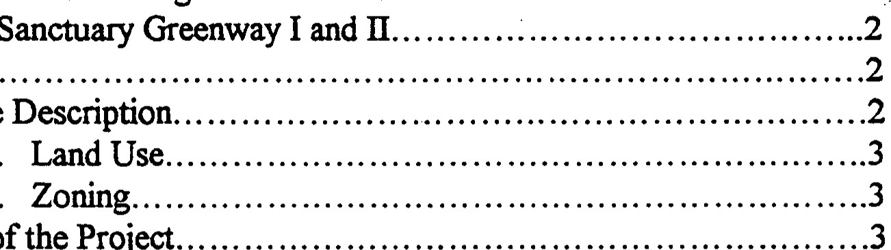
Malabar Sanctuary Greenway I and Il B. Location
Resource
1.
2.
ffstory
of
the
Project
C.
D.
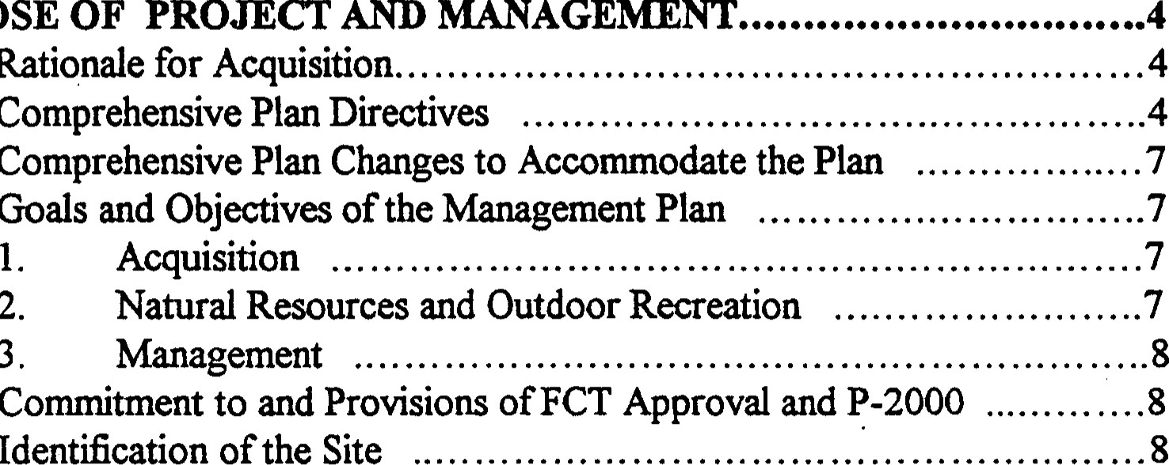
11 PURPOSE OF PROJECT AND MANAGEMENT
Comprehensive
Rationale for Acquisition
Comprehensive Plan Directives
D.
Acquisition
2.
3. Management
Identification of the Site
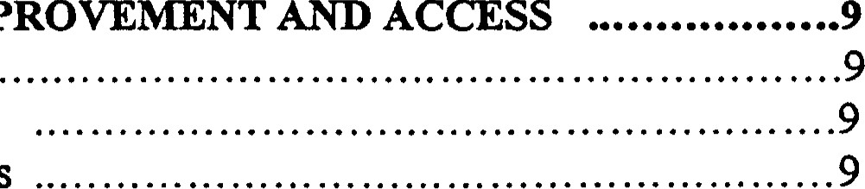
m. sr1'E DEVELOPNfENT, n^{t}fPROVENfENT AND ACCESS A. Approvals from FCT
Existing Improvements
Proposed Improvements
D. Land Alterations Related to Listed Species .10
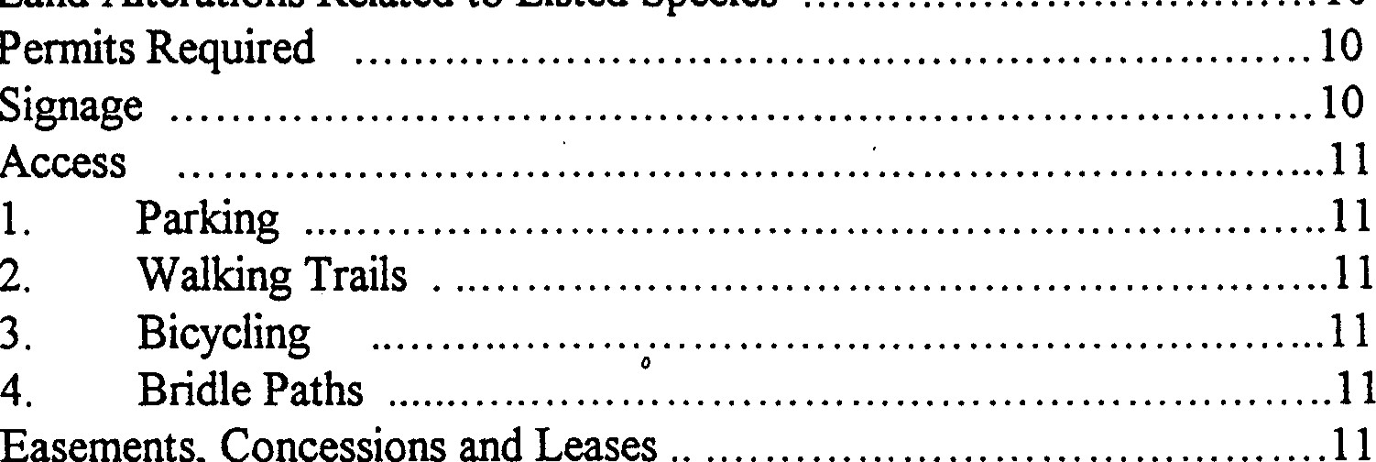
Permits Required
Easements,
Concessions
and
Leases
Signage
G. Access
2.
H.
l. Notice to FCT oflmpending Easements, Concessions or Leases
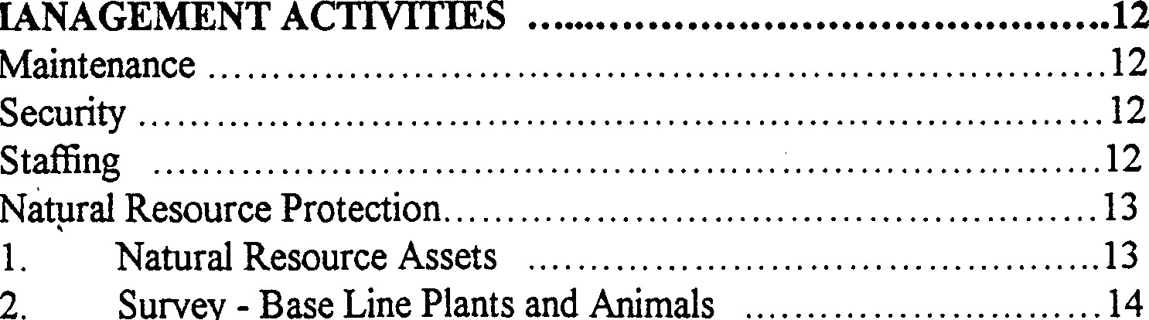
IVY. MANAGEMENT ACTIVITIES A. Maintenance Security . Staffng
Survey
-
Base
Line
Animals
D.
TABLE CONTENTS (Continued)
Protection of Endangered Species14
Protection of Imperiled or Imperiled
Vegetative Communities14
Geological Features.14
Protect Surface Water/Groundwater and Hydrology ..15
Prescribed Bums. 15 D. Resource Restoration and Enhancement15
l. Exotic Plant Removal15 2. Floodplain Wetlands .16
3. Revegetation.16
- Archaeological and Historical Elements .16
- Coordination of Impacts to and from Adjacent Landowners . . . . . . .16 H. Greenway Management17
COST ESTIMATES AND FUNDING SOURCES
Cost Estimates 17
Funding Sources . . . . . . . . . . . .17
VI. PRIORITY SCHEDULE. 18
MONITORING. 18 Annual Report18
Ecosystem Viability18
Surveys to Florida Natural Areas Inventory . 19
Plan Up-date19
LIST EXHIBITS
Map of Combined Malabar Sanctuary Greenway I and Il.
B. 100 Year Floodplain Map of Malabar.
c. Master Site Plan
LIST APPENDICES
1. Conceptual Approval Agreements Malabar Sanctuary Greenway I and Il.
11. Species Lists for Turkey Creek and Malabar with Surveys of Listed Species.
Ill. Cost Estimates.
IV. Priority Schedule.
Grant Award and recorded deed.

MALABAR SCRUB
Greenway I and Il
The materials are provided as required by Rule Chapter 9K4, Florida
Administrative Code (F.A.C.) as a prerequisite to the acquisition ffnding effort of the Florida Communities Trust Program on behalf of the Town of Malabar. This management plan be reviewed and approved by the Staff and Town Council of Malabar. The Town in association with several agencies described in the text will be for the various aspects of management procedures and implementation of the plan.
1. NTRODUCTION
- Combination of Management Plans for Malabar Sanctuary Greenway I and Il.
Proposals for land acquisition were submitted to the Florida Trust in the 1995 and 1996 grant cycles. Both projects, Malabar Sanctuary Greenway 1(1995) and Il (1996) received favorable reviews and approvals for finding. Conceptual Approval Agreements between the Florida Communities Trust and the Town of Malabar were approved in November 1995 (Greenway I) and on April 15, 1997 (Greenway Il) (Appendix I). Land acquisition is proceeding for both projects. Since the purpose is to link the two proposed projects via floodplain this managemart plan is accomplished by combining planning and management of both. Maps and references will refer to the total Greenway. The distinction for administrative purposes is that Malabar Sanctuary Greelway I is north of Malabar Road on lands surrounding Turkey Creek and its floodplain, and Malabar Sanctuary Greenway Il is south of Malabar Road exhibit A). The FCT has negotiated sales on three parcels south of Malabar road Within the Malabar Il project boundary. Main focus is put on these three parcels one on Weber Road, one on Corey Road and the third parcel east of Shiflet Road on Malabar. As further acquisition occurs the management plan will be amended to include the management details onthe parcel(s) before closing.
- Location
The project sites are found in Southem Brevard County, Florida, in the Town of Malabar. The town is located along the west shore of the Indian River Lagoon and east of interstate 1-95. The City of Palm Bay lies immediately norå of Malabar with unincorporated County lands to the south.
Tributaries of Turkey Creek form in the southem portion of the Town and flowed, historically, north between a series of ancient dune lines to the main channel of the Creek. Roads, fields, canals, ponds and fill for homesites have altered this natural flow. The project lands are located along the flowway of Turkey creek, surrounding floodplains and uplands (Exhibit B).
- Resource Description
Malabar Sanctuary Greenway is comprised of lands in the floodplain of Turkey Creek, adjacent wetlands, and upland ecosystems directly associated with the floodplain. Turkey Creek, a fresh black water creek, extends from wetland headwaters in southem Malabar through the town to join the main creek channel and the Melboume - Tillman Water Control District to the norå. Historically, the low wetland marshes were fomed by seepage from Pleistocene sand dunes. This, a series of barriers, restricted flow to the east or west.
The old dune formations of porous fine sand provide the unique condmns described as Florida Scrub or Sand Pine Scrub. Vegetation on the ecosystem of the dunes is adapted to the dry soil conditions, lack of nutrients for plant growth and frequent fires. Several plants and animals, endemic to the scrub habitat, are listed as threatened or endangered because of loss of habitat (i.e. gopher turtle (Gopheruspolyphemus), scrub jay (Confradina grandiflora), and others).
Shallow wetlands of cord grass (Spætina bakeri), St. Johns Wort (Hypernicum sp.), and other herbaceous species collect ground and surface runoff which combine to form small tributaries. Flowing north the dark tannin-rich waters are surrounded by hardwood hammocks of oaks, maples, sabal palms and giant leather ferns (Appendix Il).
  - Land Use
Much of the land surrounding the creek was drained for field crops in the 193 Os and converted to pasture from the 1940s to the present. Parcels of 10-20 acres were subdivided during the Great Depression as subsistence farms. Since 1970, there has been an increase in the number of density of single family homes encroaching on the floodplain and sand scrub lands.
  - Zoning
Existing zoning for the projected Greenway lands is primarily rural or single family residential of various densities. Two parcels on the southwestern comer of Cory Road are zoned offce institutional. The Brook Hollow reserve area (parcel 12) is listed as institutional on the zoning map.
The Town of Malabar will to the Department of Community Affairs a local government Comprehensive Plan Amendment in July to include the land use classifications for conservation, preservation and recreation/open space. Once the Town adopts this new land classification, the Town will change the Future Land Use and zoning designation of all acquired parcels within the Malabar I and Malabar Il project sites to conservation, preservation or recreation/open space.
D History of the Project
The vision held by the people of Malabar is that of a rural community with open space in native vegetation with opportunities for small farms, gardens, pastures and woodlands. Recreation in horseback riding, walking, and boating and nature study are actively pursued by the citizens of Malabar.
Issues facing the Town include:
(l) buffering the slow pace of life in Malabar from the intense urbanization of neighboring Palm Bay;
- drainage and flooding problems caused by floodplain development and drainage diversions;
- maintaining the low tax base and limiting commercial services to the minimum needed for rural development.
In 1995, citizens serving on the Malabar Parks and Recreation Board received the notice of Florida Communities Trust funds available to towns of less than 10,000 people. The Board requested assistance from the Marine Resources to prepare a proposed - Malabar Sanctuary Greenway l. The Turkey Creek floodplain lands were the focus because they are contiguous to the Turkey Creek Sanctuary in Palm Bay, are often flooded and form a

continuous greenway link between the Palm Bay Park and County owned endangered lands (432 acres) the Malabar Scrub. Parcels on two tributaries of the Creek were described in the proposal delivered and approved by the FCT Project Selection Committee. The Conceptual Project agreement was finalized in November 1995 and amended on May 30, 1997 and August 15, 1997.
The FCT proposal for the Malabar Sanctuary Greenway Il was submitted on August 2, 1996, and approved for acquisition. The Conceptual Approval Agreement was signed on April 15, 1997. Addenda were executed; I and Il on October 15, 1997, Ill on November 10, 1997, IV on March 10, 1998 and an extension granted on March 2, 1998.
PURPOSE OF THE PROJECT
A Rationale for Acquisition
Malabar is a community with commitment to a rural lifestyle and concern for natural land use patterns. Thus it is appropriate to accommodate open space, flood protection, recreation and resource protection in a multiple use land acquisition progam. The underlying impetus for the greenway is preservation of a life style important to the people of the town. Equally important is the urgent need to provide not only flood protection and drainage but also responsible water management.
The rationale is to acqu.fre floodplains, wetlands and wildlife corridors to reverse the development pattern of encroachment on drainage ways and fragile ecosystems while providing open space, urban buffers and recreation opportunities for the people of Malabar.
B. Comprehensive Plan Directives
Acquisition of land and establishment of the Malabar Sanctuary Greenway is an essential element in accomplishing the goals and objectives of the Town of Malabar's Comprehensive Plan.
Conservation
Goals, objectives, and policies of Malabar's Comprehensive Plan address several factors furthered by the acquisition of the greenway property: water quality, stormwater and floodplain management, wetland protection, maintenance of native vegetation and wildlife habitat and environmentally sensitive lands.
Water quality of the Indian River Lagoon and its tributary, Turkey Creek, is protected through Objective 6-1.2 and Policy 6-1.2.1, which calls for stormwater control and management and Section 1-8.7 of the Land Development Code that sets stormwater design criteria. Agricultural land use activities like those surrounding the Greenway are directed by Policy 6-1.2.2 not. to interfere with wetlands and the lagoon watershed. New developments are charged with protecting shorelines from erosion and water quality impacts (Policy 61.2.40. Additionally, Land Use Policy 1-3.1.3, calling for lower densities of development along the creek and Policy 1-3.1.6 directs that performance standards are implemented for land development activities.
Several objectives and policies address floodplain development and management. Objective 6-1.3 directs the Town to protect the 100-year floodplain, its storage capacity and native vegetation. The Malabar Sanctuary Greenway preserve the 100-year floodplain of two branches of Turkey Creek and the natural hardwood hammocks surrounding the streambed. This ffrthers Policy 6-1.3. I and the Land Development Code that restrict development in the floodplain, as well as implements Policies 6-1.3.2 and 6-1.8.2 in the purchase and/or acquisition of floodplains. Policies 6-1.3.2 and 6-1.4 to protect and preserve wetlands are also reflected in the Town's adopted Floodplain Ordinance (924). Policy 4 3.1.3 directs use of natural corridors and natural lands for stormwater drainageways. The Malabar Master Drainage Plan and Land Development Codes define this policy in engineering design and regulation.
Conservation Objective 6-1.7 directs the Town to protect native vegetation, particularly hammocks and wetlands. Hammock vegetation, depression marshes (including the creek bed) and mesic flatwoods buffers are protected in the proposed Malabar Greenway. The Town's Landclearing and Tree Ordinance 90-5 and Development Standards also implement this objective.
The proposed Malabar Greenway is designed to incorporate fish and wildlife habitat for indigenous as well as rare and endangered species. Objective 6-1.8 (protection of wildlife) and Policy 6-1.8.1 (restriction of development in wildlife habitat) are implemented in the Land Development Code and Ordinance 94-3 which limits densities on the Atlantic Coastal Ridge, provides for protection of scrub jay habitat and adopts a scrub jay habitat policy. The Greenway extension proposed for Malabar extends and augments the green corridor from the Malabar Sanctuary Greenway I (124 acres), to the 342 acre County-owned scrub habitat to the sand pine scrub of the Turkey Creek Sanctuary on the Atlantic Coastal Ridge.
Objective 6-1.9 (the protection of environmentally sensitive lands) are augmented by
Land Use Policies 1-3.5.1 and I-3.5.4 and all are furthered by the proposed greenway. The
Florida Natural Areas Inventory (FNAI) finds the scrub, hammocks and depression marshes of Malabar imperiled globally and/or rare throughout the state. The Brevard County Environmentally Endangered Lands Program supports efforts to protect scrublands and create greenway corridor connections between existing sanctuaries.
Coastal Management
Goals, objectives and policies for wetland protection, shoreline uses, and lagoon watershed management coordinated with the city of Palm Bay are addressed in the Malabar Comprehensive Plan and are implemented through this proposal and other community initiatives.
Wetland protection is directed by goals of both the Coastal Management and the
Future Land Use elements. Objective 5-1.1, Policy 5-1.1.1 and Land Development Codes protect coastal wetlands, and restrictions directed to ecotones surrounding wetlands. Policy 5-1.1 directs protection of wetlands from exotic plant infestation. This project proposed removal of Brazilian pepper trees from the floodplain and the hibutary of the wetlands.
The Coastal Management element of Malabar's Comprehensive Plan, just as the Conservation Element, includes policies to promote fish and wildlife (5-1.1.6 and 6-1.8.2). This is reiterated in the Future Land Use Policy I-3.5.4, and more filly described in the preceding section of this summary.
One purpose of the Malabar Sanctuary Greenway is to provide for open space access by the public to shoreline and waterways while protecting natural ecosystem ffnction (Refer to Project Purposes and Goals above). Malabar Comprehensive Plan Policy 5-1.2.1 access to shoreline uses and Policy 7-1.4.1 directs the Town to provide access points to Turkey Creek. Objective 1-1.4 applies the Town's budget process to land acquisition for recreation and open space.
Several elements of the Town's Comprehensive Plan calling for coordination between agencies are fulfilled by the Greenway proposed. Policy 1-3.10.1 directs the Town to coordinate with Palm Bay in the management of coastal resources and water of the State, i.e. Turkey Creek and the Indian River Lagoon. This is similar to directives for intergovernmental coordination in Policies 6-1.11.1 and the Intergovernmental Element.
Recreation and Open Space
The To•wn of Malabar has few recreational facilities but a wide range of private traditional recreation activities: horseback riding, hiking, swi.mming, and boating. E)dsting
•trails and access points to the natural areas and waterways have traditionally been used on the private property included in the Greenway Acquisition Program..
This project fulfills several policy initiatives to adjust land use and supply of recreation amenities to protect and maintain the heritage of this outdoor recreation. Several recreation policies are incorporated into the Future Land Use Element summaries of Malabar's plan.
Policies 1-1.5.1 and 1-2.5. I direct the establishment and protection of natural and man-made corridors in Malabar. Land use codes require screening and buffering between urban and rural development (Land Use Code 1-7.2.F) and means to ensure that adjacent land uses are compatible. Objective 1-3-1, that physical improvements be coordinated with natural systems, is supported by Policy 7-1.3.2, which directs that recreation, and access facilities be compatible with the character and quality of natural resources. This project maintains natural conidors along Turkey Creek and between the scrub sanctuaries.
Objective 7.1.5 and Policy 7-1.5.3 of the Recreation and Open Space Element are fulfilled by bringing together a cooperative of public and private agencies to design, implement and manage the Greenway. The greenway extends into Palm Bay and is integral to the recreation and floodplain management strategies of that adjacent city. The City of Palm Bay, Brevard County and the Town of Malabar are working cooperatively together in management of this integral open space corridor.
- Comprehensive Plan Changes to Accommodate the Plan
The town has committed to amendments to the Comprehensive Plan on those parcels acquired for this project. Those changes will be made following the final purchases by FCT.
- Goals and Objectives of the Management Plan
  - Acquisition Goal
The goal of this project is to create a greenway corridor in the Town of Malabar, Florida for recreation, open space buffers, habitat protection, and stormwater control.
(a) Objectives
    - To extend and augnent the existing greenway. Linking together 432 acres of County owned scrub habitat in Malabar to 113 acres of sand pine and riparian forest in the City of Palm Bay. The 290 acres of creek bed and hammock in Malabar Sanctuary Greenway I are extended to the 140 acres of Malabar the only piece of publicly owned green space in the Town south .of Malabar Road. The Greenway connects to the Malabar Scrub-Valkaria Scrub wildlife conidor.
To reduce flooding and stormwater problems in Malabar through enviromnentally viable floodplain and wetland management.
To protect the water quality of Turkey Creek and the Indian River Lagoon by acquiring floodplain lands for stormwater storage, sediment control, and nutrient uptake. To create wildlife corridors while protecting habitats of rare and endangered species
To protect areas of potential potable water for the Town of Malabar and the city of Palm Bay.
    - To provide greenway buffers between rural and urban land uses in Malabar.
    - To acquire for public use, lands for recreational opportunities for the people of Malabar, Palm Bay, and the region.
  - Natural Resource and Outdoor recreation.
    - To maintain and restore natural vegetation and habitat to the shoreline, floodplain and surrounding uplands of the Greenway.
    - To preserve the open space and rural character of the community and provide for recreation access by trails and bridle paths between rare ecosystem wildlife refuge and park lands.
    - To provide an enriching outdoor experience for hikers, horseback riders and cyclists.
    - To maintain the greenway system for multiple uses, stormwater and flood management, recreation, habitat protection and open space.
    - To remove exotic plants from the greenway and enhance the succession of natural habitats.
    - To conduct vegetative and plant species surveys of the Malabar Sanctuary Greenway prior to each development and on an annual basis to ensure protection, restoration and preservation of the acquired lands.
    - To manage the lands and waters of the Greenway to. optimize habitat for listed wildlife species including scrub jays, alligators, gopher tortoise, indigo snake and wading birds.
  - Management
Goal - to develop and manage the Malabar Sanctuary Greenways (I and Il) for maintenance of natural ecosystem ffnction of existing habitats and species while buffering rural and urban landuses, providing for water management and maintaining and extending trails and paths for recreational use.
Objectives:
    - To install and maintain natural flow patterns and ecosystems wit.hin the floodplain of Turkey Creek.
    - To utilize the floodplain storage and conveyance capacity within a natural hydroperiod for water quality improvement and infrastructure flood protection. To maintain primitive trails and bridle paths connecting parks. parking areas and rural land uses.
    - To establish a system of volunteer groups to assist the town in planning and management of trails.
- Commitment to and Provision ofFCT Approval and P-2000.
In executing Conceptual Approval Agreements #95-063-P56 and #96-019-P7A enclosed as Appendix I. the Town of Malabar has committed to conform to the plan put fonvard in those documents. The 14 conditions particular to the project site on pages 13 and 14 of the ayeement were part of the agreement and will be addressed in description of Key Management Activities (Section IV of this Plan).
- Identification of the site.
On all signage, literature, education materials and media communication, the Malabar Sanctuary Greenway be identified as having been purchased with funding from the Florida Communities Trust and the Town of Malabar. Signage and other written media will be so designed to infom visitors that the site is publicly owned, open to the public and operated for natural resource conservation and water and wetland management.
m. SITE DEVELOPMENT, IWIPROVENIENT AND ACCESS.
- Approvals from FCT.
In keeping with the contract between Florida Department of Community Affairs, the Town of Malabar will request and seek approval from FCT before undertaking any site alterations or physical improvements other than those described in the Approved Management Plan.
- Esting Improvements
The lands approved for purchase in Malabar Sanctuary Greenway projects I and Il border and surround u%utaries of Turkey Creek Most have been used for field crops or unimproved pasture in the past. The lands are wetlands and hammocks fenced and in some cases drained by field ditches. Photog•aphs made a part of the land acquisition plan show barbed wire fence lines, gates and corrals common to small ranching operations. One house exists on parcel 254 of the Malabar Scrub Sanctuary project and one in the Malabar Scrub Sanctuary I. Both wül be used as rest areas, nature education centers or for passive recreation. One may be used to highlight the history of Malabar.
Eight culverts on the branches of Turkey Creek connect the Saictuary I and Sanctuary Il projects. Florida Department of Transportation has improved these culverts in 1998 as the ongoing maintenance ofMalabar Road.
- Proposed Improvements
The purpose of land acquisition in the Malabar Scrub Sanctuaries is to maintain and preserve the natural character of the flood plain making it accessible for the people of the community. Therefore, only minimal improvements are proposed. A series of trails will border the creek flood plain at an elevation suffcient to avoid flooding in a fifty year, twenty four hour storm. In conjunction with guidance from and as permitted by the St. Johns River Water Management District, a berm at the storm elevation would accommodate the berm and trails. The horse trails would border the east side of the creek; walking and off road cycling trails would be separate and linked to nature centers and marl parking areas. Parking for horse trails would be prepared on Cory Road.
Existing fencing would be maintained and will be erected at the link to the Malabar Community Park, Malabar Road and Cory Road, and at each of the major park access points. As of September 1, 1998, the Town of Malabar has not allocated funding in its Capital Improvements Program for Sanctuary improvements, since properties have not yet been acquired. The local cycling groups, Equestrian Clubs and environmental and hiking clubs support funding for improvements through the Florida Recreation and Development Program, and volunteer programs. The Florida Trails Association will guide trail layout, blazing and maintenance.
- Land Alterations Related to Listed Species
The purpose of the Malabar Greenway is to provide habitat for several endangered species. Since the project calls for restoration of the floodplain wetlands, the project will improve habitat for sandhill cranes, caracara and other birds seen in open marshes and flood plains of South Brevard County. Bald eagles nesting in Malabar, although not on this site, will have invroved foraging and feeding grounds.
Improved water management practices, the floodplain bem and retention/detention facilities will protect the State Manatee Sanctuary downstream in Turkey Creek. A scrub jay management program, developed by Brevard's Endangered Lands Program is the model for Malabar's plans or^{t} the Greenway. All Sanctuary Greenway plans will be coordinated and addressed cooperatively with the Brevard County scrub jay protection plan.
- Permits Required
Establishment of trails and siY1age will have minimal impacts on the natural environment. Stonnwater improvements will re-establish wetland and creek hydroperiod. Proposed improvements may require contact or regulation by the following agencies:
l. Malabar City Codes and Land Use Plan;
  - St. Johns River Water Management District - Stomwater Management,.
  - Florida Deparbnent of Transportation - Malabar Road culverts;
  - Florida Game and Freshwater Fish Commission - endangered species;
  - Brevard County Environmentally Sensitive Lands Offce - use of trail along boundary of the Malabar Scrub Lands;
  - U.S. Fish and Wildli& Service Endangered Species review.
Prior to initial construction copies of all permits will be submitted to the Florida Community Trust offce for review.
F.
Signage will be provided at Cory and Malabar Roads, the Malabar Community Park, the bridle path trail head and at the nature education center and rest areas. Trail markers will indicate the trail and direct users to the appropriate path.
All siY1age will acknowledge purchase of the Malabar Sanctuary Greenway by the Florida Communities Trust through the cooperation of the Town of Malabar, the Marine Resources Council, Brevard County, and the City of Palm Bay, in cooperation with the St. Johns River Water Management District. The configuration of the land finally purchased and the establishment of conservation easements with private land owners will deterrnine the final signage placement.
- Access
l. Parking
Space for 10 horse trailers and parking for hikers (10) will be provided at Cory Road so that horses and riders can access the bridle path on the east side of Turkey Creek Channel. Existing parking facilities at the Turkey Creek Sanctuary Park in Palm Bay and at the two rest area/education caters, each providing parking for fiftea:l cars. These mcilities provide trail heads for the bridle path, cycling route and walking trail. All parking areas shall incorporate pervious materials, wherever feasible.
  - Walking Trails
A marl path and cleared trails will be developed in concert with the flood plain management plan desiY1ed to establish the hydroperiod of Turkey Creek. The exact location will be established based upon elevations established. Walking trails will also be accessible to all private land owners bordering the. greenway individual paths to the trail and the walking trails from the Turkey Creek Sanctuary Park and Ciw of Palm Bay neighborhoods.
The trail systems will be placed on a floodplain berm desiY1ed as part of the water managemart system. On some reaches of the berm which are twaxty-four feet wide, a ten foot portion will be prepared for cycling and a slope slightly below will serve as a separate walking path. The slopes will be vegetated as a buffer between uses. This benn would allow restoration of a wetland parcel located at the comer of Malabar and Weber Roads (See Map 1b).
  - Bicycling
In cooperation with the local Cycling Club, a trail will connect to an existing though unauthorized bicycle trail from Malabar Woods Road in Pah•n Bay. Following an existing canal maintenance road east, the trail will follow the fence line of the Brevard County Malabar Scrub lands to the Malabar Community Park or south to a bike way currently being developed. The new greenway trail not a part of the project, leads from Malabar, south on Marie Street, around Goat Creek in Valkaria and then to Grant, Sebastian and ultimately to the Florida Deparünent of Environmental Regulation large holds, the Sebastian River Buffer Preserve. Bicycle racks will be provided at appropriate locations at the Project Sites. The bike park on the south side of Malabar road (See Map 3b) requires a crossing at Malabar Road. The Deparünent of Transportation has already projected a plan for a stoplight at this site.
- Easements, Concession and Leases
There are no proposed or existing utility or road easements for the Malabar Sanctuary Greenway. If eqserpent concessions or leases are proposed, FCT will be notified prior to any contract agreements. The town will provide 60 day prior wrigen notice and regarding apy lease of any interest, the operation of any concession, any sale or option, any management contracts for the Project Site, and any use of the Project Site by any person other than in such person's capacity as a member of the general public.
IV. KEY MANAGEMENT ACTIVITIES
- Maintenance
Activities to ensure trash removal and upkeep of the site and the Town of Malabar will direct facilities in cooperation with volunteers. Groups for each special interest trail will lead routine monitoring of trails and sponsor clean up and work days. Brevard County cycling deparünent, clubs and equestrian groups will be augmented by homeowner's organizations for neighborhood sections of the trails. The
Malabar Public Works Department with guidance and cooperation from the St. Johns River Water District will oversee facilities associated with stonnwater and flood plain management
No public access roads will be maintained on the greenway. Existing fences discourage dumping of trash and other hazardous materials. There are no contemplated service contracts with private concems anticipated. The town of Malabar has a certified HAZMET Team to address any release of toxic substances into branches ofthe Creek
- Security
Posted "no trespassing" signs are already positioned on several of the perimeter fences of the project sites. These and others will restrict access to managed trailheads and rest areas. Obstacles to vehicular traffc will be placed where unapproved access exists or develops. The Brevard County Sheriff Deputy stationed at the Malabar Town Hall near the site will patrol the greenway. Neighborhood Watch programs for the two nearby subdivisions will assist in surveillance.
In addition, the Malabar Fire Department is located adjacent to the Malabar Community Park, a trailhead for the cycling and walking trail Fire Deparünent personnel and volunteers will be available in case of emergencies.
- Staffng
The trails are to be minimally improved and staffed. The Malabar Parks and Recreation Board will assist in planning, policy and management of the greenway. Staff from the Brevard County Environmentally Sensitive Lands program who manage the adjacent sand scrub preservation area will consult with the City Manager and Recreation Board In conservation matters. The Public Works Depanrnent under the direction of the City Manager will handle flood and drainage in the floodplain lands
Volunteers from homeowners groups, schools and trail users vill conduct regular surveillance of the trails and schedule clean-up days. Park Rangers from the Turkey Creek Sanctuary Park conduct tours to the project sites. Additionally, they conduct regular surveys of flora and fauna in both Palm Bay and Malabar.
- Natural Resource Protection
l. Natural Resource Assets
The Malabar Sanctuary Greenway includes the small tributaries of a black water creek and surrounding wetlands. Depending on the elevation and slope of the terrain, the streambeds are fringed by hardwood hammocks and/or cabbage palms. Field ditches from unimproved pastures have drained some parcels.
The Management Plan for the Malabar Sanctua.ry Greenway focuses on reestablishing and maintaining the natural hydroperiod and hence the ecosystems dependent on that seasonal fluctuation of the watertable.
Education and passive recreation programs will be developed in concert with the Brevard County Enyironmentally Endangered Lands Program, the Turkey Creek Sanctuary Staff and the St. Johns River Water Management District. The Malabar Parks and Recreation Board who conceived this project will act in an advisory and/or implementation support group.
The creekbed and banks of the Turkey Creek tributaries be maintained in pristine condition. Debris or trash will be removed from the waterway and banks but natural snags will not be disturbed. As advised by representatives of the St. Johns River Water Management District, channels and field ditches will be diverted, blocked or stepped through wetlands before discharge into the natural channels.
All recreation improvements will be designed to avoid erosion of the creek banks. Minimal channel crossings will be designed and located so as to maintain the natural contour and bottom ofthe stream and the unimpeded flow of water in the I in 100 year storm design.
The hammocks surrounding the creek and headwaters will be managed to accomplish progression to full mature, hardwood wetlands. Exotic plants — Brazilian pepper and Meleluca — will be removed and appropriate understory plants and shrubs introduced. Volunteer and neighborhood groups will undertake this project. Their efforts will be augmented by use of work crews supervised by County Sheriff Deputies.
Pastures within the project are primarily drained freshwater wetlands. In dealing with the problem of decreasing flows to the Turkey Creek Sanctuary, these lands well be reflooded or used to absorb stormwater runoff. Thus, wetland habitat function will result. The Water Management District and the Archbald Biological Station will provide guidance for this
program. The Staü)n has developed strategies for conversion and use of prairie pastures to restore wetland function. The staff of the Brevard Environmartally Endangered Lands program is also an asset
Water quality of Turkey Creek is also addressed by the Management Plan. The Water Management District, the Melboume Tillman Water Control District and Indian River Lagoon National Estuary Program have programs in place to decrease and sediment loads from the Creek into the Indian River Lagoon (an Estuary of National SiY1ificance). The Water Quality Monitoring program of the Marine Resources Council has established sites and analysis programs for turbidity, dissolved oxygen and other parameters.
2. Survey - Base Line for Plants and Animals
A survey and inventory of natural communities, processes and species will be undertaken with the cooperation of the professional biologists and rangers from the Turkey Creek Sanctuary (downstream from Malabar). The survey of vegetative communities and plant species on the Sites will be used to locate physical improvernalt.s in areas that will not adversely these resources. These studies and monitoring programs will be augmented with support from the U.S. Fish and Wildlife Serv^{r}ice, Florida Tech and the Marine Resources Council and Florida Native Plant Society.
- Protection of Endangered Species
The Malabar Sanctuary Greenway contains critical areas for both the Florida manatee and the Florida scrub jay. The tributaries of the creek in the Malabar Greenway are too small and shallow for inclusion by manatees. However, the improvements to hydroperiod and water quality to the main body of the creek area will enhance the stability of the state manatee as described by the U.S. Fish and Wildlife Service.
The scrublands of the greenway will be managed with the adjacent Brevard County Scrub Preservation area. Exotic plants, trash and other debris will be removed. Hence the addition and enhancement of these lands will positively impact the other listed species associated with scrublands (i.e. gopher tortoise, indigo snake and others). The Town shall coordinate with the Game and Fresh Water Fish Commission for appropriate guidance, recommendations, and necessary permits to avoid impacts to listed species.
- Protection of Imperiled or Critically Imperiled Vegetative Communities
The blackwater streams are classified as S2 in Florida, threatened because of rarity and vulnerable to extinction through much of its range. The description of natural community's protection previous in this plan describes the method and strategies for protecting and increasing the total area of the creek bed, stream banks, bottom and fringing wetlands.
Scrub lands are recoylized by the Florida Natural Areas Inventory FNAI) as imperiled both globally (G2) and statewide (S2). The scrub lands in the Malabar Greenway I proposal are ranked highly in the studies of scrub jay habitats by the Brevard County Environmentally Endangered Lands Program. These lands will be surveyed and delineated for preservation. Minimal use of the site for recreation is planned with passive recreation permitted only along habitat boundaries or minimum links for trails. The three parcels located south of Malabar road do not contain any scrub habitat. Any Scrub Management would be coordinated through the Brevard County Environmentally Endangered Lands program.
- Geologic Features
The sigüficant topography and hydrology of the Malabar Sanctuary Greenway will he preserved. No mimng or excavation of the typical white porous sands, which underlie the scrub habitat, will be permiüed. Paving and hardening of ground surfices will be allowed only for emergency access or fencing of restricted areas.
- Protection of Surface Water, Ground Water and Hydrology
Since the purpose of this project is to reclaim the floodplain of Turkey Creek and restoration of natural hydroperiods of adjacent wetlands, preservation of the scrub ecosystem also ensures maximum percolation into ffe shallow water aquifer. ms aquifer is the source of surface water to the wetlands during spring droughts. The aquifer is the only source of drinking water for the Town of Malabar. The aquiEr also supplies a series of wells which provide water to the utilities service for the City of Palm Bay.
No impervious surfaces are planned for the scrub lands. Trails and access may be stabilized with marl No water wells will be trilled on the scrub sites.
The surface water for Turkey Creek will be protected by trash removal and bank revegetation Field ditches and channels will be redirected through wetlands and/or retention-detention facilities 'Ihe exact configuration will be developed with the guidance ofthe St. Johns River Water Management District
- Prescribed Bums
On scrub communities, fire is a naturally occurring process which maintains the integrity of the ecosystem and it's associated flora and fauna. Since the scrub lands in Malabar are so intricately associated with those ofthe Palm Bay Turkey Creek Sanctuary and the Brevard County Malabar Scrub, all fire management strategies will be co-ordinated and initiated by those agencies. Professional biologists and natural resource managers staff both. Thus, the trained staff of the adjacent properties will direct the plans for prescribed bums. The Malabar Fire Deparünent and the Forestry Service will actively support any planned bums with personnel and equipment. The Town shall coordinate with the Division of Forestry and the Game and Fresh water Fish Commission on the development of a Prescribed Bum Plan for the scrub habitat on the Project Site.
A Fire Management Plan will include co-operated management agreements with local, state and federal agencies. Measures to protect the preservation areas in both Palm Bay and Malabar will be developed. Likewise, safety measures for surrounding homes and subdivisions will be strictly observed. If safety of residential areas is a siY1ificant possibility, altematives to prescribed buming will be explored.
- Resource, Restoration and Enhancement
  - Exotic Plant Removal
Bra.zilian pepper trees have invaded ditches and roadside channels. Work crews supervised by the Brevard County Sheriffs Department will remove them from the project areas. This effort will be augmented by the efforts of a Malabar Pepper Buster program, coordinated by Malabar Parks and Recreation committee.
Melaleuca trees have become prevalent on one site. The Sheriffs Department work crews remove these. Cleared sites will be revisited every six months until removal of regowth is assured.
  - Floodplain Wetlands
In areas where exotic plants, trash and debris are removed, native plants, seeds, seedlings or plants will be introduced. In some areas where hydroperiod is restored, native species will be allowed to establish themselves and only invasive exotics and non natives be removed.
  - Revegetation
New plantings at greenway entrances, trailheads and as buffers between residential and recreation lands may be necessary. The Florida Native Plant Society, Florida Trails Association and other youps will cooperate in revegetation projects.
- Archaeological and Cultural Site Elements
There are no known archaeological sites on any of the greenway tracts. Culturally, the lands of the greenway have been traditionally used for small farms and cattle pasture. The sun,^{z}ey team of the Florida Anthropological Society will make an assessment of the site. If any artifacts are found, a thorough inspection of the developed area will be made. State of Florida guidelines and protocols will be used to report and protect archaeological or cultural resources. All survey results be submitted to the Florida Department of State, Division of Hstorical Resources, Chapter 267, Florida Statute [sections 267.061(2)(a) and (b)] will guide management of archaeological and historic resources.
- Coordination of Impacts to or from Adjacent Landowners
Homeowners and city and county public lands adjoin the Malabar Sanctuary Greenway. The Greenway, a liü between the County Scrubland preserve and Palm Bay Turkey Creek Sanctuary is itself a coordination strategy. As described in previous sections, surveys, monitoring and recreation and education programs will be managed cooperatively. The purpose is to create a team of professional and volunteer staff to implement this management plan. Neighborhood associations on subdivisions bordering the trails will be included in planning, surveillance and special projects for reaches of the trails near homes.
- Greenway Management
The Town Council will formally incorporate the project site parcels into the Town's geenway network The Site on Weber Road connects the two Phases of the Greenway together. The Site south of Malabar Road and east of Shiflett Lane will eventually link back to the bike frail on Marie st-eet connecting it with another greenway project. As described in previous sections, surveys, monitoring and recreation and education programs will be managed cooperaüvely The purpose is to create a team of professional and volunteer staff to implement this management plan. The Town of Malabar, the City of Palm Bay and the Brevard County Environmentally Endangered Lands Program will coordinate to develop and implement a resource management stratey to protect and manage the sepa.rate parcels of greenway. Neighborhood associations on subdivisions bordering the trails will be included in planning, surveillance and special projects for reaches of the trails near homes.
V. COST ESTIMATES AND FUNDNG SOURCES
- Cost Estimates
The funds for implementing the Malabar Sanctuary Greenway plan will be derived from the Capital hinds of the city augmalted by volunteer labor, donations and grants from local, state and federal agencies. The estimates of project costs appear in this document as Appendix Ill. Security staffng will be provided by the Brevard County Sheriffs Deparünent; emergency services by the Malabar Fire Department and canal and creek bed maintenance by the City Drainage Deparünent and St. Johns River Water Managemart District.
- Funding Sources
The Town of Malabar will allocate Capital ftnds for the Malabar Sanctuary Greenway in the budgeting process in 1999. Grant proposals will be prepared to the following agencies and finding programs.
  - Federal Emergency Management Agency (FEMA) - the Town Manager is in negotiations with FEMA to improve stormwater management in Malabar' s branches of Turkey Creek. Aspects ofthe Sanctuary plan are consistent with the FEMA proposals. St. Johns River Water Management District - Conceptual plans for stormwater and floodplain management on and adjacent to the Turkey Creek tributaries finds for construction of the floodplain berm topped by trails have been discussed as part ofthat plan. Construction finding is available through the District to implement those plans.
  - TEA-2 1 - Grant finds from the Federal Department of Transportation are available for bicycle trails and non-vehicular modes of transportation. The bicycle paths for the Malabar Greenway link to a system of bikeways from Melboume, south to the south Brevard County line. Thus, the Malabar Greenway is eligible for these finds.
  - Florida Historic Preservation Grant Program - The use of long existing horse trails through Malabar and the re-creation ofthe 1916-1925 East Florida Homestead provide a basis for a historic preservation grant. There are no homestead homes restored or protected in Brevard County.
  - Florida Bureau of Trails and Greenways - The nature of the Malabar Greenways and the vital link to a coastal region greenway makes this project eligible for trail and greenway finding. Volunteer Efforts:
l. The Brevard Sheriffs Deparünent - Work crews are available to the Town at no charge. The county prisoners are trained, well equipped and overseen by
forema1 Imowledgeable in canal and exotic plant clearing. The team of 15 to 20 men will be assigned to project implementation.
2. Malabar Pepper Buster - Directed by the Malabar Parks and Recreation
Comrnitee, this team of citizens will be available for trail blazing and layout, exotic plant removal and other projects.
3 Professional biologists from the City of Palm Bay, Turkey Creek Sanctuary Park Brevard County, Florida Institute of Technology and the Marine
Resources Council will provide services in monitoring and evaluaåon, trail design and coordination to existing projects.
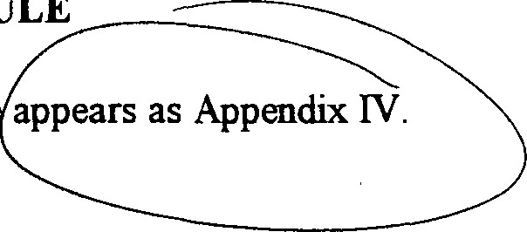
PRIORITY SCHEDULE
Priority
Schedul
MONITORING
- Annual Report
Each year the Town will evaluate the progress in reaching the goals and priority schedule of this management plan. City staff will prepare the report with the assistance from the Environmental Endangered Lands and the Turkey Creek Sanctuary Staff The Malabar Parks and Recreation Committee will review the report. The report is due and will be delivered on the anniversary date of the acquisition of the last FCT properties listed in the Malabar Sanctuary Greenway plans. The first annual stewardship report will be due October 27, 1999.
- Ecosystem Viability
The Parks and Recreation Board of Malabar will develop an ecosystem monitoring plan with the guidance of biologists and hydrologists from the U.S. Fish and Wildlife Service, the Florida Natural Areas Inventory, Florida Institute of Technology and the Florida Native Plant Society. A meeting of representatives of these groups will meet two months after the final land acquisition to establish protocols, standard methods. Permanent transects will be monitored twice yearly.
Volunteer water quality monitors will be solicited from Malabar citizens or students to test water samples weekly. This information will be collected and analyzed by the existing monitoring program of the Marine Resources Council.
Since floodplain and hydrologic management are driven by episodic events, regular monitoring programs may not be adequate to evaluate events or conditions not consistent with scheduled monitoring dates. Surveys with FEMA and the Water Management District will be made following major storm events, droughts or wild fires which impact the Greenway. Report of these field surveys will be made part of the final report and the basis for plan update.
- Surveys to Florida Natural Areas Invaltory
Malabar will make appropriate reports and forms to record ecosystems and rare and endangered plants to the appropriate offcials with the inventory. Included is a copy of the FNAI fonn.
- Plan Up-date
The Malabar Sanctuary Greenway Annual Plan will include up-dates as recommended by the advisory groups and the Town Council.

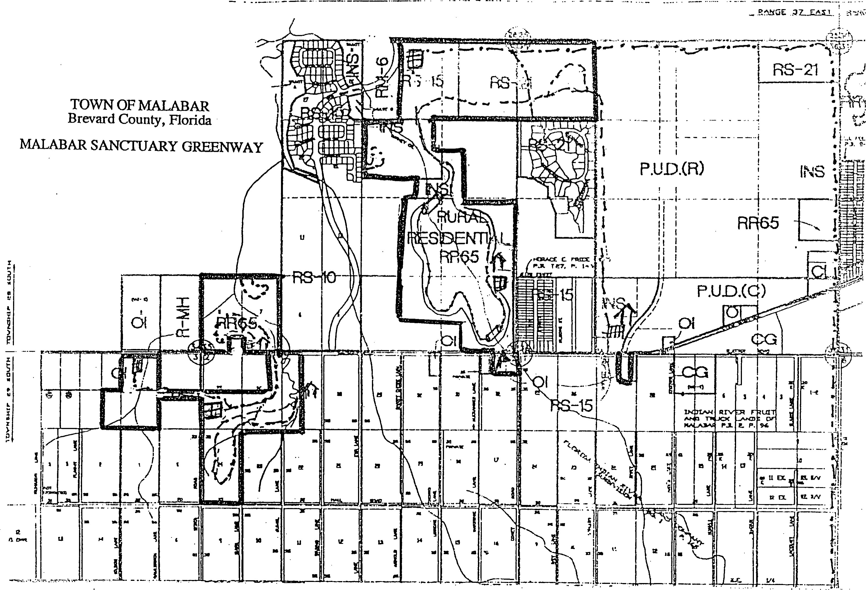

EXHIBIT A
Map of Combined Malabar Sanctuary Greenway I and Il

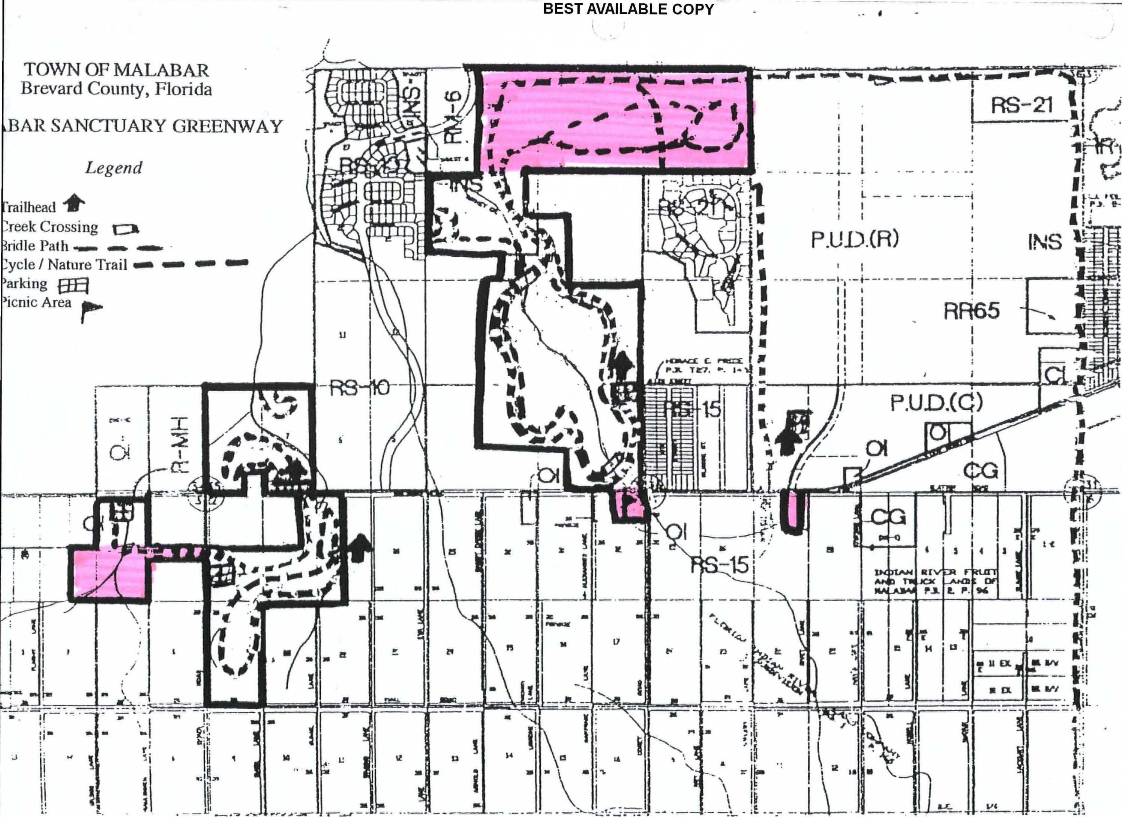

EXmBIT B
100 Year Floodplain Map of Malabar

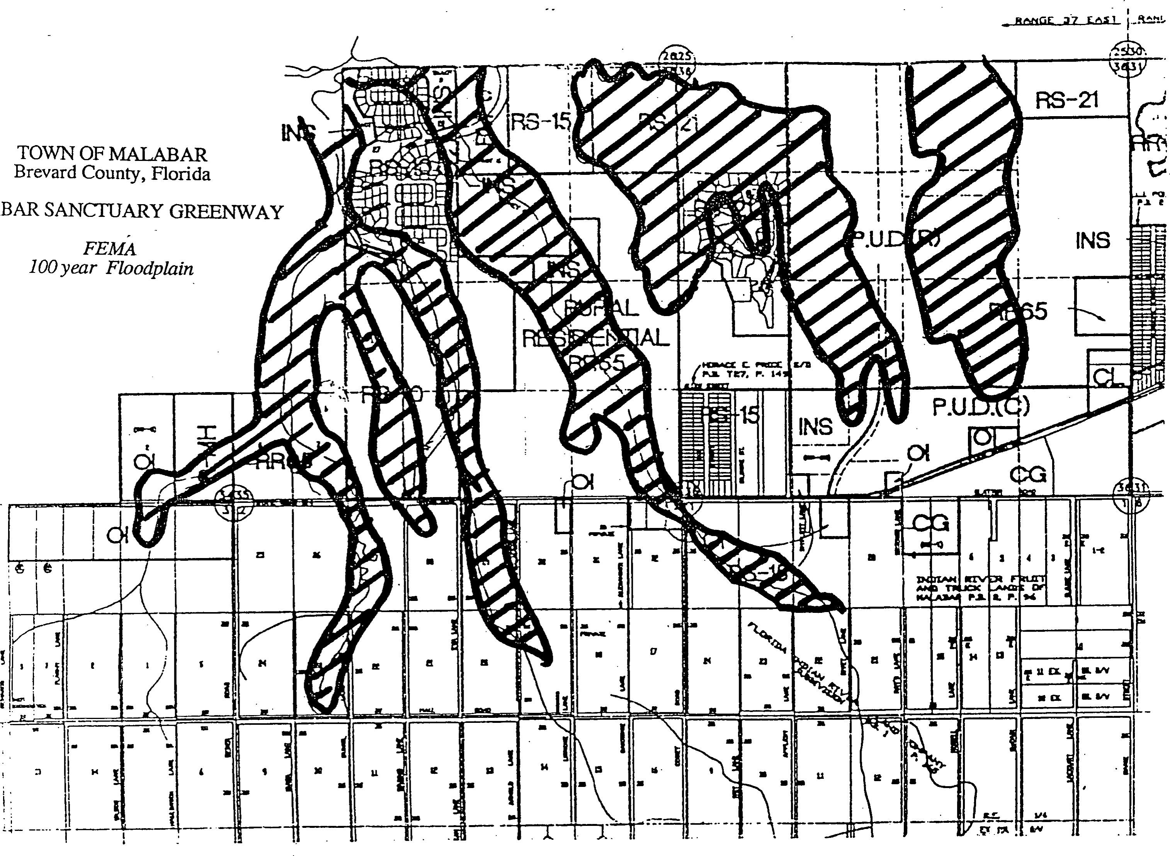
BEST AVAILABLE COPY
ABAR

Project Plan
Exhibit "C"
Writing a Management Plan
FLORIDA cmfffUNITIES TRUST
Preservation 2000 Program
Technical Assistance Bulletin: 02—Revised 2/97
This bulletin provides guidance for preparing the managementplan required in Rule 9K4.011 ( 1
Florida Administrative Code, and Section Ill b. of the Conceptual Approval Agreement (CAA). Rule 9K-4.Ol I states that a management plan must set forth the following: l) how the site will be managed to further the purpose of the project; 2) a description of planned improvements to the Project Site; 3) the costs and funding sources; and 4) the management entity and its ftnding source.
The CAA also contains conditions related •to management in various parts of the agreement, including Sections 11 6.c., 111 1.b., Iv 9., V 1., V 2., V 5., VI 2, and Vlll. All ofthe conditions in Section VIII are site specific and relate directly to management. Review the entire CAA for requirements contained in the CAA that have relevance to site management.
'Ihe conceptual management plan that was submitted as part ofthe Florida Commu.nities Trust (FCO grant application provides a foundation for the management plan. Other materials and information gathered for the application can and should be reflected in the plan where appropriate. Commitments made in the application and reinforced by conditions of the grant funding must be reflected in the management plan.
Use the best available information about the site's natural features and proposed future uses. Like all future-orientedplanning efforts, the level of detail of the management plan may be impacted by difficulties associated with obtaining sufficient information on which to base management decisions If sufficient information is not available, the management plan should identify data needs and how and when this information will be obtained.
FORMAT
Follow the recommended outline described below in formatting the management plan. Include a title page that contains the project name, FCT project number and date of preparation of the management plan. Include a table of contents and numbered pages. Label and properly reference all exhibits, attachments and appendices in the plan.
1. INTRODUCTION
The introduction provides a good summary of the project and management objectives to a firsttime reader. Provide the project name and location of the project site. Discuss any historical information relevant to site management. Provide a brief summary of the contents of the management plan.
11. PURPOSE OF THE PROJECT
Discuss the purpose(s) for acquiring the project site and proposed future uses consistent with statements made in the application or proposal. Include a provision that the project site will be managed only for conservation, protection and enhancement ofnatural resources and for public outdoor recreation that is compatible with the conservation, protection and enhancement of the project site.
Include a prioritized list of key management objectives for the site.
Summarize the key comprehensive plan directives that will be furthered by acquisition and managementofthe site, as proposed in the original FCT application. Provide a numeric citation for each directive cited.
Include a provision to amend the land use designation of the site to conservation, outdoor recreation, open space, or other similar category within one year aner acquisition. Include a commiünent to amend the zoning map to be consistent with the amended future land use for the project site.

111. sr1'E DEVELOPNfENT
Physical Improvements: List and describe all existing and proposed site improvements.
Include the placement ofan entrance sign identifring the project site as being open to the public and purchased with finds from FCT, the Recipient and other contributors, if any.
Consider providing bike paths to the site and bike racks at the site to provide an altemative to automobile transportation to the project site.
Provide a time frame for implementing and completing all proposed improvements.
Include a commitment that access to project sites will be compatible with all applicable state and federal cons&uction standards, including the Americans with Disabilities Act.
Describe proposed alterations of natural and disturbed areas at the site that would be required for each ofthe proposed improvements. Provide an estimate on the total extent of this work in quantifiable terms (square feet or acres).
Briefly summarize how proposed alterations of land or vegetation at the project site be coordinated with the protection of listed plant and animal species with more specific details to be provided under the Natural Resource Protection section.
Master Site Plan: The master site plan is a conceptual plan showing all existing and proposed physical improvemenls and activity areas. The master site plan provides a visual depiction of the overall development plan for the site.
Incorporate a provision for requesting written approval from the FCT before undertaking any site alterations or physical improvements that are not addressed in the FCT-approved management plan and shown on the master site plan.
Permits: Identify all required permits or approvals for the proposed development or restoration work on the site. Include a statement that FCT will be notified that all required licenses and permits have been obtained prior to the initiation of any consfruction on the site.
Easements, concessions, or leases: Identify existing and proposed easements, concessions, or leases. Ifeasements, concessions, or leases are anticipatedto be granted on the project site, such proposed arrangements need to be identified in the management plan. Easements, concessions or leases may be restricted under the Internal Revenue Code. Include a statement of caution in the management plan to future site managers regarding easements, concessions or leases.
Include a provision that the Recipient will provide 60 days prior notice and information to FCT regarding any sale or lease of any interest, the operation of any concession, any sale or option to buy things attached to the Site, the granting of any management contracts, and any use by any person other than in such person's capacity as a member of the general public.
IV. KEY MANAGEN•ÆNT ACI'IVITIES
Natural resource protection: Identify the natural resources at the project site, including the type of vegetative communities on the site, and significant natural resources, i.e., waterbodies or other public lands, adjacent to the site. Describe the general quality, size, and composition of any vegetative communities located on the site. Describe the general water quality of any on-site or adjacent waterbodies. Identify and discuss any degraded areas on the project site, such as fire climax communities that have not been burned recently or areas that have been cleared, invaded by exotic pest plants, ditched and drained, filled, etc.
Identify management techniques to protect and enhance the resources on the project site. Management techniques such as the following may be applicable to the project site:
a baseline survey of plant and animal species; a protection plan for listed plant and animal species; a protection and enhancement plan for native vegetative communities; a protection plan for surface water and groundwater quality;
a plan to periodically monitor the site to insure the continued viability of vegetative communities, plant species and animal species found on the site and to control invasive exotic vegetation; a procedure for forwarding survey information on the occurrence of listed plant and animal species to the Florida Natural Areas Inventory;
specific details on how proposed alterations and development activities on the project site will be coordinated with the protection of vegetative communities and listed plant and animal species;
coordinating the drafting of a prescribed Bum Plan 'Mth the Division of Foresüy and developing an outreach program to inform residents of the area of the benefits of prescribed bums.
Provide time frames for initiating and completing the various surveys and protection and enhancement plans a month and year format.
Resource restoration and enhancement: Identify the primary components of the project site enhancement and restoration effort, if any. Discuss the restoration and enhancement techniqus to be used on the project site. Locate on the Master Site Plan or another map all areas of the site to be restored or enhanced and the approximate acreage figure for each area.
Provide a detailed discussion on the restoration of the various wetland and upland community in terms of biological composition and ecological function, if appropriate.
Discuss the removal of invasive exotic vegetation on the site, if appropriate. Include a progrmn to monitor the site to prevent reinfestation by exotic vegetation.
Discuss actions needed to restore the natural hydrology of the project site or mitigate the impacts of stormwater runoff from the site, if appropriate.
Include a provision to control feral animals (hogs, dogs, cats, etc.) on the site, if appropriate.
Include monitoring programs to insure success of the resource and enhancement activities.
Provide a time frame for initiating and completing the various restoration and enhancement activities in a month and year format.
Archaeological and historical resource protection: 'Identify any archaeological or historical sites on the project site and the primary components of managing the archeological or historical sites, if applicable.
Ihclude procedures to protect archeological or historical sites that may be identified in the future by including a provision that if any archaeological and historic resources are discovered at the project site, the Recipient shall immediately contact and coordinate with the Division of Historical Resources, •Florida Department of State, to assess the archaeological and historic resources of the find.
Environmental Education Program: Describe the proposed environmental education programs, if applicable. Discuss the types ofprograms to be offered, the frequency of programs (after school, monthly, summer, etc.), the target groups, and the group responsible for developing and leading the program. Provide a time frame for developing and initiating the programs in a month and year format.
Greenway Management: If the project is part ofa greenway network, discuss how the project site will further the local greenway network and how management of the site will be integrated into the overall management of the greenway network. Describe the coordination efforts among other local, regional and state agencies to protect natural resources and manage the greenway network. Provide a map showing the relationship of the project site and other parcels that comprise the greenway network.
Coordination: Explain how the management ofthe site will be coordinated with adjacent land owners and other resource protection agencies.
Include provisions to coordinate with other agencies for appropriate guidance, recommendations, and necessary permits that may be related to the project site, such as the following:
the Florida Game and Fresh Water Fish Commission to avoid impacts to listed species;
the Water Management District and Department of Environmental Protection to ensure that development of the project site is done in a manner to protect or improve water qu@lity;
the Division of Forestry and the Game and Fresh Water Fish Commission on the implementation of a prescribed bum program.
Coordination strategies should include requesting cooperating agencies to review the management plan, comment on the proposed development plan for the site, and assist in the development of s&ategies to protect the resources on the project site.
Maintenance: Identify required maintenance activities, including but not limited to, trash removal, site cleanup, and facilities upkeep. Identify the local government employees or ser-vice contractors responsible for all aspects of property maintenance.
Security: Identify the parties responsible for security at the project site. Identify the measures and design features to be employed to protect the site and the public from vandalism, theft or assault, such as fencing, locked gate, park rangers, police patrols, etc. Consider including a security/emergency plan of action that identifies key individuals.
Staffing: Identify the expected staffing requirements for management of the project site, including both permanent and volunteer staff.
v. COST ESTIMATE AND FUNDING SOURCE
Estimate the costs associated with implementation of the management plan, including all proposed improvements (trails, boardwalks, parking, restrooms, etc.), resource restoration and enhancement activities, and other key management activities (required surveys, education programs, etc.).
Identify all funding sources associated with the implementation of the management plan.
VI, PRIORITY SCHEDULE
Discuss the proposed time lines for the development and management activities of the management plan based on established priorities and the availability of funds. Provide a graphic display of the implementation time lines. Use calendar dates (month and year) in defining the implementation time line.

Vll. MONITORNG
Identi%' procedures for assessing progress in achieving goals in the management plan, such as the percentage of property restored, inventory of species using the project site, etc. Idenffy procedures for periodic amendment of the management plan by the Recipient, with provision for approval by the FCT, when appropriate. Include a prov.ision acknowledging responsibility for preparing an annual stewardship report to the FCT, due on the anniversary date on which the Project Plan was approved by FCT.
The exhibits to the management plan should be appropriately located in the management plan in the place that contributes to the best understanding the management plan. Exhibits may include a locationmap, boundary map, vegetative maps and surveys, master site plan, estimated development cost table, and implementationtime line graph, and any other exhibit that supports the plan.
APPENDIX:
The appendix should be placed at the very end ofthe management plan document. The appendix should contain a copy ofthe Conceptual Approval Agreement, the FNAI notification form, the Exotic Pest Plant Council's List of Florida's Most Invasive Species. The recorded deed and Grant Award Agreement should be included when they become available.

The Florida Communities Trust
2555 Shumard Oak Boulevard Tallahassee, FL 32399-2100 phone 904/922-2207 (Suncom 292-2207)
Fax 904/921-1747

Contract No: 7-7A %4/-0/7
FCT Project No: 95-019-P7A
CONFIDENTIALITY AGREEPIENT
This is a Confidentiality Agreement ("Agreement") pursuant to Rule , Florida Administrative Code (F.A.C,) .
parties to. the confidentiality Agreement: '1'0WN or MALABAR ("FCT Recipient") , a municipality within State of Florida, and the Florida Communities Trust ("FCI'") , a nonregulatory • agency within the Department of community Affairs .
Parcels covered by this Agreement: This Agreement covers all parcels identified as part of the project site in FCT application BANCTVARY GREENWAY that was selected for funding and is governed by a Conceptual Approval Agreement for FCT Project Number 11/96-019-P7A ("Project Site") •
confidentiality :
- Pursuant to Rule 91<-6.002 (17) , F.A. C. , the term "Confidential" refers to information that shall not be available for public disclosure or inspection and is exempt from the provisions of Section 119.07 (1) , Florida Statutes (F. S. ) .
- The FCC Recipient and its agents shall maintain the confidentiality of all appraisals, offers, and counteroffers as required by Section 125.355 (1) (a) , F. S. , for counties i or Section 166.045(1) (a) , F. S. , for municipalities, and Rule Chapter 9K-6 , F.A.C. The • FCI' Recipient may disclose such • confidential information only to the individuals listed herein below.
- Requests to add persons to the disclosure list must be made in writing and the FCC Recipient must receive the written consent of the PCT Executive Director and execute an Addendum to the Agreement. All confidentiality requirements outlined above shall apply to individuals added to the list,
- The undersigned board members and staff of the FCT Recipient ("FCT Recipient") and its agents, if any, agree to maintain the confidentiality of appraisal information, offers and counter-offers concerning FCT Project Number MALABAR SANCTUARY GREENWAY as required by section 125.355 (1) (a) , for counties , or section 166.045 (1) (A) , for municipalities , and Rule Chapter 9K—6, F. A. C. , and by this Confidentiality Agreement between the FCT Recipient and FCT.
The undersigned certify that they have no legal or beneficial ihterest in the Project site,
CONFID/E'CT#96-019-P7Ä
REV. 2/23/95
Date FCT Recipient Board Member , Signature
Staff or Agent name

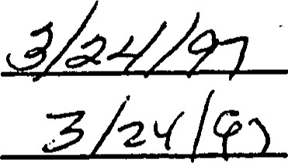
8//9%/17 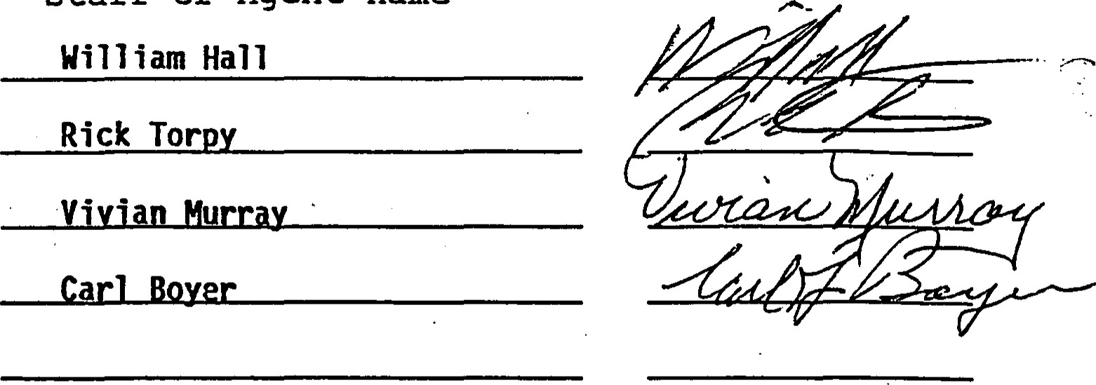
FCT RECIPIENT | FLORIDA COPMUNITIES TRUST
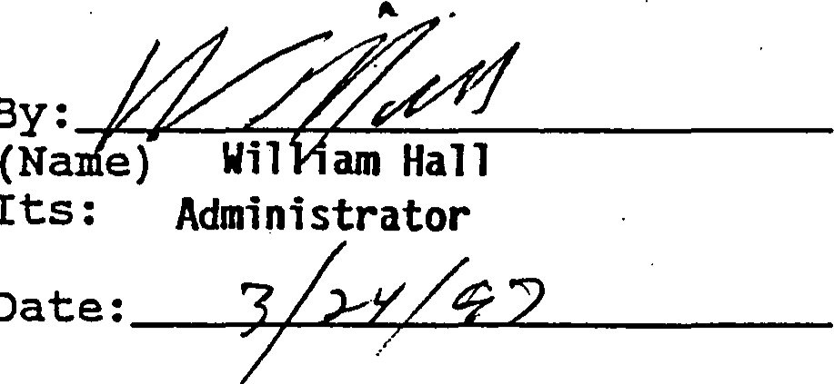
Director
By:
Its
Date:
Anne
Peery,
Executive
Date:
Approved | as | to | Form | and | Approved | as | to | Form | and

Legality : Legality :
By: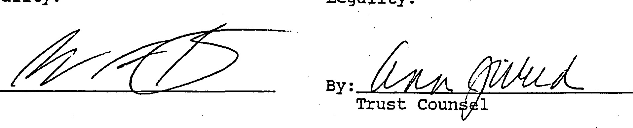
CONFID/FCT#
REV. 2/23/95
APPENDIX 1
Conceptual Approval Agreements
Malabar Sanctuary Greenway I and Il

RECEIVED APR 1 1996
April 10, 1996
Mr. William Hall City Manager
Town of Malabar
2725 Malabar Road
Malabar, Florida 32950
RE: Malabar Sanctuary Greenway Town of Malabar
Project #95-063-P56
Dear Mr. Hall:
Enclosed please find a fully executed original of the Conceptual Approval Agreement and Confidentiality Agreement for the above referenced Florida Communities Trust Project.
Please call me at (904) 922—2207 or Suncom 292—2207, if you have any questions. Sincerely,
A. Diane Langston
Grant Specialist Il
Florida Communities Trust
ADL/
Enclosure
C..OMMUNrry AFFAIRS • 2740 CENTERVIEW DRIVE TALLAHASSEE, FL 32399-2100 • 904/922-2207 SUNCOM 292-2207
FLORIDA COMMUNITIES TRI'ST RECYCLES

FCT Contract # 46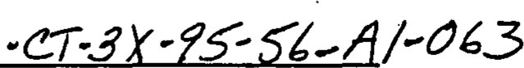 FLORDA COIvnvfUNITIES TRUST

P56 AWARD# 95-063-P56
CONCEPTUAL APPROVAL AGREE&ENT
Tl-ns AGREENENT is entered into on 1996, the date the last by theFLOPDA cm,mfUNITIES TRUST (FCT), a nonregulatory agency within the State of Florida Department of Community Affairs, and TOWN OF MALABAR (FCT Recipient), a local government of the State of Florida. The intent of this Agreement is to impose terms and conditions on the use of the proceeds of certain bonds, hereinafter described, and the lands acquired with such proceeds (Project Site), that are necessary to ensure compliance with applicable Florida Law and income tax law and to otherwise implement provisions of Sections 259.101, 375.045, and Chapter 380, Part Ill, Florida Statutes
WI-EREAS, Chapter 380, Part Ill, F.S., the Florida Communities Trust Act, creates a nonregulatory agency within the Department of Community Affairs (Department) that assist local governments in bringing local comprehensive plans into compliance and implementing the goals, objectives, and policies of the conservation, recreation and open space, and coastal elements of local comprehensive plans, or in conserving natural resources and resolving land use conflicts by providing financial assistance to local governments to carry out projects and activities authorized by the Florida Communities Trust Act;
Section 259.101(3)(c) ofthe Florida Preservation 2000 Act provides for the distribution often percent (10%) of the net Preservation 2000 Revenue Bond proceeds to the Department of Community Affairs to provide land acquisition grants and loans to local governments through the FCT;
WHEREAS, the Governor and Cabinet authorized the sale and issuance of State of
Florida Department of Environmental Protection Preservation 2000 Revenue Bonds (Bonds);
WHEREAS, the Bonds are issued as tax-exempt bonds, meaning that the interest on the Bonds is excludedfrom the gross income of Bondholders for federal income tax purposes;
WI-EREAS, Rule Chapter 9K-4, Florida Administrative Code (F.AC.), describes the procedures for evaluation and selection of lands proposed for acquisition using funds allocated to the FCT through the Department of Community Affairs from the Preservation 2000 Trust Fund; WHEREAS, the FCT Governing Body met on December 14, 1995, to score, rank and select projects that were to receive Conceptual Approval for. åanding•,
WI-EREAS, the FCT Recipient's project, described in an application submitted for evaluation, was selected for finding and in accordance with Rule Chapter 9K-4, F.AC., and more particularly described within this Agreement;
W^{T}HEREAS, Rule 9K-4.010(2)(f), F.A.C., authorizes FCT to impose conditions for funding on those FCT applicants whose projects have been selected for ftznding•, and
WHEREAS, the purpose ofthis Agreement is to set forth the conditions of Conceptual
Approval that must be satisfied by FCT Recipient prior to the disbursement of any FCT
Preservation 2000 funds awarded, as well as the restrictions that are imposed on the Project Site subsequent to its acquisition with the FCT Preserv^{e}ation 2000 Series Bond Proceeds.
NOW TÆREFORE, FCT and FCT Recipient mutually as follows:
L GENERAL CONDITIONS
l. At least two original copies oftl•is Agreement shall be executed by FCT Recipient and returned to the FCT offce at 2740 Centerview Drive, Tallahassee, Florida 32399-2100 as soon as possible and before April 1, 1996. Upon receipt of the signed Agreements by FCT , FCT will execute the Agreements, retain one original copy and return all other copies that have been executed to FCT Recipient. If the FCT Recipient requires more than one original document, the FCT Recipient should photocopy the number of additional copies needed, and then execute each as an original document.
- The name Conceptual Approval Agreement is used to indicate that the project has been approved as a concept that was described in FCT Application #95-063-P56. Since the project site has not yet been negotiated for acquisition, some elements of the project are. not yet known, such as the purchase price, other project costs, and the terms upon which an owner will voluntarily convey the property. The Conceptual Approval Agreement is in every-respect a grant contract between the parties. The Agreement describes activities that will be conducted both prior and subsequent to acquisition of the project site, which is the subject of the application that was submitted and selected for flinding by the FCT.
- Conceptual Approval for funding shall be until November 8, 1996. In the event the project has not been completed in full by November 8, 1996, the Conceptual Approval Agreement must be extended in order that the grant will remain in effect. In advance of the November 8, 1996, date and in suffcienf time before a meeting of the FCT governing board that would allow approval of an extension to this Agreement before its expiration, the FCT Recipient must request a written extension to the Conceptual Approval Agreement for project continuation in compliance with Rule 9K-4.OlO(2)(k), F.A.C. If the FCT Recipient does not request an extension, or if an extension is not granted to the FCT Recipient by the FCT Goverping Body, the Preservation 2000 award granted to the FCT Recipient by the Goveming Body sh•all terminate and all obligations hereunder shall cease.
- Extensions to this Agreement, described in Paragraph 3 above, shall not exceed two (2) years from date the Agreement was approved by the FCT, except as described in this paragraph. Ifthe project is not concluded by February 7, 1998, the project may only be extended if the FCT Governing Body determines that a requesf for additional time to complete the project is based upon compelling and extraordinary circumstances that would have precluded the from been concluded sooner. Tffs two-year is based upon the FCTs continuing concem at the length of time required by many local governments to conclude their projects, as well as the Florida Legislature's on-going concern at the rate of expenditure ofFCTs Preservation 2000 funds.
- This Ageement may be terminated before its expiration at the written request of the FCT Recipient. Such a request shall filly descr%e the circumstances that compel the FCT Recipient to terminate the project. A request for termination should be to the offces of the FCT at the address gven in paragraph I above. The request for termination will be placed on the agenda of the next regularly scheduled meeting of the FCT Governing Body for concurrence by the FCT. The termination shall be acknowledged by the FCT in a letter to the FCT Recipient.
Circumstances may arise thåt, in the analysis of the FCT, warrant termination of the project before its completion . In such an event, the FCT will advise the FCT Recipient of its analysis and will eo•nfer with the FCT Recipient on continuation of the project. If the FCT Recipient concurs, a request for termination will be considered at the next regularly scheduled meeting ofthe FCT Governing Body.
- FCT Recipient agees to make diligent efforts to submit the that is required in this Agreement as soon as is reasonably possible to FCT so that the Project Site may be acquired in an expditious manner. Deadlines stated in this Agreement, as well as deadlines associated with any FCT activity relating to the project, are strictly enforced. Failure to adhere to deadlines, whether stated in tffs Agreement or associated vit.h meetings of the FCT Governing Body, may result in delays in the project, may result in allocation'oftime or resources to other recipients that responded timely, and may result in this Agreement being voidable. It is the respons1Ylity of the FCT Recipient to know all project deadlines, to devise a method of monitoring the project, and to adhere to all deadlines.
- The FCT Preservation 2000 award granted to the FCT Recipient will in no event exceed the lesser of OI•AE HUNDRED percent (100%) of the final total project costs, as defined in Rule F.AC., or ONE hrLLION ONE HUNDRED NNETEEN THOUSAND TWO HUNDRED NNETY-NINE and 00/100 Dollars ($1, 119,299.00), unless the FCT Governing Body approves a greater amount pursuant to Rule 9K-4.011(2)(a), F.AC.
- The grant ambunt stated in paragraph 7 above is based on the FCT Recipient's estimate of Total Project Costs in application #95-063-P56, as well as limits on awards in the Notice of Application Period announcing the application cycle. When disbursing åmds for the project, the FCT ',GII recognize the actual total Project Costs, defined in Rule 9K-4.002(31), F.A.C., for acquisition of the Project Site. The total project costs will be reflected on a grant reconciliation statement prepared pursuant to paragaph 10 below. The FCT will participate in the land cost at either the actual purchase price, or the maximum approved purchase. price based on appraisal reports that comply with requirements set forth in Rule 9K-6.007, F.AC., whichever is less, and multiplied by the percent stated in paragraph 7 above..
- The FCT Governing Body has given Conceptual Approval for funding to acquige the entire Project Site identified in the FCT Recipient's application #95-063-P56. The Governing Body reserves the right to withdraw the FCT award if the acreage that comprises the Project Site is reduced so that the objectives of the acquisition cannot be achieved. Where the Project Site is comprised of multiple parcels, the Governing Body reserves the right to withdraw the FCT award if the priority parcel(s), identified in the acquisition plan prepared pursuant to Paragraph 4 of Section below and attached as Exhibit "A " to this Agreement, cannot be acquired.
- The FCT finds shall be delivered either in the form of eligible Project Costs prepaid by FCT to vendors or in the form of a state warrant at the closing of the Project Site to the Seller or the Seller's designated agent authorized by law to receive such payment, provided the Comptroller determines that such disbursement is consistent with good business practices and can be completed in a manner minimizing costs and risks to the State, or to the FCT Recipient to the extent expended by the FCT Recipient in excess of any local match required. If the Project Site is
comprised of multiple parcels, FCT shall deliver at the closing of each parcel only the share of the . FCT award that corresponds to the parcel being closed. FCT will prepare a grant reconciliation statement prior to the closing of the Project Site parcel that will evidence the amount of local match, if any is required, provided by the FCT Recipient and the portion of the FCT award that corresponds to the parcel being closed. Cash expended by the FCT for eligible Project Costs incurred by the FCT will be recognized as part of the FCT grant award amount on the grant reconciliation statement.
- The FCT Recipient's local match, if any is required, shall be delivered either in the form of eligible Project Costs prepaid to vendors by the FCT Recipient, or in the form of cash, eligible donation of land value or FCT Recipient's warrant at the closing of the Project Site. If the Project Site is comprised of multiple parcels, the FCT Recipient shall deliver at the closing of each parcel the share of the local match, if any is required, that corresponds to the parcel being closed. The cash expended by the FCT Recipient for eligible Project Costs incurred by the FCT Recipient conducting acquisition activities will be recognized as part of the local match, if any is required, on the reconciliation statement prepared pursuant to paragraph 10 above. In the event FCT Recipient's application #95-063-P56 represents that land is the source of local match, if any is required, the value attributed to the land local match, if any is required, shall be determined after an appraisal report that complies with the procedures and requirements set forth in Rule 9K6.007, F.A.C.
- The FCT Governing Body adopted the Preservation 2000 Program Approved List of Complete Applications for Series P56 Funding Cycle on September 14, 1995, at'which time the
Project Site became part of a list of lands that were approved for consideration for land acquisition. If action initiated by the FCT Recipient that is the local government having jurisdiction over the project site, subsequent to September 14, 1995, results in a governmentallyderived higher value due to an enhanced highest and best use, the FCT acquisition aüities will be terminated unless the seller agrees that the appraisal pill be done at the highest and best use of the Project Site on or before September 14, 1995.
- FCT Recipient hereby notifies the FCT that the following individual is the authorized key contact, or project manager, on behalf of the FCT Recipient for purposes of coordinating project activities for the duration of the project:
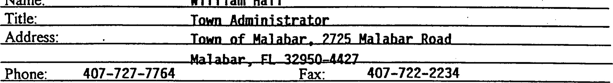
Name:
William
Hall
- This Agreement may be amended at any time prior to FCT giving project plan approval to the FCT Recipient. Any amendment must be set forth in a instrument and agreed to by both the FCT Recipient and FCT.
n. REQUIREMENTS THAT MUST BE PRIOR TO

NITIATION OF PROJECr srrE NEGOTIATION
- As was requested in the letter from FCT to FCT Recipient dated December 20, 1995, the FCT Recipient must provide FCT with copies of the Property Tax Identification cards for each parcel that comprises the Project Site no later than February 8, 1996.
- The FCT Recipient hereby notifies the FCT thatFCT
[note: elect either FCT, FCT Recipient or FCT Recipient Agent] will be the party responsible for all negotiation and acquisition activities.
The parties agree that mutual agreement as to the terms of the real estate contract is in the best interest of both parties and agree to share all information regarding the acquisition of the project site. In particular, the parties agree that prior to initiation of negotiations with owner(s), the appraisal(s) and appraisal review memoranda will be provided by the party responsible for all negotiation and acquisition activities to the other party.
- As was requested in the letter from FCT to FCT Recipient dated December 20, 1995, no later than March 1, 1996, the FCT Recipient must deliver to FCT a witten statement from the Project Site property owner(s) evidencing that the owner(s) is willing to entertain an offer from the FCT Recipient and FCT.
- Pursuant to Rule 9K-4.010(2)(j), F.A.C., in the event the Project Site is comprised of multiple parcels, FCT Recipient will provide an acquisition plan attached as Exhibit "A" and made a part of this Agreement. The acquisition plan must be approved by FCT prior to the commencement Of negotiations for any parcel in the Project Site. The acquisition plan addresses the order in which the Project Site parcels be acquired and the measures that will be taken to assure that the entire Project Site will be acquired with the FCT Preservation award to the FCT Recipient. Approval of the Conceptual Approval Agreement, with the acquisition plan attached as Exhibit "A", shall constitute approval of the acquisition plan by FCT.
5. No later than April 1, 1996, the FCT Recipient shall execute a Confidentiality Agreement pursuant to Rule 9K-6.010(5), F.AC. A sample of a Confidentiality Agreement is attached as Exhibit "B"; an Agreement specific to this project will be prepared by FCT for execution by the FCT Recipient. This Confidentiality Agreement is not a part of this Agreement and may be amended without amending this Agreement, if needed.
6. By execution of this agreement, the FCT Recipient affrms that:
- the FCT Recipient is ready, willing and able to provide the local match, if any is required;
- the FCT Recipient reaffrms the representations made in FCT Application
#95-063-P56•,
- the FCT Recipient shall, on the anniversary date ofthe approval of the project plan by the Governing Body, prepare and submit to FCT an annual report as required by Rule 91<-4.013, F.A.C.
d. the FCT Recipient authorizes the individual named in this paragraph to execute all documents in connection with this project on behalf of the FCT Recipient, including but not limited to the Conceptual Approval Agreement or any addenda thereto, purchase agreement for the property, grant reconciliation statement, closing documents, statements submitted as a part of the project plan, and Grant Award Agreement pursuant to Rule 9K6.014(6), F.AC.:
Name: Title:
Address: Malabar, 2725 Mal abar Road
Town
of
Mal
ahar,
Phone: 407-727-7 764 Fax: 407-722-2234
m. PROJECT PLAN APPROVAL
l . Prior to closing of the real estate transaction and final disbursement of award funds by FCT, the FCT Recipient must prepare a project plan that complies with Rule 9K-4.011, F.A.C. This project plan is a ofthe following items listed below, wffch must be reviewed and approved by FCT in a meeting ofthe Governing•Body. In the event that the FCT Recipient is a partnership, the FCT Recipient must provide FCT with the interlocal agreement that sets forth the relationship among the partners and the fiscal and management responsibilities and obligations inaarred by each partnerfor the Project Site as a part of its project plan.
The project plan shall include, and shall notbe considered by FCT unless it includes all of the following:
a. A purchase agreement for acquisition of the Site, executed by the property seller and the FCT Recipient, that is based on an appraisal or appraisals prepared consistent with the requirements ofRule Chapter9K-6, F.AC., and be otherwise consistent %ith. the provisions of that rule chapter and in a form and with terms that are acceptable to FCT. (See
Paragraph I of Section IV below)
- A management plan that complies with the following: written according to Exhibit C (FCT Technical Assistance Bulletin #2—Writing a Management Plan), which is attached hereto and incorporated herein by reference; acceptable to FCT; addresses the criteria and conditions set forth in Section V, VI, VII and hereinbelow; and, at a minimum, sets forth how the site will be managed to filrther the purpose of the project, contains a description of all planned improvements to the Project Site, identifies the costs of management and site improvement and fimding sources, and identifies the management entity and its funding source.
If the FCT Recipient is not the proposed managing entity, the project plan must include a signed agreement between the FCT Recipient •and the managing entity stating the managing entity's willingness to manage the site, the manner in which the site will be managed to further the purpose(s) ofthe project, and identificationofthe source of funding for management.
- A statement of the total Project Cost, including all non-recurring costs of project deve!opment.
- A statement of the amount ofthe award being requested from the FCT.
e. A statement from each local government in whose jurisdiction the Project Site is located that the project plan is consistent 'kith the local comprehensive plan.
Evidence that the conditions imposed as part of the Conceptual Approval Agreement have been satisfied.
g. An affdavit from the FCT Recipient evidencing that after conducting a diligent search, the FCT Recipient, to the best of its knowledge, represents that there are no existing or pending violations of any local, state, regional and federal laws and regulations on the Project Site.
2. The FCT strongly encourages the FCT Recipient to request a courtesy review of its entire project plan, but especially its management plan, well in advance of the meeting of the FCT Governing Body where the project plan will be considered for approval and funds will be authorized for disbursement. As a part ofits duties to the Governing Body, FCT Staff will make a recommendation of approval of complete and accurate project plans or disapprovd of incomplete or insuffcient project plans. FCT Recipient is strongly urged to coordinate with the FCT staff in order that the FCT review of the management plan coincides with both the anticipated Governing Body approval and the closing date of the real estate transaction(s) associated v4,ith the project.
3. Pursuant to F.AC., FCT shall vithhold project plan approval if the local comprehensive plan(s) of the FCT Recipient or the FCT Recipient's ia.rtner is, for any reason found not in compliance by the Department after conceptual approval has been granted by FCT, unless the FCT Recipient has executed a Compliance Agreement (formerly called a stipulated settlement ageement) with the Department to resolve all of the issues raised by the Department in a statement of intent to find a plan not in compliance issued to pursuant to Section 163.3184(8), F.S.
4. Pursuant to Rule 9K-4.010(3), F.ÆC., the FCT shall publish a Notice of Approval for Preservation 2000 Funds in the Florida Administrative Weekly that shall list each project plan that has received approval for finding and the amount of funding approved. Any person vhth a substantial interest that is or may be determined by the decision of the FCT to reject or approve the project plan may request an administrative proceeding pursuant to Section 120.57, F.S. %dthin 21 days from publication of the Notice of Approval for Preservation 2000 Funds. Real estate closings associated with the project may close only after expiration of the 21-day notice period, so long as no requests for an administrative proceeding have been filed.
N. -PROJECT SITE ACQUISITION REQUIRENfENTS EYQOSED BY
CHAPTER 259, CHAPTER 375, AND CHAPTER 380, PART m, F.S.
FCT RECPIENT AGREES AS FOLLOWS:
l . FCT shall approve the terms under which the interest in land is acquired, pursuant to Section 380.510(3), F.S. Such approval is deemed given when the FCT governing body approves and executes the purchase agreement for acquisition of the Project Site, further described in Section Ill. l.a. above, to which FCT is a party.
- Title to the Project Site shall be titled in the FCT Recipient, unless the FCT
Recipient specifically requests that title shall permanently vest in the Board of Trustees of the
Internal Improvement Trust Fund (Trustees). Such request shall be subject to the approval of
FCT and the Trustees. The FCT Recipient hereby elects that title to the Project Site shall be vested in the Town of Mal ahar [Note—insert either the name of FCT Recipient or Board of Trustees of Internal Improvement Trust Fund]. If the FCT Recipient elects ffat title shall vest in the Trustees, then all acquisition activities shall be administered by the Division of State lands as specified in Section 253.025, F.S., and Rule 18-1, F.AC.
- The transfer of title to the FCT Recipient for the Project Site shall not occur until the requirements for the acquisition of lands, as specified in Section 380.507(11), F.S., and Rule Chapter 9K-6, F.AC., have been fully complied with by the FCT Recipient and FCT.
- Any deed whereby the FCT Recipient acquires tide to the Project Site shall contain or be subject to such covenants and restrictions as are, at a minimum, suffcient to ensure that the use of the Project Site at all times complies with Section 375.045 and 375.051, F.S.; Section 9, Article of the State Constitution; the applicable bond indenture under which the Bonds were issued; and any provision of the Internal Revenue Code or the regulations promulgated thereunder that pertain to tax exempt bonds and shall contain clauses providing for the conveyance of title to the Project Site in the Board of Trustees of the Internal Improvement Trust Fund upon failure to use the Project Site conveyed thereby for such purposes. Such covenants and restrictions as are described in this paragraph shall be in the form of a Grant Award Agreement, prepared by FCT, executed by the parties to the Conceptual Approval Agreement and recorded at the time of closing of the Project Site. The recordable Grant Award Agreement shall restate the conditions that were placed on the Project Site at the time of project selection and initial grant approval. All statements contained in the recordable Grant Award Agreement are contained in this Conceptual Approval Agreement, 'r'hth the exception of statements that do not survive the real estate closing of the Project Site.
- The Grant Award Agreement containing such covenants and restrictions as referenced in paragraph 4 above and describing the real property subject to the Agreement shall be executed by the FCT and FCT Recipient at the time of the conveyance of the Project Site and shall be recorded in the county in which the Project Site is located.
6. If any essential term or condition of the Grant Award Ageement is violated, and the FCT Recipient does not correct the violation within 30 days of notice of violation, title to all interest in the Project Site shall be conveyed to the Board of Trustees of the Internal Improvement Trust Fund. The deed transferring title to the Project Site to the FCT Recipient shall set forth the executory interest of the Board of Trustees of the Internal Improvement Trust Fund.
- The interest, if any, acquired by the FCT Recipient in the Project Site shall not serve as security for any debt of the FCT Recipient.
- If the existence of the FCT Recipient terminates for any reason, title to all interest in real property it has acquired with the FCT award shall be conveyed or revert to the Board of Trustees of the Internal Improvement Trust Fund, unless FCT negotiates an agreement with another local government or nonprofit organization which agrees to accept title to all interest in and to manage the Project Site.
- The Project Site shall be managed only for the conservation, protection and enhancement of natural resources and for public outdoor recreation that is compatible with the conservation, protection and enhancement of the Project Site, along with other related uses necessary for the accomplishment of this purpose. The proposed uses for the Project Site must be specifically designated in the management plan approved by the FCT as a part of the project plan.
v. OBLIGATIONS OF THE FCT RECIPIENT AS

A CONDITION OF PROJECT FUNDNG
- Following the acquisition of the Project Site, the FCT Recipient shall ensure that the ålture land use designation assigned to the Project Site is for a category dedicated to open space, conservation, or outdoor recreation uses as appropriate. If an amendment w•the FCT Recipient's comprehensive plan is required, the amendment shall be proposed at the next comprehensive plan amendment cycle available to the FCT Recipient subsequent to the Project Site's acquisition.
- FCT Recipient shall ensure, and provide evidence thereof to FCT, that all ctivities under this Agreement comply with all applicable local, state, regional and federal laws and regulations, including zoning ordinances and the applicable adopted and approved comprehensive plan. Evidence shall be provided to FCT that all required licenses and permits have been obtained prior to the commencement of any construction.
- The FCT Recipient shall, through its agents and employees, prevent the unauthorized use •of the Project Site or any use thereof not in conformity with the management plan approve by the FCT as a part of the project plan.
- FCT staff or its duly authorized representatives shall have the right at any time to inspect the Project Site and the operations of the FCT Recipient at the Project Site.
- All buildings; structures, improvements, and signs shall require the prior Mitten approval ofFCT as to purpose. Further, tree removal, other than non-native species, and major. land alterations shall require the written approval ofFCT. The approvals.required from FCT shall not be urreasonably withheld by FCT upon suffcient demonstration that the proposed buildings, improvements, signs, vegetation removal or land alterations will not adversely impact the natural resources of the Project Site. The approval by FCT of the FCT Recipient's management plan addressing the items mentioned herein shall be considered written approval from FCT.
OBLIGATIONS OF THE FCT RECIPENT
RELATNG TO THE USE OF BOND PROCEEDS
l . FCT is authorized by Sections 375.045(4) and 380.5 and (b), F.S., to impose conditions for fundihg on FCT Recipient in order to ensure that the project complies ,with the requirements for the use of Preservation 2000 Bond proceeds including without limitation, the provisions of the Internal Revenue Code and the regulations promulgated thereunder the same pertain to tax exempt bonds.
2. If the Project Site is to remain subject, after its acquisition by the FCT Recipient and/or the Trustees, to any of the below listed transactions, events, and circumstances, the FCT Recipient shall provide at lea.st 60 days advance written notice of any such transactions, events, and cira.tmstances to FCT, and shall provide to FCT such information with respect thereto as FCT reasonably requests in order to evaluate the legal and tax consequences of such activity or interest. FCT Recipient agrees and ack10%ddges that the f0110%'ing transactions, events, and circumstances may be disallowed on the Project Site as they may have negative legal and tax consequences under Florida law and income tax law. The FCT Recipient ffrther agrees and achowledges that the following transactions, events, and circumstances may be allowed up to a certain extent based on guidelines or tests outlined in the Federal Private Activity regulations of the Internal Revenue Service:
any sale or lease of any interest in the Project Site to any person or organization;
b. the operation of any concession on the Project Site by any person or organimtion;
c. any sales contract or option to buy things attached to the Project Site to be severed from the Project Site, with any person or organization;
d. any use ofthe Project Site by any person other than in such person's capacity as a member of the general public;
any change in the character or use of the Project Site from that use expected at the date of the issuance of any series ofbonds from which the disbursement is to be made;
f. a management contract of the Project Site vith any person or organization;
or such other activity or interest as may be specified from time to time in writing by FCT to the FCT Recipient.
The foregoing are collectively referred to as the "Disallowable Activities. "
vn. DISALLOWABLE ACTIVITIES/REMEDIES
In the event that FCT determines at any time or from time to time that the FCT Recipient is engaging or allowing others to engage in Disallowable Activities on the Project Site, the FCT Recipient agees to immediately cease or cause the cessation of the Disallowable Activity upon receipt of written notice from the FCT. To the extent allowed by law, FCT Recipient hereby indemnifies and agrees to hold FCT harmless from all claims, causes of action or damages of any nature whatsoever arising from or with respect to Disallowable Activities on the Pr*t Site. Nothing herein shall be deemed a waiver of the FCT Recipient's sovereign immunity. In addition to all other rights and remedies at law or in equity, FCT shall have the right to temporary and permanent injunctions against FCT Recipient for any Disallowable Activity on the Project Site.
DELEGATIONS AND CONTRACTUAL ARRANGEIÆNTS BETWEEN FCT
RECIPIENT OTTER GOVEP&WENTAL BODIES, NOT FOR PROFIT ENTITIES, OR
NON PERSONS FOR USE OR MANAGEhdENT OF PROJECT
SITE NO WAY RELIEVE Fcr RECIPENT OF RESPONSIBLITY To
ENSURE THAT TIE CONDITIONS n.QOSED I-EREN ON PROJECT SITE AS A RESULT OF UTLIZNG BOND PROCEEDS TO ACQUIRE PROJECT SITE ARE
FILLY corvTLIED WITH BY CONTRACTING PARTY.
vm. CONDITIONS PARTICULAR TO THE PROJECT SITE THAT

MUST BE ADDRESSED m THE MANAGE&fENT PLAN
The management plan for the Project Site is mentioned throughout this Agreement, and is particularly described in Paragaph l.b. of Section Ill above. In addition to the various conditions already described in this Agreement, which apply to all sites acquired with FCT funds, the management plan shall address the following conditions that are particular to the Project Site and result from either representadons made in the application that received scoring points or observations made by the FCT staff during the site visit described in Rule 9K-4.010(2)(f), F.A.C.:
I. The FCT Recipient shall provide outdoor recreational facilities including nature trails, bridle paths, interpreff€^{p}e signage and scenic overlooks on the Project Site. The facilities shall be developed in a manner that allows the general public reasonable access for observation and appreciation of the significant natural resources on the Project Site without causing harm to those resources.
- The timing and extent of a vegetative communities and plant species survey of the Project Site shall be specified in the management plan. The FCT Recipient shall detail how the survey shall be used during development Of the site to insure the protection, restoration, and preservation of the natural resources on the Project Site.
- The sand pine scrub, blackwater creek, xeric hardwood, hydric hammock and depressional wetlands that edst on the Project Site shall be preserved and appropriately managed to ensure the long-tem viability of these vegetative communities.
- The Project Site shall be managed in a manner that optimizes habitat for listed wildlife species that utilize or could potentially utilize the Project Site, including the scrub jay, alligator, gopher tortoise, indigo snake and wading birds. The FCT Recipient shall coordinate with the Game and Freshwater Fish Commission on the management of the Project on the mangement of the Project Site for the protection of listed species and listed species habitat. The FCT Recipient shall also conduct periodic surveys of listed species using the Project Site and develop informational signs relating to the protection of listed animal species and their habitat.
- The FCT Recipient shall ensure that the Project Site and listed animal species and their habitat are suffciently buffered from th impacts of adjacent land uses.
- The FCT Recipient shall r ore 6 acres o the Project Site by removing exotic vegetation and replanting with native vegeta e speci
- The FCT Recipient shall remove improperly placed fill from the Project Site and install adverts to restore the natural hydrology ofthe site. The FCT Recipient shall coordinate with the St. Johns River Water Management District in the development and implementation of a Stormwater management and hydrologic restoration plan for the Project Site.
- The FCT Recipient shall coordinate the management of the Project Site with the adjacent Turkey Creek Sanctuary Park and develop a greenway management strategy designed to link local and conservation and recreation lands.
- A vegetation analysis of the Project Site shall be performed to determine which areas of the Project Site næd a prescnbed burring regime implemented to maintain natural fire. dependent vegetative communities. The FCT Recipient shall coordinate with Division of Forestry and Game and Fresh Water Fish Commission on the development of a prescribed burn plan for the Project Site.
- Prior to the commencement of any proposed development activities, measures be taken to determine the presence of any archaeological sites. All planned activities involving known archaeological sites or potential site areas shall be closely coordinated with the Department of State, Division offfstoricResources, in order to prevent the disturbance of significant sites.
I l. Access to the Project Site by pedestrians, bicyclists and persons on non-motorized vehicles shall be promoted except in those areas where resource protection considerations warrant limiting access.
12. The requirements imposed by other grant program funds that may be sought by the FCT Recipient for activities associated with the Project Site shall not conflict with the terms and conditions of the FCT award.
ms Agreement including Exhibits "A", "B" and "C" embodies the entire agreement between the parties.
WITNESS WHEREOF, the parties hereto have duly executed this Agrepnient..

TOWN OF By:
Name:
Date:
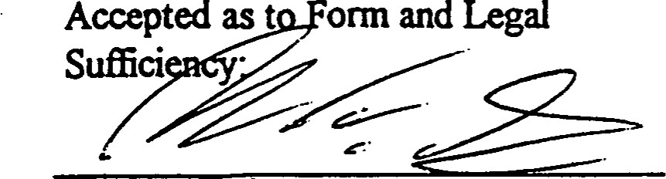
Rißhard Torpy
Date: e/oa//9C

FLORIDA COIvMUNITIES TRUST
By:
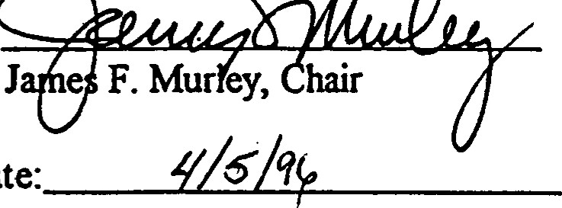
Date:
Accepted as to Form and Legal
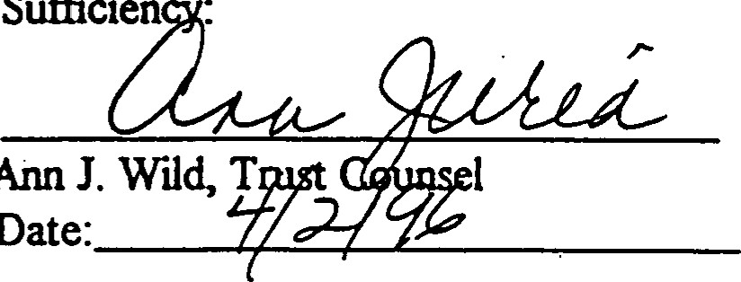
Suffcien
Ann
Date:

orn a ommun%ies Trust
April 17, 1997
Mr. WIIfiam Hall
Town Administrator
Town of Malabar
2725 Malabar Road
Malabar, Florida 32950
RE: Fcr Project Number: 96-019-P7A
Malabar Sanctuary Greenway 111Town of Malabar
Dear Hall:
Enclosed please find a fully executed ori$.nal of the Conceptual Approval Agreement and Confidentiality Agreement for the above- referenced Florida Communities Trust Project.
Please call me at (904) 922-2207 or Suncom 292-2207, if you have any questions.
Sincerely,
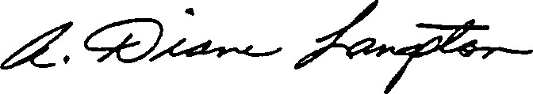
A. Diane Langston
Grant Specialist
Florida Communities Trust
ADL/
Enclosure
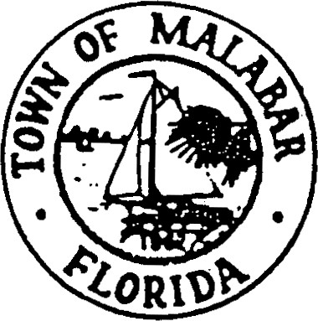
WILLIAM HALL
TOWN ADMINISTRATOR2725 MALABAR ROAD

(407) 723-3261MALABAR, FLORIDA 329504427
FAX (407) 722-2234
March 25, 1997

Ms. Anne Peery, Executive Director
Florida Communities Trust
Room 310
2555 Shumard Oak Boulevard Tallahassee, FL 32399-2100
Dear Ms. Peery:
Re: FCT Project Number: 96-019-P7A
Malabar Sanctuary Greenway Il - Town of Malabar
Enclosed are the signed Conceptual Approval Agreement and the Confidentiality Agreement for the above project.
It is our understanding that the CAA would extend until October 31, 1997 and that any request for an extension must be made in sufficient time to be received prior to the meeting of the FCT governing board. Would your receiving our request for an extension by September 15 allow sufficient time for this purpose?
Thank you for your assistance and cooperation.
Yours very. Muly,
William Hall
/vm
encl.
(wp51 \pt2-caa.wh)
FCT Contract# 97Cf.5 F-97-2A.A/.019 FLORIDA COVM.JNITIES TRUST PIA AWARD #96-Ol 9-P7A
CONCEPTUAL APPROVAL AGREENIENT
AGREEMENT is entered into on, 1997, the date the last party executes this Agreement, by and betwe n the FLORIDA COMMUNITIES TRUST (FCT), a nonregulatory agency within the State of Florida Department of Community Affairs, and the TOWN OF MALABAR (FCT Recipient), a local govemment of the State of Florida. The intent of this Agreement is to impose terms and conditions on the use of the proceeds of certain bonds, hereinafter described, and the lands acquired with such proceeds (Project Site), that are necessary to ensure compliance with applicable Florida Law and federal income tax law and to otherwise implement provisions of Sections 259.101, 375.045, and Chapter 380, Part Ill, Florida Statutes (F.s.).
WHEREAS, Chapter 380, Part Ill, F.S., the Florida Communities Trust Act, creates a nonregulatory agency within the Department of Community Affairs (Department) that will assist local governments in bringing local comprehensive plans into compliance and implementing the • goals, objectives, and policies of the conservation, recreation and open space, and coastal elements of local comprehensive plans, or in conserving natural resources and resolving land use conflicts by providing financial assistance to local governments to carry out projects and activities authorized by the Florida Communities Trust Act;
WHEREAS, Section 259.101 (3)(c) of the Florida Preservation 2000 Act provides for the distribution of ten percent (10%) less certain reductions of the net Preservation 2000 Revenue Bond proceeds to the Department of Community Affairs to provide land acquisition grants and loans to local governments through the FCT;
WHEREAS, the Governor and Cabinet authorized the sale and issuance of State of
Florida Department of Environmental Protection Preservation 2000 Revenue Bonds (Bonds);
WHEREAS, the Bonds are issued as tax-exempt bonds, meaning that the interest on the Bonds is excluded from the gross income of Bondholders for federal income tax purposes;
CAA/96-Ol

WHEREAS, Rule Chapter 9K4, Florida Administrative Code (F.A.C.), describes the procedures for evaluation and selection of lands proposed for acquisition using funds allocated to the FCT through the Departnent of Community Affairs from the Preservation 2000 Trust Fund;
WHEREAS, the FCT Goveming Body met on December 3, 1996, to score, rank and select projects that were to receive Conceptual Approval for ftnding;
WHEREAS, the FCT Recipient's project, described in an application submitted for evaluation, was selected for funding contingent upon and until the sale of the Series PIA Preservation 2000 Bonds and in accordance with Rule Chapter 9K-4, F.A.C., and more particularly described within this Agreement;
WHEREAS, Rule F.A.C., authorizes FCT to impose conditions for funding on those FCT applicants whose projects have been selected for funding; and
WHEREAS, the purpose of this Agreement is to set forth the conditions of Conceptual
Approval that must be satisfied by FCT Recipient prior to the disbursement of any FCT
Preservation 2000 ftmds awarded, as well as the restrictions that are imposed on the Project Site subsequent to its acquisition with the FCT Preservation 2000 Series Bond Proceeds.
NOW THEREFORE, FCT and FCT Recipient mutually agree as follows:
1. GENERAL CONDITIONS
1. At least two original copies of this Agreement shall be executed by FCT Recipient and retumed to the FCT office at 2555 Shumard Oak Blvd., Tallahassee, Florida 32399-2100 as soon as possible and before April 1, 1997. Upon receipt of the signed Agreements by FCT , FCT execute the Agreements, retain one original copy and return all other copies that have been executed to FCT Recipient. If the FCT Recipient requires more than one original document, the FCT Recipient should photocopy the number of additional copies needed, and then execute each as an original document.
2. The name Conceptual Approval Agreement is used to indicate that the project has been approved as a concept that was described in FCT Application #96-019-P7A . •Since the project site has not yet been negotiated for acquisition, some elements of•the project are not yet knovm, such as the purchase price, other project costs, and the terms upon which an owner will voluntarily convey the property. The Conceptual Approval Agreement is in every respect a grant contract between the parties. The Agreement describes activities that will be conducted both prior and subsequent to acquisition of the project site, which is the subject of the application that was submitted and selected for funding by the FCT.
CAA/96-Ol$P7A
- Conceptual Approval for funding shall be contingent upon and until the sale of the Series P7A Preservation 2000 Bonds, expected to occur in April, 1997. Upon the sale of the Series P7A Bonds, this contingency clause shall be removed by an addendum to this Agreement. Conceptual Approval for finding shall be until October 31, 1997. In the event the project has not been completed in full by October 31, 1997, the Conceptual Approval Agreement must be extended in order that the grant will remain in effect. In advance of the October 31, 1997, date and in sufficient time before a meeting of the FCT goveming board that would allow approval of an extension to this Agreement before its expiration, the FCT Recipient must request a extension to the Conceptual Approval Agreement for project continuation in compliance with Rule 9K4.010(2)(k), F.A.C. If the FCT Recipient does not request an extension, or if an extension is not granted to the FCT Recipient by the FCT Governing Body, the Preserzation 2000 award granted to the FCT Recipient by the Governing Body shall terminate and all obligations hereunder shall cease.
Based upon the Florida Legislature's ongoing oversight of the rate of expenditure of funds, and the impact on future funding if expenditures do not timely occur, the FCT expects that the project will be completed as soon as possible after project selection.
- Extensions to this Agreement, described in Paragraph 3 above, shall not exceed 24 months from the date the Agreement was approved by the FCT, except as described in this paragraph. If the project is not concluded by January 31, 1999, the project shall only be extended if the FCT Governing Body determines that a request for additional time to complete the project is warranted based upon FCT Recipient's demonstration that significant progress is being made toward closing the project or that extenuating circumstances warrant an extension of time
- This Agreement may be tenninated before its expiration at the request of the FCT Recipient. Such a request shall fully describe the circumstances that compel the FCT Recipient to terminate the project. A request for termination should be mailed to the offices of • the FCT at the address given in paragraph 1 above. The request for temination will be placed on the agenda of the next regularly scheduled meeting of the FCT Goveming Body for concurrence by the FCT. The termination shall be acknowledged by the FCT in a letter to the FCT Recipient.
Circumstances may arise that, in the analysis of the FCT, warrant termination of the project before its completion . In such an event, the FCT will advise the FCT Recipient of its analysis and will confer with the FCT Recipient on continuation of the project. If the FCT Recipient concurs, a request for termination will be considered at the next regularly scheduled meeting of the FCT Governing Body.
CAA/96-019tP7A
- FCT Recipient agrees to make diligent efforts to submit the documentation that is required in this Agreement as soon as is reasonably possible to FCT so that the Project Site may be acquired in an expeditious manner. Deadlines stated in this Agreement, as well as deadlines associated with any FCT activity relating to the project, are strictly enforced. Failure to adhere to deadlines, whether stated in this Agreement or associated with meetings of the FCT Governing Body, may result in delays in the project, may result in allocation of time or resources to other recipients that responded timely, and may result in this Agreement being voidable. It is the responsibility of the FCT Recipient to know all project deadlines, to devise a method of monitoring the project, and to adhere to all deadlines.
- The FCT Preservation 2000 award granted to the FCT Recipient will in no event exceed the lesser of ONE HUNDRED percent (100%) of the final total project costs, as defined in Rule 9K-4.002(31), F.A.C., or ONE MILLION TWENTY-ONE THOUSAND SIX HUNDRED NINETY-ONE AND NO/IOO Dollars ($ ,691.00), unless the FCT Governing Body approves a greater amount pursuant to Rule 9K-4.011 (2)(a), F.A.C.
- The grant amount stated paragraph 7 above is based on the FCT Recipient's estimate of Total Project Costs in application #96-019-P7A , as well as limits on awards in the Notice of Application Period amouncing the application cycle. When disbursing ftlnds for the project, the FCT. will recognize the actual total Project Costs, defined in Rule 9K-4.002(31), F.A.C., for acquisition of the Project Site. The total project costs will be reflected on a grant reconciliation statement prepared pursuant to paragraph 10 below. The FCT will participate in the land cost at either the actual purchase price, or the maximum approved purchase price based on appraisal reports that comply with requirements set forth in Rule 9K-6.007, F.A.C., whichever is less, and multiplied by the percent stated in paragraph 7 above.
- The FCT Governing Body has given Conceptual Approval for ftlnding to acquire the entire Project Site identified in the FCT Recipient's application #96-019-P7A . The
Goveming Body reserves the right to withdraw the FCT award if the acreage that comprises the
Project Site is reduced so that the objectives of the acquisition cannot be achieved. Where the Project Site is comprised of multiple parcels, the Governing Body reserves the right to withdraw the FCT award if the priority parcel(s), identified in the acquisition plan prepared pursuant to Paragraph 4 of Section Il below and attached as Exhibit "A " to this Agreement, cannot be acquired.
- The FCT ftnds shall be delivered either in the form of eligible Project Costs prepaid by FCT to vendors or in the form of a state warrant at the closing of the Project Site to the Seller or the Seller's designated agent authorized by law to receive such payment, provided the Comptroller determines that such disbursement is consistent with good business practices and can be completed in a manner minimizing costs and risks to the State. If the Project Site is comprised of multiple parcels, FCT shall deliver at the closing of each parcel only the share of the FCT award that corresponds to the parcel being closed. FCT will prepare a grant

reconciliation statement prior to the closing of the Project Site parcel that will evidence the amount of local match, if any is required, provided by the FCT Recipient and the portion of the FCT award that corresponds to the parcel being closed. Cash expended by the FCT for eligible Project Costs incurred by the FCT will be recognized as part of the FCT grant award amount on the grant reconciliation statement.
11. The FCT Recipient's local match, if any is required, shall be delivered either in the form of eligible Project Costs prepaid to vendors by the FCT Recipient, or in the fom of cash, or eligible donation by Seller of land value, or FCT Recipient's warrant at the closing of the Project Site. If the Project Site is comprised of multiple parcels, the FCT Recipient shall deliver at the closing of each parcel the share of the local match, if any is required, that corresponds to the parcel being closed. The cash expended by the FCT Recipient for eligible Project Costs incurred by the FCT Recipient conducting acquisition activities will be recognized as part of the local match, if any is required, on the reconciliation statement prepared pursuant to paragraph 10 above. In the event FCT Recipient's application #96-019-P7A represents that land value is the source of local match, if any is required, the value attributed to the land local match, if any is required, shall be determined after an appraisal report that complies with the procedures and requirements set forth in Rule 9K-6.007, F.A.C.
- The FCT Governing Body adopted the Preservation 2000 Program Approved List of Complete Applications for Series P7A Funding Cycle on August 22, 1996, at which time the Project Site became part of a list of lands that were approved for consideration for land acquisition. If action initiated by the FCT Recipient that is the local government having jurisdiction over the project site, subsequent to August 22, 1996, results in a governmentally- derived higher value due to an enhanced highest and best use, the FCT acquisition activities will be terminated unless the seller agrees that the appraisal will be done at the highest and best use of the Project Site on or before August 22, 1996.
- FCT Recipient hereby notifies the FCT that the following local government employee or official is the authorized key contact, or project manager, on behalf of the FCT Recipient for purposes of coordinating project activities for the duration of the project:
Name: William Hall

Title: Town Administrator

Address: Town of Malabar, 2725 Malabar Road

Malabar, FL 32950-4427

Phone: 407-727-7764 Fax: 407-722-2234
CAA/96-Ol
14. This Agreement may be amended at any time prior to FCT giving project plan approval to the FCT Recipient. Any amendment must be set forth in a written instument and agreed to by both the FCT Recipient and FCT. Such amendments shall become a part of this Agreement.
11. REQUIREMENTS THAT MUST BE MET PRIOR TO INITIATION OF PROJECr SITE NEGOTIATION
l . As was requested in the letter from FCT to FCT Recipient dated December 16, 1996, the FCT Recipient must provide FCT Yith copies of the Property Tax Identification cards for each parcel that comprises the Project Site no later than January 21, 1997.
- The FCT Recipient hereby notifies the FCT that FCT
[note: elect either FCT, FCT Recipient or FCT Recipient Agent] will be the party responsible for all negotiation and acquisition activities.
- As was requested in the letter from FCT to FCT Recipient dated December 1 6, 1996, no later than March 1, 1997, the FCT Recipient must deliver to FCT a %Titten statement from the Project Site property owner(s) evidencing that the owner(s) is willing to entertain an offer from the FCT Recipient and FCT.
4. Pursuant to Rule 9K-4.010(2)(j), F.A.C., in the event the Project Site is comprised of multiple parcels, FCT Recipient will provide an acquisition plan attached as Exhibit "A" and made a part of this Agreement. The acquisition plan must be approved by FCT prior to the commencement of negotiations for any parcel in the Project Site. The acquisition plan addresses the order in which the Project Site parcels '*dll be acquired and the measures that ^{l}ödll be taken to assure that the entire Project Site will be acquired with the FCT Preservation award to the FCT Recipient. Approval of the Conceptual Approval Agreement, with the acquisition plan attached as Exhibit "A", shall constitute approval of the acquisition plan by FCT.
- No later than April 1, 1997, the FCT Recipient shall execute a Confidentiality Agreement pursuant to Rule 9K-6.010(5), F.A.C. A sample of a Confidentiality Agreement is attached as Exhibit "B"; an Agreement specific to this project will be prepared by FCT for execution by the FCT Recipient. This Confidentiality Agreement is not a part of this Agreement and may be miended without amending this Agreement, if needed.
- By execution of this agreement, the FCT Recipient affirms that:
  - the FCT Recipient is ready, willing and able to provide the local match, if any is required;
  - the FCT Recipient reaffirms the representations made in FCT Application
#96-019-P7A ;
  - the FCT Recipient shall, on the anniversary date of the approval of the project plan by the Governing Body, prepare and submit to FCT an annual report as required by Rule 91<4.013, F.A.C.
  - the FCT Recipient authorizes the local government employee, official or authorized representative named in this paragraph to execute all documents in connection with this project on behalf of the FCT Recipient, including but not limited to the Conceptual Approval Agreement or any addenda thereto, purchase agreement for the property, grant reconciliation statement, closing documents, statements submitted as a part of the project plan, and Grant Award Agreement pursuant to Rule 9K-6.014(6), F.A.C.:
Name: William
Title:
Town  Administrator  Town of Malabar. 2725 | Road
Malabar. FL 32950-4427
Address:
Phone: 407-727-7764 Fax: 407-722-2234
111. PROJECT PLAN APPROVAL
- Prior to closing of the real estate transaction and final disbursement of award funds by FCT, the FCT Recipient must prepare a project plan that complies with Rule 9K-4.011, F.A.C. This project plan is a compilation of the following items listed below, which must be reviewed and approved by FCT in a meeting of the FCT Governing Body. In the event that the FCT Recipient is a partnership, the FCT Recipient must also provide FCT with the interlocal agreement that sets forth the relationship among the partners and the fiscal and management responsibilities and obligations incurred by each partner for the Project Site as a part of its project plan.
The project plan shall include, and shall not be considered by FCT unless it includes all of the following:
  - A purchase agreement for acquisition of the Project Site, reviewed and approved by the FCT staff prior to being executed by the property seller and the FCT Recipient, that is based on an appraisal or appraisals prepared consistent with the requirements of Rule Chapter 9K-6, F.A.C., and be otherwise consistent with the provisions of that rule chapter and in a form and with terms that are acceptable to FCT. (See Paragraph I of Section IV below)
1-31-97
  - A management plan that complies with the following: written according to Exhibit C (FCT Technical Assistance Bulletin #2--Writing a Management Plan), which is attached hereto and incorporated herein by reference; acceptable to FCT; addresses the criteria and conditions set forth in Section V, VI, VII and VIII hereinbelow; and, at a minimum, sets forth how the site will be managed to further the purpose of the project, contains a description of all planned improvements to the Project Site, identifies the costs of management and site improvement and finnding sources, and identifies the management entity and its finding source.
If the FCT Recipient is not the proposed managing entity, the project plan must also include a signed agreement between the FCT Recipient and the managing entity stating the managing entity's yillingness to manage the site, the manner in which the site will be managed to further the purpose(s) of the project, and identification of the source of finding for management.
  - A statement of the total Project Cost, including all non-recurring costs of project development.
  - A statement of the amount of the award being requested from the FCT.
  - A statement from each local government in whose jurisdiction the Project
Site is located that the project plan is consistent %dth the local comprehensive plan.
Evidence that the conditions imposed as part of the Conceptual Approval Agreement have been satisfied.
g. An affidavit from the FCT Recipient evidencing that after conducting a diligent search, the FCT. Recipient, to the best of its knowledge, represents that there are no existing or pending violations of any local, state, regional and federal laws and regulations on the Project Site.
- The FCT strongly encourages the FCT Recipient to request a courtesy review of its entire project plan, but especially its management plan, well in advance of the meeting of the FCT Governing Body where the project plan will be considered för approval and funds will be authorized for disbursement. As a.part of its duties to the Governing Body, FCT Staff will make a recommendation of approval of complete and accurate project plans or diSapproval of incomplete or insufficient project plans. FCT Recipient is strongly urged .to coordinate with the FCT staff in order that the FCT review of the management plan coincides with both the anticipated Goveming Body approval and the closing date of the. real estate transaction(s) associated with the project.
- Pursuant to 9K-4.01 1(2)(h), F.A.C., FCT shall withhold project plan approval if the local comprehensive plan(s) of the FCT Recipient or the FCT Recipient's partner is, for any reason, found not in compliance by the Department after conceptual approval has been granted by FCT, unless the FCT Recipient has executed a Compliance Agreement (formerly called a stipulated settlement agreement) with the Department to resolve all of the issues raised by the Department in a statement of intent to find a plan not in compliance issued to pursuant to Section 163.3184(8), F.S.
4. Pursuant to Rule 9K4.010(3), F.A.C., the FCT shall publish a Notice of Approval for Preservation 2000 Funds in the Florida Administrative Weekly that shall list each project plan that has received approval for ffnding and the amount of funding approved. Any person a substantial interest that are or may be determined by the decision of the FCT to reject or approve the project plan may request an adminisüative proceeding pursuant to Section 120.57, F.S. within 21 days from publication of the Notice of Approval for Preservation 2000 Funds. Real estate closings associated with the project may close only after expiration of the 21-day notice period, so long as nQ requests for an administrative proceeding have been filed.
IV. PROJECT SITE ACQUISITION REQUIRENÆNTS IMPOSED BY
CHAPTER 259, CHAPTER 375, AND CHAPTER 380, PART 111, F.S.
FCT RECIPIENT AGREES AS FOLLOWS:
1. FCT shall approve the terms under which the interest in land is acquired, pursuant to Section 380.510(3), F.S. Such approval is deemed given when the FCT governing body approves and executes the purchase agreement for acquisition of the Project Site, funher described in Section Ill. I .a. above, to which FCT is a party.
2. Title to the Project Site shall be titled in the FCT Recipient, unless the FCT
Recipient specifically requests that title shall permanently vest in the Board of Trustees of the
Internal Improvement Trust Fund (Trustees). Such request shall be subject to the approval of FCT and the Trustees. The FCT Recipient hereby elects that title to the Project Site shall be vested in the Town of Mal abar [Note—insert either the name ofFCT Recipient or Board of Trustees ofInternal Improvement Trust Fund]. If the FCT Recipient elects that title shall vest in the Trustees, then all acquisition activities shall be administered by the Division of State Lands as specified in Section 253.025, F.S., and Rule 18-1, F.A.C.
- The transfer of title to the FCT Recipient for the Project Site shall not occur until the requirements for the acquisition of lands, as specified in Section 380.507(11), F.S., and Rule Chapter 9K-6, F.A.C., have been fully complied with by the FCT Recipient and FCT.
- Any deed whereby the FCT Recipient acquires title to the Project Site shall contain or be subject to such covenants and restrictions as are, at a minimum, sufficient to ensure that the use of the Project Site at all times complies with Section 375.045 and 375.051, F.S.; Section 9, Article XII of the State Constitution; the applicable bond indenture under which the
Bonds were issued; and any provision of the Internal Revenue Code or the regulations promulgated thereunder that pertain to tax exempt bonds and shall contain clauses providing for the conveyance of title to the Project Site in the Board of Trustees of the Internal Improvement Trust Fund upon failure to use the Project Site conveyed thereby for such purposes. Such covenants and restrictions as are described in this paragraph shall be in the form of a Grant Award Agreement, prepared by FCT, executed by the parties to the Conceptual Approval
Agreement and recorded at the time of closing of the Project Site. The recordable Grant Award Agreement shall restate the conditions that were placed on the Project Site at the time of project selection and initial grant approval. All statements contained in the recordable Grant Award Agreement are contained in this Conceptual Approval Agreement, with the exception of statements that do not survive the real estate closing of the Project Site.
- The Grant Award Agreement containing such covenants and restrictions as referenced in paragraph 4 above and describing the real property subject to the Agreement shall be executed by the FCT and FCT Recipient at the time of the conveyance of the Project Site and shall be recorded in the county in which the Project Site is located.
- If any essential term or condition of the Grant Award Agreement is violated, and the FCT Recipient does not correct the violation within 30 days of written notice of violation, title to all interest in the Project Site shall be conveyed to the Board of Trustees of the Internal Improvement Trust Fund. The deed transferring title to the Project Site to the FCT Recipient shall set forth the executory interest of the Board of Trustees of the Internal Improvement Trust Fund.
- The interest, if any, acquired by the FCT Recipient in the Project Site shall not serve as security for any debt of the FCT Recipient.
- If the existence of the FCT Recipient terminates for any reason, title to all interest in real property it has acquired vhth the FCT award shall be conveyed or revert to the Board of Trustees of the Internal Improvement Trust Fund, unless FCT negotiates an agreement with another local government or nonprofit organization which agrees to accept title to all interest in and to manage the Project Site.
9. The Project Site shall be managed only for the conservation, protection and enhancement of natural resources and for public outdoor recreation that is__compatible with the conservation, protection and enhancement ofthe Project Site, along with other related uses necessary for the accomplishment of this purpose. The proposed uses for the Project Site must be specifically designated in the management plan approved by the FCT as a part of the project plan.

v. OBLIGATIONS OF THE FCT RECIPIENT AS A CONDITION OF PROJECT FUNDING
l. Following the acquisition of the Project Site, the FCT Recipient shall ensure that the future land use designation assigned to the Project Site is for a category dedicated to open space, conservation, or outdoor recreation uses as appropriate. If an amendment to the FCT Recipient's comprehensive plan is required, the amendment shall be proposed at the next comprehensive plan amendment cycle available to the FCT Recipient subsequent to the Project Site's acquisition.
- FCT Recipient shall ensure, and provide evidence thereof to FCT, that all activities under this Agreement comply with all applicable local, state, regional and federal laws and regulations, including zoning ordinances and the applicable adopted and approved comprehensive plan. Evidence shall be provided to FCT that all required licenses and perrnits have been obtained prior to the commencement of any construction.
- The FCT Recipient shall, through its agents and employees, prevent the unauthorized use of the Project Site or any use thereof not in conformity with the management plan approve by the FCT as a part of the project plan.
- FCT staff or its duly authorized representatives shall have the right at any time to inspect the Project Site and the operations of the FCT Recipient at the Project Site.
- All buildings, structures, improvements, and signs shall require the prior approval of FCT as to purpose. Further, tree removal, other than non-native species, and major land alterations shall require the written approval of FCT. 'Ihe approvals required from FCT shall not be unreasonably withheld by FCT upon sufficient demonstration that the proposed structures, buildings, improvements, signs, vegetation removal or land alterations ¹,4dll not adversely impact the natural .resources of the Project Site. The approval by FCT of the FCT Recipient's management plan addressing the items mentioned herein shall be considered approval from FCT.
OBLIGATIONS OF THE FCT RECIPIENT
RELATING To THE USE OF BOND PROCEEDS
- FCT is authorized by Sections 375.045(4) and 380.510(7)(a) and (b), F.S., to impose conditions for ftmding on FCT Recipient in order to ensure that the project complies with the requirements for the use of Preservation 2000 Bond proceeds including without limitation, the provisions of the Internal Revenue Code and the regulations promulgated thereunder as the same pertain to tax exempt bonds.
CAA/%-OI
I l
- If the Project Site is to remain subject, after its acquisition by the FCT Recipient and/or the Trustees, to any of the below listed transactions, events, and circumstances, the FCT Recipient shall provide at least 60 days advance written notice of any such transactions, events, and circumstances to FCT, and shall provide to FCT such information respect thereto as FCT reasonably requests in order to evaluate the legal and tax consequences of such activity or interest. FCT Recipient agrees and acknowledges that the following &ansactions, events, and circumstances may be disallowed on the Project Site as they may have negative legal and tax consequences under Florida law and federal income tax law. The FCT Recipient further agrees and acknowledges that the following transactions, events, and circumstances may be allowed up to a certain extent based on guidelines or tests outlined in the Federal Private Activity regulations of the Internal Revenue Service:
  - any sale or lease of any interest in the Project Site to any person or organization;
  - the operation of any concession on the Project Site by any person or organization;
  - any sales contract or option to buy things attached to the Project Site to be severed from the Project Site, with any person or organization;
  - any use of the Project Site by any person other than in such person's capacity as a member of the general public;
any change in the character or use of the Project Site from that use expected at the date of the issuance of any series of bonds from which the disbursement is to be made;
a management contract of the Project Site with any person or organization;
or
g. such other activity or interest as may be specified from time to time in writing by FCT to the FCT Recipient.
The foregoing are collectively referred to as the "Disallowable Activities. "
Vll. DISALLOWABLE ACTIVITIES/REMEDIES
In the event that FCT determines at any time or from time to time that the FCT Recipient is engaging or allowing others to engage in Disallowable Activities on the Project Site, the FCT Recipient agrees to immediately cease or cause the cessation of the Disallowable Activity upon receipt ofvvritten notice from the FCT. To the extent allowed by law, FCT Recipient hereby indemnifies and agrees to hold FCT harmless from all claims, causes of action or damages of any
CAA]96-019Ä-P7A
nature whatsoever arising from or with respect to Disallowable Activities on the Project Site. Nothing herein shall be deemed a waiver of the FCT Recipient's sovereign immunity. In addition to all other rights and remedies at law or in equity, FCT shall have the right to temporary and permanent injunctions against FCT Recipient for any Disallowable Activity on the Project Site.
DELEGATIONS AND CONTRACTUAL ARRANGEYENTS BETWEEN FCT RECIPIENT AND OTHER GOVERNMENTAL BODIES, NOT FOR PROFIT ENTITIES, OR
NON GOVERNMENTAL PERSONS FOR USE OR OF PROJECT
SITE WILL IN NO WAY RELIEVE FCT RECIPIENT OF RESPONSIBILITY TO
ENSURE THAT THE CONDITIONS ftYQOSED HER-EN ON PROJECT SITE AS A RESI..LT OF UTILIZING BOND PROCEEDS To ACQUIRE PROJECT SITE ARE FULLY COIvPLIED BY TI--IE CONTRACTING PARTY.
Vlll. CONDITIONS PARTICULAR TO THE PROJECT SITE THAT MUST BE ADDRESSED IN THE MANAGEMENT PLAN
The management plan for the Project Site is mentioned throughout this Agreement, and is particularly described in Paragraph l.b. of Section Ill above. In addition to the various conditions already described in this Agreement, which apply to all sites acquired with FCT funds, the management plan shall address the following conditions that are particular to the Project Site and result from either representations made in the application that received scoring points or observations made by the FCT staff during the site visit described in Rule 9K-
F.A.C.:
- The FCT Recipient shall provide outdoor recreational facilities including nature trails, bridle paths, interpretive signage and scenic overlooks on the Project Site. The facilities
. shall be developed in a manner that allows the general public reasonable access for obsewation and appreciation of the significant natural resources on the Project Site without causing harm to those resources.
- The timing and extent of a vegetative communities and plant species survey of the Project Site shall be specified in the management plan. The FCT Recipient shall detail how the survey shall be used during development of the site to insure the protection, restoration, and preservation of the natural resources on the Project Site.
- The blackwater creek, hydric hammock and depressional marsh communities that exist on the Project Site shall be preserved and appropriately managed to ensure the long-tem viability of these vegetative communities.
CAA/96-019tP7A
- The Project Site shall be managed in a manner that optimizes habitat for listed wildlife species that utilize or could potentially utilize the Project Site, including the scrub jay, indigo snake, saltmarsh snake, alligator, gopher tortoise and wading birds. The FCT Recipient shall coordinate with the Game and Freshwater Fish.Commission on the management of the Project Site for the protection of listed species and listed species habitat. The FCT Recipient shall also conduct periodic surveys of listed species using the Project Site and develop informational signs relating to the protection of listed animal species and their habitat.
- The FCT Recipient shall ensure that the Project Site and listed animal species and their habitat are sufficiently buffered from the adverse impacts of adjacent land uses.
- The FCT Recipient shall re ore four acres the Project Site by removing exotic species and replanting with native vegetati
- The FCT Recipient shall improve water quality on the Project Site by removing debris and fill, planting wetland vegetation to control sedimentation and removing or improving existing culverts to improve hydrological flow patterns within the Turkey Creek watershed.
- The FCT Recipient shall coordinate with the St. Johns River Water Management Disfrict in the development and implementation of a hydrologic restoration and stormwater management plan for the Project Site.
- The FCT Recipient The FCT Recipient shall incorporate the Project Site into an overall greenway management and resource protection strategy that includes the Malabar Sanctuary Greenway and the Turkey Creek and' Indian River Lagoon Greenway networks being established within the City of Palm Bay.
- The FCT Recipient shall remove all trash and debris from the Project Site.
l l . Prior to the commencement of any proposed development activities, measures will be taken to determine the presence of any archaeological sites. All planned activities involving known archaeological sites or potential site areas shall be closely coordinated with the Department of State, Division of Historic Resources, in order to prevent the disturbance of significant sites.
- Access to the Project Site by pedestrians, bicyclists and persons on non-motorized vehicles shall be promoted except in those areas where resource protection considerations warrant limiting access.
- The requirements imposed by other grant program funds that may be sought by the FCT Recipient for activities associated with the Project Site shall not conflict with the terms and conditions of the. FCT award.
CAA/96-Ol
This Agreement including Exhibits "A", "B" and "C" embodies the entire agreement between the parties.
IN \VHEREOF, the parties hereto have duly executed this Agreement.

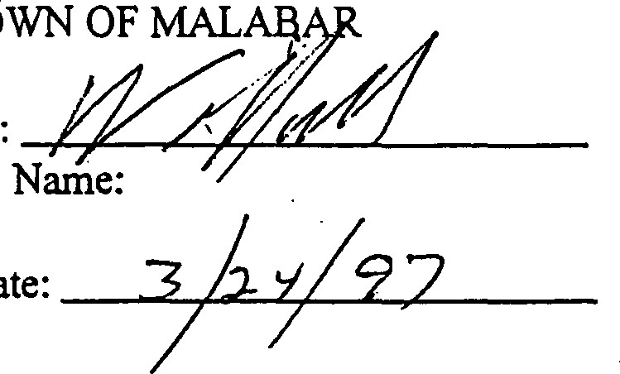
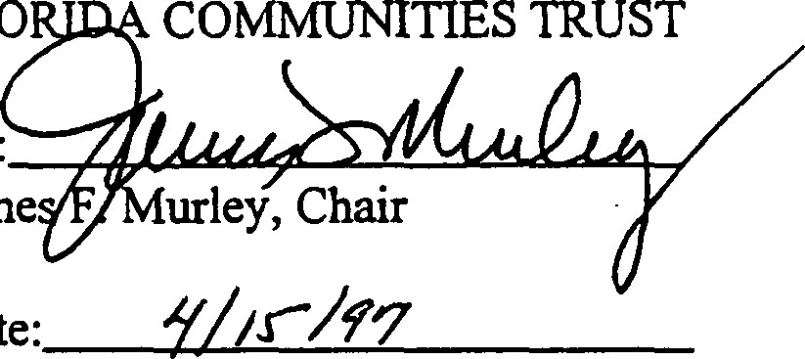
FLO
TOWN
Date:
By: By:
Jame
Date:
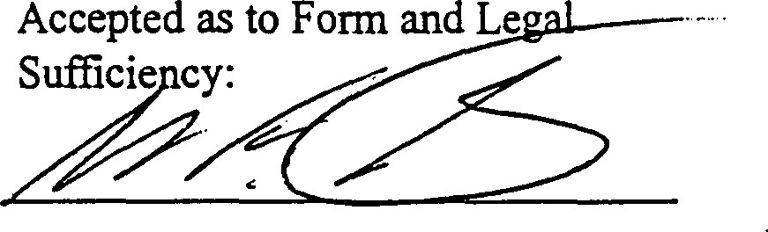
Accepted as to Form and Legal Sufficiency:
Date: 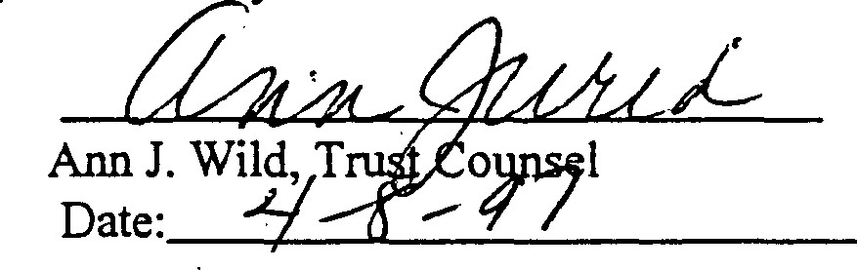
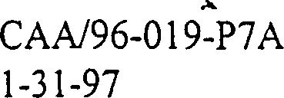

Contract No:
FCI' Project No: 96-019-P7A
CONFIDENTIALITY AGREEMENT
This is a Confidentiality Agreement ( 'I Agreement") pursuant to Rule 9K—6.010 (5) , Florida Administrative Code (F. A. C. ) .
Parties to the confidentiality Agreement: TOWN OF MALABAR ("FCT Recipient") , a municipality within State of Florida, and the Florida Communities Trust ( ^{N} FC!" ) , a nonregulatory agency within the Department of C0Dmunity Affairs.
Parcels Covered by this Agreement: This Agreement covers all parcels identified as part of the project site in FCT application 11/96-019-P7A that was selected for funding and is governed by a Conceptual Appioval Agreement for FCT Project Number GREENWAY XX/96-019-P7A ("Project Site )
confidentiality:
- Pursuant to Rule 9K-6.002 (17) , F.A.C. , the term "Confidential" refers to information that shall not be available for public disclosure or inspection and is exempt from the provisions of Section 119.07 (1) , Florida Statutes (F. S.) .
- The FCT Recipient and its agents shall maintain the confidentiality of all appraisals, offers, and counteroffers as required by Section 125.355 (1) (a) , F.S. , for counties, or Section
166. 045 (1) F. S. , for municipalities, and Rule Chapter 91<-6 ,
The FCC Recipient may disclose such confidential information only to the individuals listed herein below.
- Requests to add persons to the disclosure list must be made in writing and the FCT Recipient must receive the written consent of the FCT Executive Director and execute an Addendum to the Agreement. All confidentiality requirements outlined above shall apply to individuals added to the list.
- The undersigned board members and staff of the FCC Recipient ( 'C FC'? Recipient") and its agents, if any, agree to maintain the confidentiality of appraisal information, offers and counter—offers concerning FCT Project Number MALABAR SANCTUARY 11/96-09-P7A, as required by Section 125.355 (1) (a) , F. S . , for counties , or Section 166.045 (1) (A) , for municipalities , and Rule Chapter 9K-6 , F.A. C. , and by this Confidentiality Agreement between the FCT Recipient and FCC .
The undersigned certify that they have no legal or beneficial ihterest in the Project Site.
CONFID/FCT#96-019-P7A

REV. 2/23/95
EXHIBIT
Date FCT Recipient Board Member , S ignature
Staff or Agent name

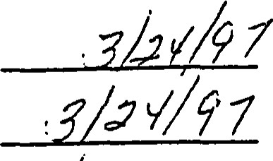
2_.222,___ 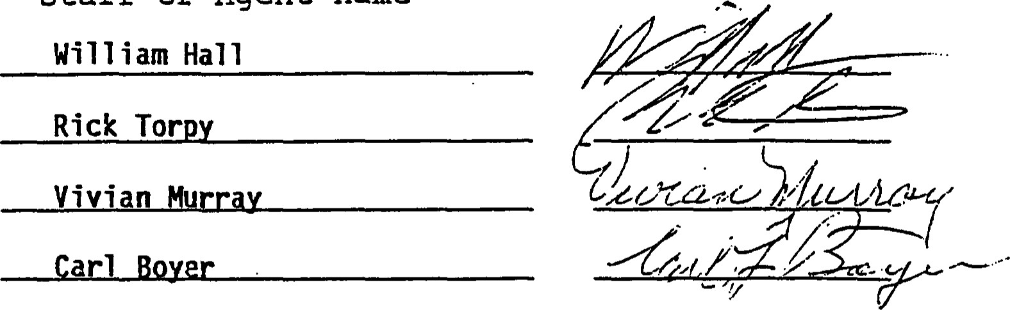
FCT RECIPIENT | FLORIDA cowmrUNITIES TRUST
By:
(Name) Wil I iam Hall | Anne Peery , | Executive
Its : Admini strator | Director
Date: Date:
Approved  Legality: | as | to | Form | and | Approved  Legality: | as | to | Form | and
Trust Counsel
CONFID/FCT#
REV. 2/23/95
BEST AVAILABLE COPY
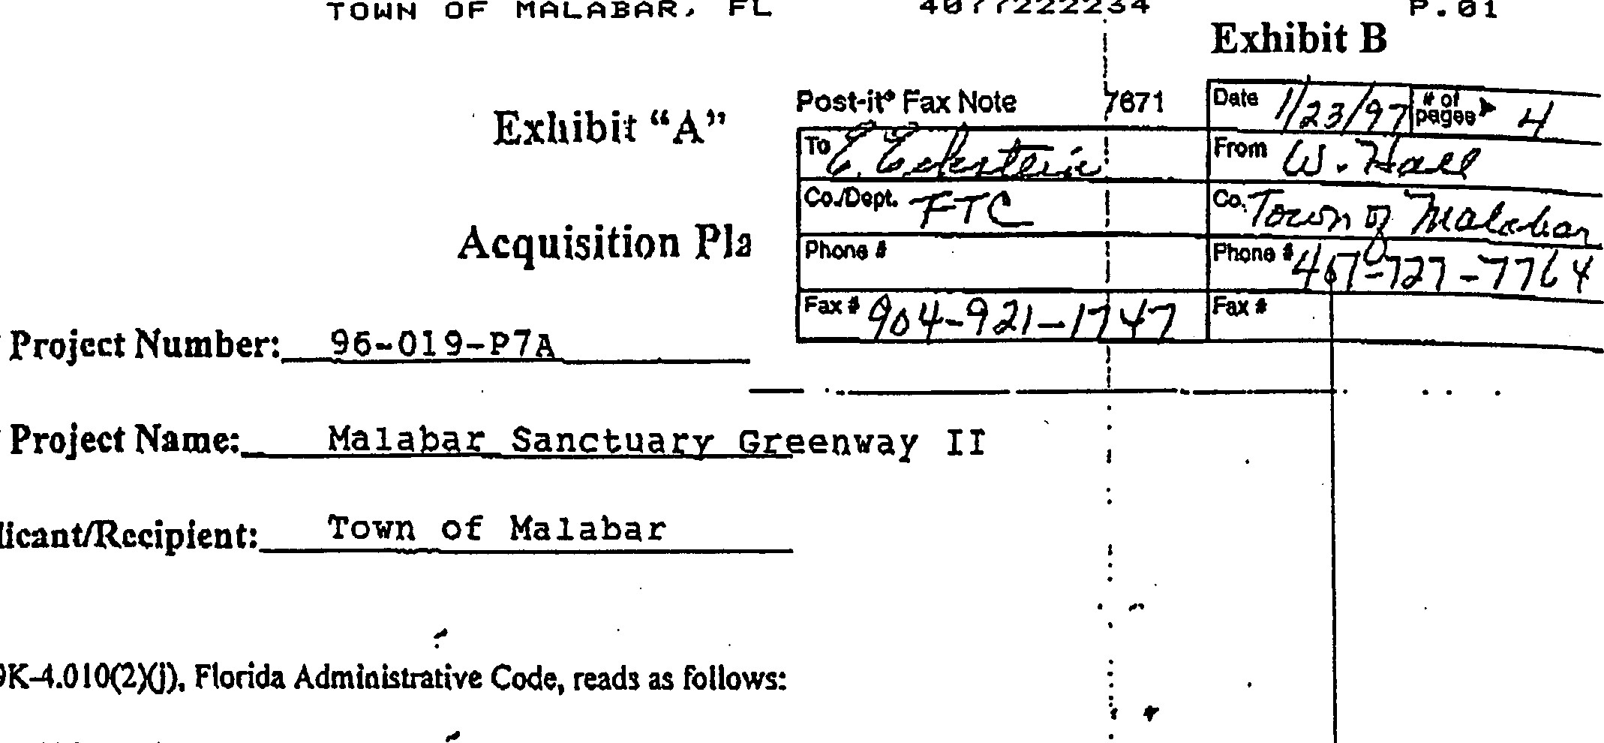
PCT
FL
4ø77222234
T
OWN
OF
ApplicantIRecipient:

FCT
Rule
If the project site is comprised of multiple parcels, the applicant, in conjunction with the Trust staff, sh Il develop an acquisition plan to be made a part of the Conceptual Approval Agreemeqt. The plan shall identify the priority parcels, the general order in which parcels will be acquired and the measures that ill be taken to assyre that all reasonable effptt is made to secu«.tbe entire project site.
Florida Communities Tmst (FCT) staff will review the acquisition plan to assure that the purposes of the •projec can be achieved in the event all parcels can not be acquired.
13 your project site comprised of multiple parcels? (yc or
Is your project site comprised of multiple owners? (yes or Ito* If yes, how many owners?
Please complete the following information, Use additional paper Of attachments if needed;
Identify the priority parcels needed to achieve the purposes of the project.
See attached,
Identify the general order in which the parcels will be acquired,
See attached.
Identity the measures that will be taken to assure that all reasonable effort is made to secure the entire project site.
See attached'.
Approved by FCT Staff:
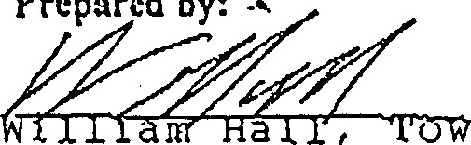
o n Admin i SEFä-t•o•
Prepared
by:
T OWN OF MALABAR, 40772222.34

Exhibit B
OFFICE OF THE TOWN CLERK
(407) 727-7764• 2725 MALABAR ROAD

FAX (407) 722-2204MALABAR, FLORIDA 329504427
Exhibit "A'
Acquisition Plan
Page 2
FTC Project Number: 96-019-P7A
FTC Project Name: Malabar Sanctuary' Greenway Il
Identify the priority parcels needed to achieve the purposes of the project.
Section 3: Parcels 3 & 4
Section 2: Parcels 254 & 263
Section 1: Parcels 256.2, 256, 256.1 & 257
Identify the general order in which the parcels will be acquired.
Section 3: Parcels 3 & 4
Section 2: Parcels 254 & 253
Section 1 : Parcels 256.2, 256, 256.1 & 257
Section 3: Parcels 16, 16, 29, 25, 14, 765, 762, 794, 767, 770,
6,1 and 7
Section 2: Parcels 262, 255, 283, 256, 256.1, 264, 262, 263
Section 1: Parcels 290, 255, 252, 251, 250, 38 & i2
Identify the measures that will be taken to assure that all reasonable effort is made to secure the entire project site.
Either personal contact will be made or follow-up letters will be sent to property owners who did not respond to our initial mailing. We will suggest they discuss the project with us in the hope they agree to negotiate the sale of their property or a conservation easement with Florida Communities Trust,
/vm

1/23/97
APPENDIX 11
Species Lists for Turkey Creek and Malabar
With Surveys ofListed Species
Endangered, Threatened, and Species of Special concern In sand Pine and Hammock vegeetlve communities of the Turkey Creek sanctuary and FCT parcels.
From Turkey Creek Ranger Reports (1994), Turkey Creek Management Plan (1991), as designated by the Florida Game and Fresh water Flsh Commlsslon, Offldal Llsts of Endangered and Potentially Endangered Fauna and Flora In Florida, 1994.

Species FDA USFIUS aTES CFC

PLANTS
Butterfly orchid
Encyclla empensls
Alr Plant  Tlllandsla fasclculaä  Wild pine  Tlllandsla setcea  Alr Plant | CE
Tlllandsla uålculaä | CE
Dahoon Holly  Ilex casslne crollna Hotly  Ilex amblgua  Simpson's Stopper  Marcjanåles fragrans  Prickly Pear actus  Opunäa s&lcä |  | CE
Royal Fem  Osmunda regalls  Golden Polyplody  Phleöodlum aureum  MAMMALS west Indian Manatee  Trlchecfius manatus  REPTILES | CE
American Alligator  Alligator mlsslsslpplensis |  |  | ssc
Gopher Tortoise |  |  | ssc

Gopherus polyphemus
KEY: FDA - Florida Department of Agrlcutture and Consumer Services - United States Fish and Wildlife service aTES - Convention on •International Trade In Endangered species of Wild Fauna and Flora
OFC - Florida Game and Fresh water Flsh Commission
E - endangered T - threatened TWA) - threatened/slmllarlty of appearance
CE commercially exploited
C2 - candldate for federal listing with some evidence of vulnerablllty, but for which not enough Information exists to Justify llstlng Il - CITES Appendix Il species
Species | Common Name
Myrica palustris | Wax myrtle
Cladiumjamaicense | Sawgrass
Osmunda regalis | Royal fem
Belchaum serrulatum | Swamp fern
7he.lypteris spp. | Shield fern
Daubentonia punicea | Rattlebush
Sagattaria spp. | Arrowhead
Nymphaea spp.  Depression Marsh | Water lily  Common Name
Myrica palustris | Wax myrtle
Lyonia Lucida | Fetterbush
Lyoniaferruginea | Staggerbush
Belchaum serrulatum | Swamp fern
Hypericum spp. | St. John's wort
Phragmites australis | Common reed
Lachnocaulon spp. | Bog buttons
Nymphaea spp. | Water lily
Fuirena scirpoidea | Umbrella grass
Sagittaria spp. | Arrowhead
Panicum repens | Torpedo grass
Nymphoides spp. | Floating hearts
Basin Marsh
Flatwoodsærairie Lake - Open Water
Species | CQmmnn Name
Sagittaria spp. | Arrowhead
Panicum repens | Torpedo grass
Nymphaea spp. | Water lily
Typha spp. | Cattail
Wetland Flora of the Malabar Scrub Sanctuary
Basin Swamp
Common Name
Persea palustris Swamp bay
Myrica cerifera Wax myrtle
Cephalanthus occidentalis Buttonbush
Salix spp. Willow
Osmunda regalis Royal fern
Belchaum serrulatum Swamp fern
Zhelypteris spp. Shield fern
Cladiumjamaicense Sawgrass
Pontederia spp. Pickerel weed
Sagittaria spp. Arrowhead
Gordonia lasianthus Loblolly Bay
Acer rubrum Maple
Lyoniaferruginea Staggerbush
Lyonia lucida Fetterbush
Myriophyllum spp. Water-milfoils
Hypericum spp. St. John's wort
Eriocaulon decangulare Pipewort
Typha spp. Cauil
MesicIWet Flatwoods

Common Name
Persea palustris Swamp bay
Myrica cerifera Wax myrtle
Salix spp. Willow
Sabal palmetto Cabbage Palm
Acer rubrum Red Maple
Osnunda regalis Royal fern
Belchaum serrulatum Swamp fern
Thelypteris spp. Shield fem
Cladiumjamaicense Sawgrass
Myriophyllum spp. Water-milfoils
Hypericum spp. St. John's wort
Lyonia fenuginea Staggerbush
Pinus spp. Longleaf or Slash pine
Live Oak | Quercus virginiana | x | x | x
Winged Sumac | Rhus copal lina | x
Natalgrass | Rhynchelytrum repens |  | x | x
Rhynochosia | Rhynchosia sp. |  | x |  | x
Beak-rush | Rhynchospora megal ocarpa | x
Richardia | Richardia brasili ensis | x |  | x
Rouge Plant | Rivina humilis | x
Blackberry | Rubus sp. |  |  | x | x
Cabbage Palm | Sabal palmetto | x | x
Coastal Plain Willow | Salix caroliniana | x |  | x | x
Braziliän Pepper | Schinus terebin chi foli us | x | x | x
Bulrush  Tall Nutrush | Scirpus sp.  Scl eria triglomera ta | x
Sawtooth Palmetto | Serenoa repens | x | x | x | x
Foxtail Grass | Setaria geni culata | x |  | x
Broornweed | Sida acuta | x | x
Brooraweed | Sida cordifolia |  |  | x
Catbriar  Nightshade | Smilax sp.  Solanum ameri cant..üü/ nigrescens | x  x | x | x | x
Goldenrod | Solidago sp. | x |  |  | x
Sow—Thi st le | Sonchus sp. | x
Goatweed | Soparia dulcis |  |  | x
Smutgrass | Sporobol us indi cus | x
St. Augustine Grass | Stenotaphrum secundtum | x
Air Plant * | Tillandsia fasiculata | x
Ball Moss | Tiflandsia recurvata | x | x | x | x
Spanish Moss | Tillandsia usneoides |  |  |  | x
Air Plant, Wild Pine | Tillandsia utriculata | x |  | x
Poison Ivy | Toxi codenron radi cans | x
Urban Daisy | Tridax procumbens | x
Ceasar Weed | Urena lobata | x |  | x | x
Shiny Blueberry | Vaccinium myrsini tes | x | x | x | x
Deerberry | vaccinium stamineun | x | x | x | x
Cowpea | Vigna luteola | x |  | x | x
Suwner ( pigeon) Grape | vitis aestivalis | x |  |  | x
Munson Grape | vitis munsoniana | x | x | x | x
Creeping Oxeye  Netted Chain Fern | Wedelia trilobaca  Woodwardia areola ta | x | x | x
Hog Plum, Tall owvqood | Ximenia ameri cana | x | x | x | x
Youngia | Youngia japoni ca | x |  | x
Beargrass | Yucca aloifolia |  | x | x
Beargrass , Yucca | Yucca filamentosa | x |  | x
B C D

KEY: name
BROOKHOLLOW WEST
= SANDY PINES
BROOKHOLLOW EAST
D PARCEL B
vegetative community sand pine scrub sand pine scrub (disturbed) sand pine scrub sand pine scrub and hydric hammock
B c D
Blazing Sear | Liaeris sp. |  | x
Gopher Apple | Li cania michauxii | x | x | x
Capeweed | Lippia nodiflora | x |  | x
Primrose willow | Ludwigia peruviana | x
Ludwigia | Ludwigia repens | x
Lupine | Lupinus diffusus | x | x
Roserush | Lygodesmia aphylla |  |  | x
Rusty Lyonia | Lyonia ferruginea | x | x | x | x
Shiny Lyonia | Lyonia lucida |  |  | x | x
Climbing Hernpweed | Mikania scandens | x |  | x | x
Partridge Berry White Mulberry | Mitchella repens Morus alba | x
Wax Myrtle, Bayberry | Myrica ceri fera | x |  | x | x
Evening Primrose | Oenothera laciniata |  |  | x
Prickly Pear Cactus | Opuntia humi fusa | x | x | x
Prickly Pear Cactus | Opuntia stricta |  |  | x
Wild Olive | Osman thus ameri cana | x | x |  | x
Royal Fern * | Osmunda regal is | x |  |  | x
Sorrel | Oxalis sp. | x
Palafoxia | Pal afoxia feayi | x | x
Palafoxia | Palafoxia integrifolia |  | x |  | x
Grass  Virginia Creeper | Panicum sp.  Parthenocissus quinquefolia | x  x
Bahia Grass | Paspalum notatun | x | x | x
Thin Paspalum | Paspalum setaceum | x
Vasey Grass | Paspalun urvill ei | x
Pectis | Pectis prostrata | x
Golden Polypody * | Phl ebodium aureum | x |  | x
Phylanthus | Phyllanthus tenell us |  | x
Physalis | Physalis sp. |  |  | x
Pokeweed | Phytolacca americana | x |  |  | x
Sand pine | Pinus clausa | x | x | x | x
Slash pine | pinus elliocii | x
Longleaf pine | Pinus pal uscris |  | x | x
Silkgrass | Pi tyopsis graminifolia | x | x | x | x
Salt Marsh Fleabane | PI uchea odorata | x
Painted Leaf | Poinsettia cyathophora | x
Resurrection Fern | Polypodium polypoides | x | x |  | x
Rus tweed | Polypremum procumbens | x
Purslane, pink | Portulaca pi losa | x |  | x
Portulaca | Portulca anilis |  |  |  | x
Wild Coffee, Shiny | psychotria nervosa | x
Bracken Fern | pteridium aquilinum | x |  | x | x
Blackfoot | Pterocaulon virgatun | x | x | x | x
Chapman Oak | Quercus chapmanii |  | x | x, | x
Scrub Live Oak | Quercus geminata | x |  |  | x
Turkey Oak | Quercus laevis | x | x | x | x
Dwarf Live Oak | Quercus minima |  | x |  | x
Myrtle Oak | Quercus nyrti folia | x | x | x | x

KEY: name
A BROOKHOLLOW WEST SANDY PINES c BROOKHOLLOW EAST D PARCEL B
community sand pine scrub sand pine scrub (disturbed) sand pine scrub sand pine scrub and nvdric hammock

Name
Ximenia americana | Tallowood
Xyris fimbriata | Yellow-eyed Grass
Yucca filamentosa | Yucca

Name
Linum carteri
Lyoniaferruginea Rusty Lyonia
Lyonia Lucida | Shiny Lyonia
Magnolia virginiana | Sweet Bay
Mercardomia acuminara | Sma.ll Scroph
Myrica cerifera | Wax Myflle
Molina atopocarpa | Bear Grass | Endangeted
Phoebanthus grandiflora | Golden Aster | Endemic
Piloblephis rigida | Pennyroyal | Endemic=l
Pinguicula lutea | Yellow Buttetwort
Pinus Clausa | Sand Pine
Pinus elliomii var. densa | Slash Pine | Endemic=l

Pinus palustris Long Leaf Pine

Polygala cruciataMilkwort Purple Cap
Polygala elliotic Milkwort
Polygala polygama Milkwort spp.
Polygala rugelii Big Yellow Milkwott Endemic=l, FDA=T
Prickly pear Opuntia humifusa Cites=ff, FDA=T
Pteridium aquilinum Blacken Fem
Quercus chapmanii Chapman Oak
Quercus geminata Sand Live Oak
Quercus laevis Turkey Oak
Quercus minimi Dwart Live Oak
Quercus myrtifolia Myrtle Oak
Quercus pumila Running Oak
Rhus Copallina Winged Sumac
Rhus SP. Shiny Sumac
Rubus cuneifolius Sand Blackberry
Sabal paLmetto Cabbage Palm
Salix caroliniana Coastal Plain Willow
Schinus terebinthifolius Brazilian Pepper
Schranha microphylla Sensitive Bria.r
Scleria baldwinii Nutmsh
Serenoa repens Saw Palmetto
Sisyrinchium atlanticum Blue-eyed Grass
Smilax ariculata Smilax Greenbriar
Solidago spp. Goldenrod
Thelypteris dentara Downy Shield Fern
Utricularia comuta Horned Bladderwort
Vaccinium darrowii BluebeffY
Vccinium myrsinites Shiny Blueberry
Vigna luteola Cowpea
Name
Linum carteri Flax
Lyoniafekruginea | Rusty Lyonia
Lyonia Lucida | Shiny Lyonia
Magnolia virginiana | Sweet Bay
Mercardomia acuminata | Small Scroph
Myrica cerifera | wax Myrtle
Nolina atopocarpa | Bear Grass | Endangered
Phoebanthus grandiflora | Golden Aster | Endemic
Piloblephis rigida | Pennyroyal | Endemic—I
Pinguicula lutea | Yellow Butterwort
Pinus Clausa | Sand Pine | Endemic=2
Pinus elliottii var. densa | Slash Pine | Endemic—I
Pinus palustris Long Leaf Pine

Polygala cruciata Milkwort Purple Cap
Polygala elliotic Milkwort
Polygala polygama Milkwort spp.
Polygala rugelii Big Yellow Milk-wort Endemic-I, FDA=T
Prickly pear Opuntia humifusa Cites=n, FDA=T
Pteridium aquilinum Blacken Fem
Quercus chapmanii Chapman Oak
Quercus germinata Sand Live Oak
Quercus laevis Turkey Oak
Quercus minimi Dwart Live Oak
Quercus myrtifolia Myrtle Oak
Quercus pumila Running Oak
Rhus Copallina Winged Sumac
Rhus sp. Shiny Sumac
Rubus cuneifolius Sand Blackberry
Sabal palmetto Cabbage Palm
Salix caroliniana Coastal Plain Willow
Schinus terebinthifolius Brazilian Pepper
Schrankia microphylla Sensitive Briar
Scleria baldwinii Nutrush
Serenoa repens Saw Pa.lmetto
Sisyrinchium atlanticum Blue-eyed Grass
Smilax ariculata Smilax Greenbriar
Solidago spp. Goldenrod
Thelypteris dentata Downy Shield Fern
Utricularia cornuta Horned Bladderw•ort
Vaccinium darrowii Blueberry
Vccinium myrsinites Shiny Bluebeny
Vigna luteola Cowpea

GENERAL PLANT SPECLS LISTS: MALABAR WOODS MESIC FLATLANDS
Scientific Name | Common Name | Stams
Aletris lutea | Colic Root
Andropogon virginicus var. glaucus | Broomsedge
Araceae heath | Tarflower
Aristida stricta | Wire Grass
Asimina reticulata | Pawpaw | Endemic=2
Aster concolor White Aster
Baccharis halimifolia Saltbush
Befaria racemosa Health Family Shrub
Carphephorus Paniculatus Dær Tongue
Centella asiatica Coinwort
Ceratiola ericoides Rosemary
Chaptalia tomentosa Pine Lmd Daisy
Chrysopsis scabrella Golden Aster
Cirsium horridulum %istle
Cladonia sp. Bridsh Soldier Moss
Coreopsis gladiata | Tickseed | Endemic
Coreopsis nudata | Swamp Coreopsis
Cyperus retrorsus | Sedge
Dichromena colorata | White Top Sedge
Drosera capillaris | Sundew
Erigeron quercifolius | Southem Fleabane
Eryngium yuccifolium | Button Snakeroot
Eupatorium capillifolium | Dog Fennel
Euphorbia polyphylla | Spurge
Fungus parasite sp. | Fungus Disease
Gaylussacia dumosa | Huckleberø•'
Hypericum cistifolium | SL John's Wort
Hypericumfasiculatum | Sandweed
H. hypericoides | St. Andrew's Cross
H. tetrapetalum | SL Peter's Wort
Hypoxis hirsuta | Yellow Star Grass
Hypoxis Juncea | Yellow-star Grass may be listed
Ilex galbra | Gallbetw
Lachnocaulon anceps | Bog Buttons
L.adnathes caroliniana | Red Root
Lechia cernua? | Pin-weed Endemic-I, FDA=E
Licania michauxii | Gopher Apple
Basin Marsh
Comman Name
Myrica palustris Wax myrtle
Cladiumjamaicense Sawgrass
Osmunda regalis Royal fern
Belchaum serrulatum Swamp fern
7helypteris spp. Shield fern Daubentonia punicea Rattlebush
Sagattaria spp. Arowhead Nymphaea spp. Water lily
Depression Marsh

Common Name
Myrica palustris Wax myrtle Lyonia lucida Feüerbush
Lyoniaferruginea Staggerbush
Belchaum serrulatum Swamp fern
Hypericum spp. St. John's wort
Phragmites australis Common reed
Lachnocaulon spp. Bog buttons
Nymphaea spp. Water lily
Fuirena scirpoidea Umbrella grass
Sagittaria spp. Amwhead
Panicum repens Torpedo grass Nymphoides spp. Floating hearts
Flatwoods/Prairie Lake - Open Water

Common Name,
Sagittaria spp. Arrowhead
Panicum repens Torpedo grass
Nymphaea spp. Water lily
Typha spp. Cattail
GENERAL PLANT SPECE.S LISTS: MALABAR WOODS MESIC FLATLANDS
Scientific Name | Common Name | Status
Aletris lutea | Colic Root
Andropogon virginicus var. glaucus | Broomsedge
Araceae heath | Tarflower
Aristida stricta | Wire Grass
Asimina reticulata | Pawpaw | Endemic-2
Aster concolor White Aster
Baccharis halimifolia Saltbush
Befaria racemosa Health Family Shrub
Carphephorus Paniculatus Deer Tongue
Centella asiatica Coinwort
Ceratiola ericoides Rosemary
Chaptalia tomentosa Pine Land Daisy
Chrysopsis scabrella Golden Aster
Cirsium horridulum
Cladonia sp. British Soldier Moss
Coreopsis gladiata | Tickseed | Endemic
Coreopsis nudata | Swamp Coreopsis
Cyperus retrorsus | Sedge
Dichromena colorata | White Top sedge
Drosera capillaris | Sundew
Erigeron quercifolius | Southem Fleabane
Eryngium yuccifolium | Button Snakeroot
Eupatorium capillifolium | Dog Fennel
Euphorbia polyphylla | Spurge
Fungus parasite sp. | Fungus Disease
Gaylussacia dumosa | Huckleberry
Hypericum cistifolium | st John's Wort
Hypericumfasiculatum | Sandweed
H. hypericoides | St. Andrew's Cross
H. tetrapetalum | St Peter's Wort
Hypoxis hirsuta | Yellow Star Grass
Hypoxis Juncea | Yellow-star Grass may be listed
Ilex galbra | Gallberry
Lachnocaulon anceps | Bog Buttons
L.adnathes caroliniana | Red Root
Lechia cernua ? | Pin-weed Endemic-I, FDA=E
Licania michauxii | Gopher Apple
Day- f lower Conradina | Commel ina erecta  Conradina grandi fl ora | x | x |  | x
Dwarf Horseweed | Conyza canadensis | x | x | x
Swamp Dogwood | Cornus foemina | x
Crotalaria | Crotalaria mucronata |  | x | x
Rabbit Bells | Crotolaria rotundi folia | x | x
Croton | Croton glanulosus |  | x | x
Roseling | Cuthbertia ornata | x | x | x
Bermuda Grass | Cynodon dactyl on |  | x | x
Nutgrass | Cyperus sp. | x | x | x
Helicopter Grass | Dactyloctenium aegyptiu.m | x
Sticktight | Desamodium incanum | x | x | x
Beggar-tick | Desmodium tri fl orum |  |  | x
India Crabgrass | Digi tax-ia longiflora |  | x
Pers irmnon | Diospyros virginiana |  | x |  | x
Eclipta | Eclipta alba | x
Elephant Foot | Elephantopus elatus | x | x
Goosegrass | Eleusine indica |  |  | x
Tassel flower | Anil ia fosbergii | x | x | x | x
Tassel flower, Lavende | Anil ia sonchifolia | x |  | x
Butterfly Orchid * | Encyclia tampensis | x
Gophertail Lovegrass | Eragrostis ciliaris |  |  | x
Fireweed  Coralbean | Erechti tes hieracifolia Erythrina herbacea | •x |  | x
Fennel | Eupatorium sp. | x | x | x
Spurge | Euphorbia polyphylla |  | x
Flat—top Goldenrod | Euthamia minor |  |  | x
Cot tonweed | Froelichia floridana |  | x
Galactia (White Pea) | Galactia elliotti | x | x | x
Galactia (Pink Pea) | Galactia sp. | x | x
marf Huckleberry Cudweed | Gayl ussacia dunosa  Gnaphalium falcatum |  |  | x
Cudweed | Gnaphalium sp. | x
Globe amaranth | Gomphrena serra ta |  |  | x
Innocence | Hedyotis procumbens | x | x
Helianthemum | Helianthenum cozy^{r}mbosu.m |  |  |  | x
Camphor Weed | Heterotheca subaxillaris | x | x | x
Hawkweed | Hieraciun sp. | x
Whorled Pennywort St. John•'s or | Hydrocotlye verti cellata |  |  | x
Peter's Wort Sand Holly * | Hypericum sp. rlex ambigua | x |  |  | x
Hairy Indigo | Indigofera hirsuta | x |  | x | x
Indigo | Indigofera spicata |  | x
Moon vine | Ipomoea alba | x
Morning Glory | Ipomoea cairica | x
Iresine | -Tresine diffusa | x
Wild Lettuce | Lactuca graminifolia | x | x
Pepper Grass | Lepidium virginicum | x |  | x
Lespedeza  KEY: name  A BROOKHOLLOW WEST  - SANDY PINES c BROOKHOLLOW EAST | Lespedeza hirta  vegetative community sand plne scrub |  | x
 | sand plne scrub (disturbed) sand pine scrub
D PARCEL B | sand pine scrub and hydric hammock
Species List - Turkey creek Basin ; Plant species
List of plant species identified by Florida Native Plant Society members in the FCT parcels - June 1991.
* denotes a listed species

= BROOKHOLLOW WEST
B = SANDY PINES
BROOIGOLLOW EAST D = PARCEL B
SCIENTIFIC NAME |  | B | c
Abrus precatorius x |  | x | x
Acer rubrum x |  |  |  | x
Al cernathera philoxeroides |  | x
Amaranthus sp. |  |  | x
Ambrosia artemisifolia Andropogon sp.  Arisaema triphyll um | x x |  | x
Aristida stricta | x | x | x | x
Arnoglossum floridanum | x | x | x
Ascl epias tomentosa |  | x | x
Asimina obovata  Asimina reticulata | x | x | x
Baccharis halimifolia  Balduina angustifolium  Befaria racemosa | x | x | x
Bidens alba  Bohmeria q^{r}lindrica | x | x

COh,MON NAME
Rosary Pea, Crab Eye
Red Maple
Alligator Weed Amaranth Ragweed
Bluestem
Jack-in-the-pulpit
^{T}ire Grass
Indian Plantain
Milkweed Pawpaw
Pawpaw
Sea Myrtle
Honeycon•b Head Tarflower
Spanish Needles
False Nettle
Bulbostylis ciliatifola
Calli carpa ameri cana | x | x | x | x
Carex absol utescens Carica papaya | x |  |  | x
Carphephorus sp . | x | x | x | x
Carya glabra cassia chamaecrista Catharanthus roseus | x | x | x | x  x
Cenchrus sp. Centella asiatica | x | x | x x
Centrosema virginianum  Cephalanthus occidental is | x x |  |  | x
Chamaesyce sp.  Ci cuta mexicana  Colocasia escul enta  vegetative community sand pine scrub | x x x |  | x
sand pine scrub (disturbed) sand pine scrub

Hairsedge
Beauty Berry
Sedge
Papaya
Deer Tongue
Pignut Hickory
Partridge Pea
Periwinkle
Sandspur
Coinwort ,
Butterfly Pea
Button Bush
Spurge
Water Henüock Wild Taro
KEY: name
BROOKHOLLOW WEST B SANDY PINES c BROOKHOLLOW EAST

Laughing Gull | Larus acricilla
Ring-billed Gull | Larus del awarensis
Red-shouldered Hawk | Buceo lineacus
Red- tailed Hawk | Buteo ja.maicensis
Sharp—shinned Hawk | Accipi ter scriacus
American Kestrel | Falco sparveri us
Belted Kingfisher | Cez)'le al
Chipping Sparrow | Spizella passerina
House Sparrow | Passer domesticus
Savannah Sparrow | Passerculus sandwichensis
Swamp Sparrow | Melospiza georgiana
Barn Swaklow | Hirundo rustica
Tree Swallow | Tachycineea bi color
Chimney Swift | Chaetura pelagica
Sumner Tanager | Piranga rubra
Least Tren | Strena ancillarum
Brown Thrasher | Toxostoma ruft.un
Gray—cheeked Thrush | Catharus minimus
Swainson' s Thrush | Cathan.as ustulatus
Rufous-sided Towhée | Pipilo erythropthalmus
Veery | Catharus fuscescens
Red-eyed Vireo | Vireo olivaceus
Solitary Vireo | Vireo soli Cari us
White—eyed Vireo | Vireo griseus
Yellow—throated Vireo | Vireo flavi fron
American Swallow—tailed Kite | Elanoides forficatus
Purple Martin | Progne subis
Northern Mockingbird | Minus polyglot tos
Corcmon Moorhen | Gallinula chloropus
Eastern Screech Owl | Otus asio
Eas tern Phoebe | Sayornis phoebe
American Robin | nurdus migratorius
Black Vulture | Coragyps atratus
mrkey Vulture | Cathartes aura
Blue Jay | Cyanoci tea cristata
Blue—gray Gnatcatcher | Polioptila caerulea
Northern Cardinal | Cardinalis cardinal is
Carolina Wren | Thryothorus ludovicianus
House Wren | Troglodytes aedon
Gray Catbird | Dumetella carolinensis
Yellow-bellied Sapsucker | Sphyrapi cus varius
Downy Woodpecker | Picoides pubescens
Hairy Woodpecker | Picoides villosus
Pileated Woodpecker | Dxycopus pileatus
Red-bellied Woodpecker | Melanerpes carolinus
Red-headed Woodpecker | Melanerpes erythrocephal us
Great Blue Heron | Ardea herodias
Little Blue Heron | Egretta caerulea
Tricolored Heron | Egretta tri color
Green Heron | Bucorides striatus
White Ibis | Eudocimus albus
Ruby-throated Humrningbird | Archilochus col ubris
Belted Kingfisher | Ceryle al cyon
Osprey | Pandion haliaetus
Ruby-crowned Kinglet | Regulus calendula
Wild ffh-lrkey | Mel eagris gall opavo
Wood Thrush | Hyloci chla must el ina
Species List TUrkey creek Basin ; Bird species
List of bird species identified at Turkey Creek Sanctuary (1985 May 1991) by Florida Audubon Society

* denotes a listed species

COIOfON NAME
American Redstart
Black & Warbler
Black—throated Blue Warbler
Blackburnian Warbler Blackpoll Warbler
Cape May Warbler
Chestnut—sided Warbler
Conunon Yellowthroat Warbler Hooded Warbler
Northern Parula Warbler
Northern Waterthrush Warbler Orange—crowned Warbler
Ovenbird Warbler Palm Warbler
Pine Warbler
Prairie Warbler
Tennessee Warbler
Worm—eating Warbler
Yellow—ru.mped Warbler
Yellow—throated Warbler
Cedar Waxwing
Anhinga
Red—winged Blackbird
Northern Bobwhite Indigo Bunting
Painted Bunting
Double—crested Cormorant Brown-headed Cowbird
Fish Crow
Yellow-billed Cuckoo
Conunon Ground Dove
Rock Dove
Bald Eagle *
Cattle Egret
Great Egret
Northen Flicker
Empidonax Flycatcher
American Goldfinch
Boat-tailed Grackle
Corrunon Grackle Blue Grosbeak
Rose-breasted Grosbeak SCIENTIFIC NAME
Setophaga rutici-lla
*fliotilta varia Dendroica caerul escens
Dendroica fusca
Dendroica striata
Dendroica tigråna
Dendroica pensyl vani ca Geothlypis tri chas
Wilsonia ci trina
Parula anericana
Seiurus noveboracensis Vermivora celata

Seiuauro capillusrus
Dendroica discolor Dendroica pinus
Dendroica discolor
Vermivora peregrina
Helmintheros vermi vorous
Dendroica corona ta
Vireo flavi frons
Bornbycilla cedrorum Anhinga anhinga
Agelaius phoeni ceus Colinus virginianus
Passerina q.^{r}anea
Passerina ciris
Phalacrocorax auri tus
Molothrus ater Corvus ossifragus Coccyzus minor
Columbina passerina Columba livia Haliaeetus leucocephalus Bubulcus ibis
Casmerodius albus Colaptes auratus ZIPidonax sp.
Carduelis tristis
Quiscalus major
Quiscalus quiscalus
Guiraca caerulea
Pheucticus ludovi cianus

COMMON NAME | SCIENTIFIC  NAME
FLA Sandhill crane | Grus canadensis pratensis |  |  |  |  | S2S3 |  | 2
Bald eagle | Haliaeetus leucoce halus |  |  |  |  | S2S3
Wood stork | Mycteria amertcana | E | E |  | E
Sno e ret | É reffa *hula | ssc |  |  | ssc
 | 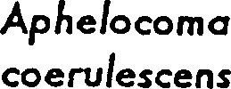
Merlin | columbarius
Little blue heron | caerulea | ssc |  |  | ssc
FLA prairie warbler | Dendroica discolor aludicola |  |  |  | ssc
Great egret | Cdsmerodius albus |  |  |  | ssc
White ibis | Eudocimus albus |  |  |  | ssc
Osprey | Pandion haliaetus |  |  |  |  | S3S4
KEY
A-FGFWFC E — Endangered
B-USMS T — Threatened
CCITES SSC — Species of Special Concern
D-FCREPA I — Appendix I Species
E.FNÅI (STATE) Il — Appendix Il Species
F-FNAI (GLOBAL) SU — Status Undetermined
G-ENDEMIC Sl•S5 — Most endangered(S 1 ) to least endangered(S5) state rank
Gl-G5 = Most endangered(G 1 ) to least endangered(G5) global rank
T2 = A vulnerable species T3 = A threatened species
Chimney swift | Chaetura ela ica | open areas |  | resident
Cape May warbler | Dendroica tigrina | pine flatwoods |  | migrant
Pur le martin | Pro ne subis | o en woods |  | resident
Downy woodpecker | Picoides ubescens | pine  Ratwoods | 1 | resident
Killdeer | Charadrius vodferus | open areas |  | resident
Brown thrasher | Toxostoma rufum | scrub |  | resident
Cedar waxwing | Bombycilla cedrocum | pine flatwood/scru b | 1 | migrant
Common flicker | Colaptes auratus | pine  Ra"toods | 1 | resident
FLA. sandhill crane | Gcus canadensis ratensis | wetlands | 1 per M. Hames | resident
Bald eagle | Haliaeetus leucoce halus- | wetlands | 1 per Dave  Sim son | resident
Wood stock | Mycferia amencana | wetlands |  | resident
 | E retia thula | wetlands |  | resident
Scrub iay | Aphelocoma coerulescens | scrub | 6 | resident
Merlin | Falco columbarius | scrubby flat-woods |  | migrant
Little blue heron | E reffa caerulea | wetlands |  | resident
Os re | Pandion haliaetus | wetlands | 6 | resident
American redstart | Setophaga ruticilla | scrub |  | migrant

Red-bellied wood ecker | Centurus carolinus | pine flabæoods | 2 | resident
Mockin bird | Mimus o lotios | o en areas | 6 | resident
Yellow-rumped warbler | Dendroica coronata | pinewoods | 2 | resident
Cardinal | Cardinalis cardinalis | scrub | 2 | resident
Double-breasted cormorant | Phala«ocorax auritus | wetland |  | resident
Black vulture | Coragyps atratus | pine/ scrub |  | resident
Mourning dove | Zenaida macroura | scrub & open areas |  | resident
Common ni hthawk | Chordeiles minor | o en areas |  | resident
Carolina wren | Thryothorus ludoviäanus | scrub | 3. | resident
Chuck-will%-widow | Caprimulgus carolinensis | pine flatwoods |  | resident
Common ellowthroat | Grothylpis trichas | scrub | 2 | resident
fish crow | Coryus ossifragus | open areas/ wetlands |  | resident
Northern bobwhite | Colinus nuanus | scrub/open areas |  | resident
Common grackle | Quiscalus quiscula | open areas pine flatw.oods | 2 | resident
Mottled duck | Anas fulvi Ula | wetlands | 3 | resident
White ibis | Eudocimus albus | wetlands |  | resident
Northern arula | Parula americana | scrub |  | mi rant
White-e ed vireo | Vireo riseus | scrub |  | resident
Pileated woodecker | Dryocopus ileatus | pine flatwoods |  | resident
Common groun& dove | Columbina asserrna | scrub |  | resident

Malabar scrub Sanctuary
Bird Survey
COMMON NAME | SCIENTIFIC  NAME | HABITAT | OCCURRENCE | RANGE
Boat4ailed cackle | Quiscalus major | wetland | 1 per Dave  Sim son | resident
Spotted sandpiper | Actitis macularia | wetlands | per Dave  Sim son | migrant
Black-throated blue warbler | Dendroica caerulescens | pine flatwoods | 1 per Dave  Sim son | migrant
Brown-headed cowbird | Molothrus afer | open areas | 1 per Dave  Sim son | resident
Black-and-white warbler | Mniotilta• varia | scrub |  | resident
FLA. prairie warbler | Dendroica discolor aludicola | scrub |  | resident
Blue jay | Cyanocitta cristata | open areas | 3 | resident
Turke vulture | CafhaHes aura | scrub | 2 | resident
Rufus-sided towhee | Pipilo erythrohthalmus | scrub | 6 | resident
White-breasted nuthatch | Sitta carofinensis | scrub | 2 | resident
Scarlet tanager | Piranga olivacea | pine flatwoods | 2 | migrant
Pine warbler | Dendroica pinus | pine flatwoods |  | resident
Blue-gray natcatcher | Polioptila caeculea | wetlands & scrub | 2 | resident
Great egret | Casmerodius albus | wetlands | 2 | resident
Cattle egret | BUbUlCUS ibis | wetlands/ open rasslands |  | resident
Species South Wetland Swamp Aquatic
Florida Hardwood Hardwoods Preserves Flatwoods Hammock

BIRDS (cont'd)
Brown pelican pelecanus occldentalis |  | ssc | ssc
American owtercatcner  Haematopus palliatus  Least tern  Sterna anällarum  Roseate tern sterna dougalli |  | ssc | ssc
Little blue heron  Egretä caerurea |  | ssc
Tricolored heron  Egretü tricolor |  | ssc
Roseate spoonbill Naia ajaja  MAMMALS |  | ssc | ssc
Florida mouse | ssc | ssc
POdomys florjdanus west Indian Manatee
Trichecfius manatus
River otter

Lutra canadensis
KEY:
Florida Department of Agriculture and consumer services
T - threatened
E - endangered
Florida Game and Fresh water Fish Commission SSC - species of special concern convention on International Trade in Endangered Species of Wild Fauna and
Flora (CITES)
Il - CITES Appendix Il species
Endangered, Threatened, and Species of Special concern by Habitt as listed by tne Florida Game and Freshwater Flsn Commission
From Town of Malabar, Florida, comprehensive Plan, Dao Inventory and Analysis Component, 1988
species South wetland Swamp Aauatlc
Florida Hardwood Hardwoods preserves
Flatwoods Hammock

FISH
Common Snook •  Cennpomus undecimalls  AMPHIBIANS AND REPTILES |  |  | ssc
Gopher tortolse ssc  Gopherus Polyphemus  Eastern Indigo snake  Drymarchon corais couperi  Atlantic salt marsh snake  Nerodla fasciae äeniata | ssc
American Alligator  Alligator mississjppiensis  BIRDS  American Bald Eagle  Hallaeews leucocephalus  Southeastern kestrel  Falco sparverius paulus |  | ssc
Snovw egret ssc  Egretü mula  Florida scrub jay | ssc | ssc | ssc
Aphelocoma coerulescens coerulescens
Wood stork
Mycteria americana
Florida Sandhill crane
Grus canadensls pratensis
Osprey ssc  Pandion haliaetus peregrine Falcon  Falco peregrjnus |  | ssc | ssc
Reddisn egret ssc |  | ssc | ssc

Egretta rufescens

Scientific Name | Common Name | Status
Ximenia americana | Tallowood
Xyris fimbriata | Yellow-eyed Grass
Yucca filamentosa | Yucca

77—
Wetland Flora of the Malabar Scrub Sanctuary
Basin Swamp
Common Name
Persea palustris Swamp bay
Myrica cerifera Wax myrtle
Cephalanthus occidentalis Buttonbush
Salix spp. Willow
Osmunda regalis Royal fern
Belchaum serrulatum Swamp fern
Thelypteris spp. Shield fern
Cladiumjamaicense Sawgrass
Pontederia spp. Pickerel weed
Sagittaria spp. Arrowhead
Gordonia lasianthus Loblolly Bay
Acer rubrum Red Maple
Lyoniaferruginea Staggerbush
Lyonia lucida Fetterbush
Myriophyllum spp. Water-milfoils
Hypericum spp. St. John's wort
Eriocaulon decangulare Pipewort
Typha spp. Caüail
MesicIWet Flatwoods
Species Common Name
Persea palustris Swamp bay
Myrica cerifera Wax myrtle
Salix spp. Willow
Sabal palmetto Cabbage Palm
Acer rubrum Red Maple
Osmunda regalis Royal fem
Belchaum serrulatum Swamp fern
Thelypteris spp. Shield fern
Cladiumjamaicense Sawgrass
Myriophyllum spp. Water-milfoils
Hypericum spp. St. John's wort
Lyonia fen-uginea Staggerbush
Pinus spp. Longleaf or Slash pine
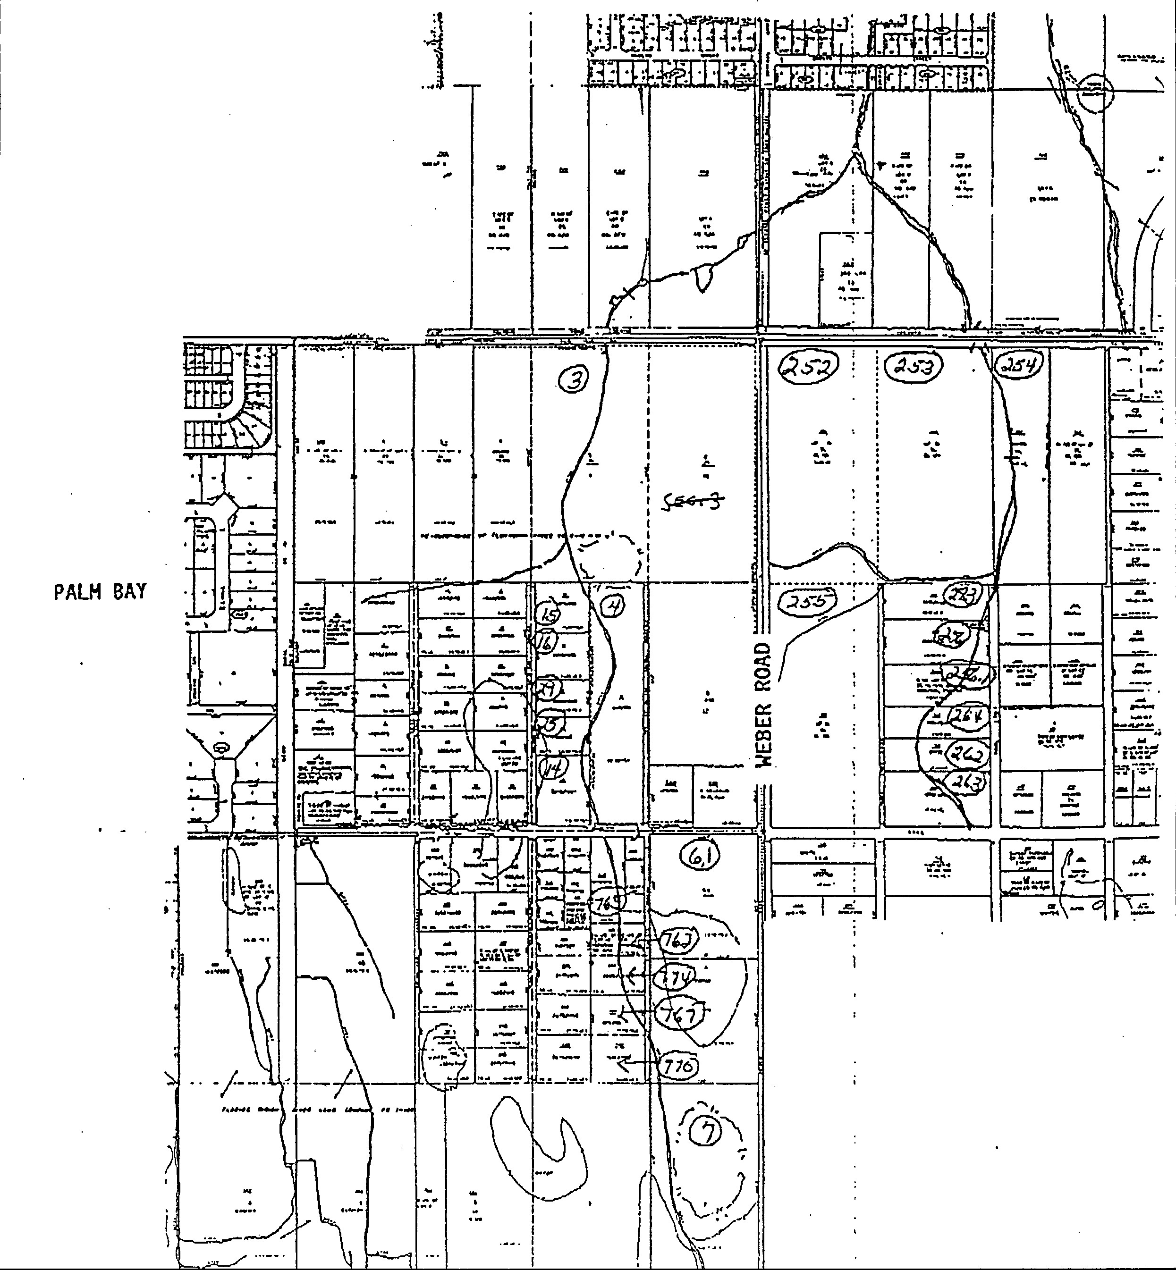
тоын ОР мае аваа, 4377222234
РАИЧ вку

TOWN OF FL 4077222234

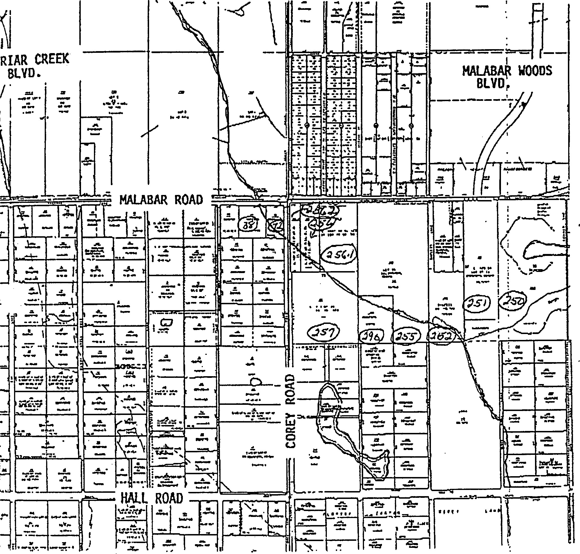
MALABAR SANCTUARY GREENhiAY 11
SCALE 1 :800

m
Cost Estimates
m

COST ESTMATES
Signage*
Entrances (12) @ $150 each  Education Signs * + | $1,800
Trail Headcenters (2) @ $500 each | 1,000
Property Boundary (75) @ $50 each  Fencing | 3,750
Chain Link and Split Rail  Trail Construction* T | 50,000
Cycle  Nature Trails Bridle Paths | 18,000
Picnic Tables and Benches at Cory & Malabar Roads * | 3,000
Creek Crossings (2) @ $2,000 each + | 4,000
Education Centers Renovation * | 30,000
Reynolds Ranch Homestead Moving & Restoration º | 120,000
Water Management Berm and Trail Stabilization + T | 180,000

TOTAL $411,550
Sources of Funding
* Florida recreation Development and Assistance Program
St. Johns River Water Management District
TEA-21
Preservation Grant Program
IV
Priority Schedule
IV
PRIORITY SCHEDULE
1999-2000 2001-2003 2004+

l. Post Property Boundary Signs
- Apply for Permits
- Conduct Vegetative Surveys
- Remove Invasive Exotic Plants
- Develop Water Management Plan with Water Management District
- Extend Fences
- Prepare Parking Areas
- Apply for FRDAP Grant

- Implement Water Management Plan
- Install Creek Crossovers
- Renovate Nature Carter Site
- Replant Native Vegetation
- Move Reynold' 5 Ranch House
- Restore Reynolds Ranch Homestead

I- I commun It les I rust Fax Jan 20 '99 11 .•oo P. 01/01
Post-it' Fax Note | 7671 | Date |  |  | # of
^{To} stev | ) | From
CoJDept.
Phone #  Fax |  | Phone #
 |  | Fax #

FACSIMILE
to: Bill Hall - Town of Malabar
from:
Edward Eckstein phone # 850 922-2207 Fax # 850 921-1747 re: Malabar Sanctuary I and Il Management Plan

01-20-99
At our 01 •19-99 FCT acquisition meedng Anne Peery stated that 3 parcels In Matabar
Il project site could possibly dose [n February 1999. These are the Churyak, Oliveira and Shaw parcels. However, In order to close on these 3 parcels we need to review and approve the combined Malabar Sancwary I and Il Management Plan.
The 3 parcels that could close in February 1999 are not associated with the two stomwater detention ponds proposed by the St. Johns WMD, The stormwater ponds would only affect the Reynolds and Galvez parcels. Therefore, In order to expedite review and approval of combined management plan we are. suggesting åe following:
If It would take an extraordinary amount of time for Dlane Barile to completely address the
2 stormwater ponds In the revised management plan (per our 12-10-98, 12-31-98 and 01-1 5-99 comment letters and fax), addressing the ponds in the management plan could be postponed until the Reynolds and Galvez parcels are about to be purchased. In essence, the combined management plan could be amended in the fuwre to include the two stomwater ponds and related information.
Therefore, by February 1, 1999, FCT needs to recelve a revised management plan for the Malabar Sanctuary I and Il sites that address the comments made In our 12-1098 letter, except for those comments that relate to the ONO proposed stormwater ponds. All other comments must be addressed, including the comment made on culvert improvements.
Please make Ms. Diane Barf[e and Mr. Steve Morgan aware of fris strategy and have Ms. Barite submit a revised management plan to FCT by February 1, 1999, so we can close on the 3 parcels.
Please call me if any information is needed. Thanks Ill!
HI Communities Trust Fax:8SO-921-1747 Jan IS '99 12:38 P. 01/01
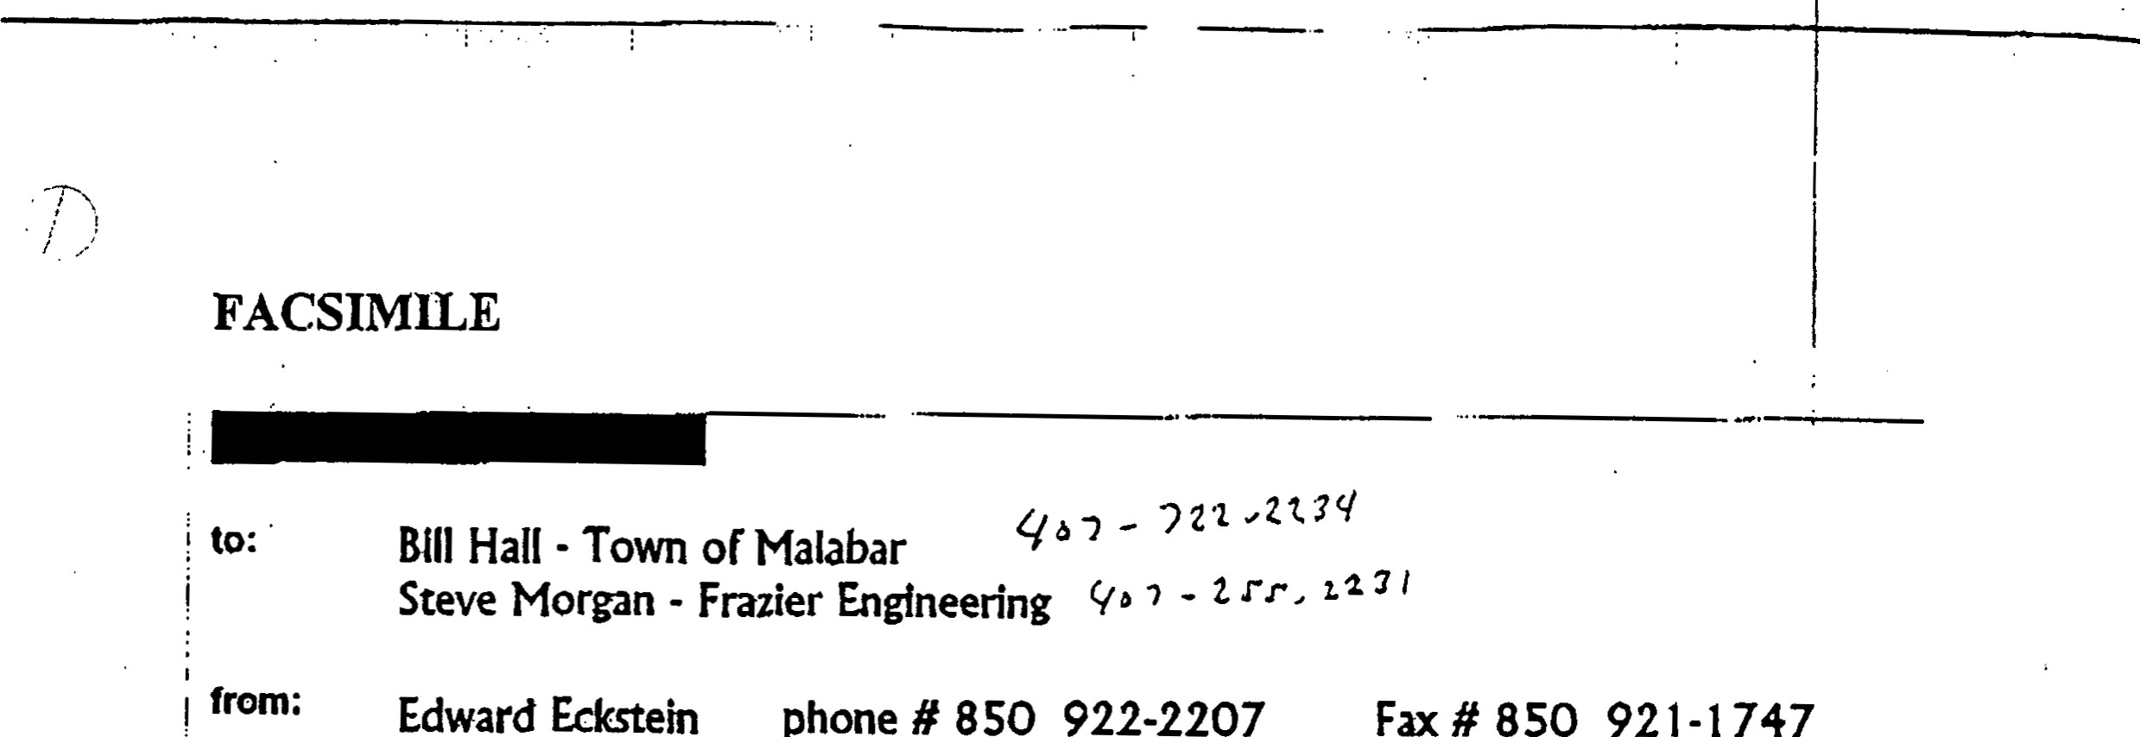
Malabar Management Plan Comment date: 01-15-99
Eckstein
phone
Fax
921-1747
The followtng provision needs to be added to the stormwater management section of i the revised Malabar Sancwaty Greenway Management Plan. Please see diat Diane Barile is made aware of this addidon.
Provtslon to add:
! To ensure that the proposed stomwater detention ponds are compadb(e with the protection of nawra{ resources and meets the multi-use objectives proposed In the original application, the following parameters shall be Incorporated into the design of åe detendon ponds. In addition, final design of the detention ponds shall be submitted to FCT for review and approval prior to constNCdon.
- the stormwater detention ponds shall Incorporate a sloped littoral zone that provides wildlife habitat and Is attractive to park visitors.
- the stormwater detention ponds shall Incorporate a flat underwater safety bench where possible to eliminate the need for a continuous fence. all fill material associated with the stomwater detention ponds shall be located outside of the 100-year floodplain to prevent encroachment on the natural shoreline ecosystem.
the stormwater detendon ponds shall Incorporate locadons for educational displays,
Consulting Civil and Structural
Mr. Edward Eckstein January 7, 1999
Florida Community Trust
Department of Community Affairs 2555 Shumard Oak Boulevard
Tallahassee, Florida 32399-2100
Subleet: Proposed Stormwater Improvements for FCT Pr.ojects #95-063-P56 (Milabar Sanctuary I) And #96019-P7A (Malabar Sanctuary Il)
Dear Mr. Ecksein,
This.letter serves as a response to your letter dated December 31. 1998, Included below are responses to the requested information from your letter.
Item # I The approximate locations of the two wet detention ponds are shown on the attached aerial photograph.
Item #2 The wet detention pond8 are being built to provide the Town of Malabar with flood protection and watet quality improvements. A majority of the Town of Malabar is susceptible: to flooding during various storm events.
1682
N.
Harbor
City
Blvd.
Melbourne,
FL
32935
407-25.1-81.31
Thß. Town of•Malabar 8tormwatet management plan is being developed in conjunction with-the St. Johns River Water Management District (SJRWMD). Thig p?oject witl take into account the future land uses of the Town and apply those uses in developing stormwater runoff These calculations will be applied to the proposed wet detention ponds to calculate peak flow rate and provide flood attenuation and water quality improvements with the addition of the two wet detention ponds. Pollutant levels will also be greatly reduced with the addition of the two wet detention systems.
Item #3 Two proposed wet detention ponds will be approximately 20 acres each. The first proposed pond location is at the northeast corner of Weber and Hall Roads. Discharge from the pond will be along Weber Road, which will eventually discharge into Turkey Creek. The second propogd pond will be northwest of-Corey and Malabar Roads. Inflow and outflow will. be from atributary. of Turkey Creek, The natufhl base flow of Turkey Creek will be maintained. We will propose a minimum buffet of 25 feet from the top bank ofTurkey Creek to the top bank ofthe wet detention pond.
NAtiye vegetation will be removed from both sites, however we feel this impact will be very minimal due to the fact that both sites are being used as pastureland for grazing animals. Both ponds will be 12 feet in depth or less per regulations,
The addition of the ponds will greatly improve the water quality of Turkey Creek, which eventually discharges into the Indian River. The target pollutant loads after construction and operation of the ponds will be to the year 1943. (before most development occurred in the Town of Malabar).
Item #4 We feel the recreation benefits will greatly outweigh the negative impacts of the project. We are planning to integrate into the plans of the project, areas for bike trails and interpretive trails describing the positive impacts of the stormwater management system. We are also planning to coordinate with the Florida Game and Fresh Water Fish Commission to stock each system with fish for catch and release fishing. We feel this project would be of great recreational value too not only the residents of Malabar but of residents from surrounding communities.
Item #5 We anticipate the water quality discharged from these ponds to improve greatly over current pollutant levels. Because the runoff is discharged into Turkey Creek and eventually into the Indian Rivet, the pollutant reduction of these systems will greatly reduce the impacts downstream, therefore benefiting both the wildlife residing in and around these systems and the water quality of these systems.
Item #6 Enclosed is a copy of the contract between the Town of Malabar and the SJRW?vD.
I hope the above mentioned information will answer all the questions you have concerning this very important and beneficial project to the residents of the Town of Malabar and surroun.ding communities. If I can be of further assistance in this matter please call myself at (407) 253-8131, or Mt. William Hall at (407) 727-7764.
very Truly Yours, Frazier Engineering Inc,
Steven J. Morgan, P.E.
Cc. William Hall, Town of Malabar
Whit Green, SJRWhYD
⁷ 25 MALABAR ROAD FAX (407) 722-2234
MALABAR, FL 32950-4427
(407) 727-7764

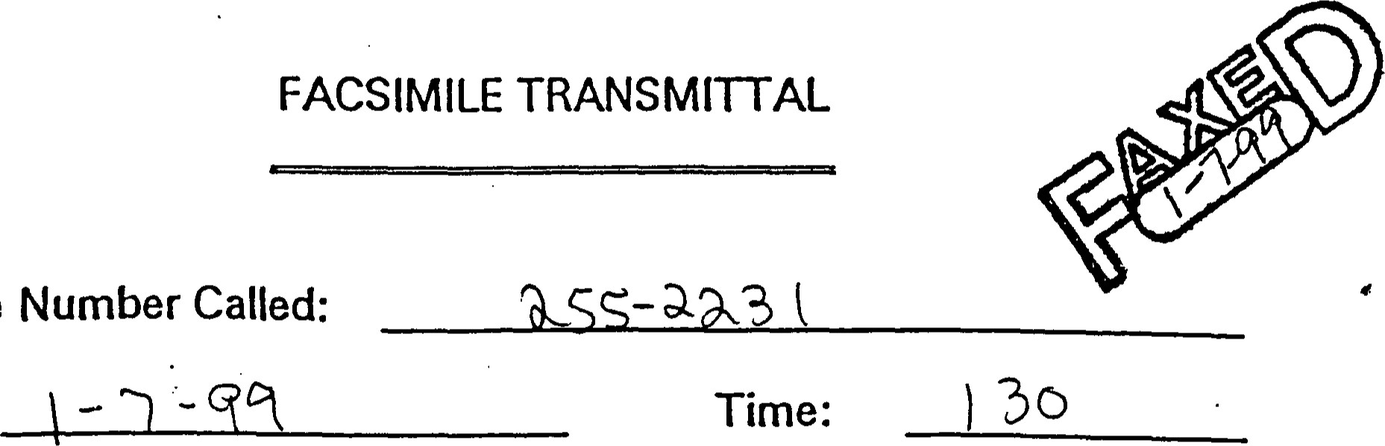Date:
Facsimile
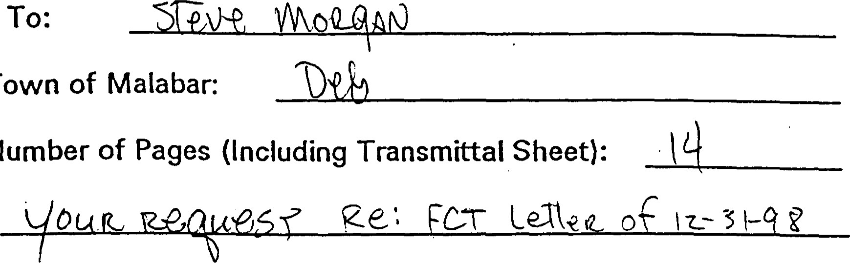
Deliver To:
Town
Total
Number
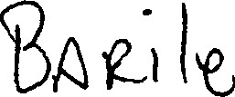
From
(F YOU DO NOT RECEIVE ALL PAGES SHOWN ABOVE, PLEASE CALL 727-7764,
THANK YOU.
IMPORTANT: This message is intended only for the use of the individual or •entity to which it is addressed and may contain information that is privileged, confidential and exempt from the disclosure under applicable law. If the reader of this message is not the intended recipient, you are hereby notified that any dissemination, distribution or copying of this communication is strictly prohibited. If you have received this communi-cation in error, please notify us immediately by telephone and return the originat message to us at the above address via the US Postal Service.

MANAGENENT PLAN
FOR
MALABAR SANCTUARY GREENWAY I AND

BREVARD COUM'Y, FLORIDA
PREPARED FOR THE TOWN OF MALABAR
BY
MARRO RESOURCES COUNCIL OF Easr FLORIDA

SEVI'ENDER 1998

TABLE CONTENTS
1. NTRODUCTION2
A. Combination of Management Plans for
Malabar Sanctuary Greenway I and Il. . ....2 B. Location.... . . . . . . . . . . . . . . . . . . . .
- Resource Description. . . . . . . . .2
    - Land Use...
    - Zoning... . . .
- mstory of the Project.... . . . . . . . . . . . . . . . . . . . . . . . . .
11. PURPOSE OF PROJECT AND MANAGEMENT | 4
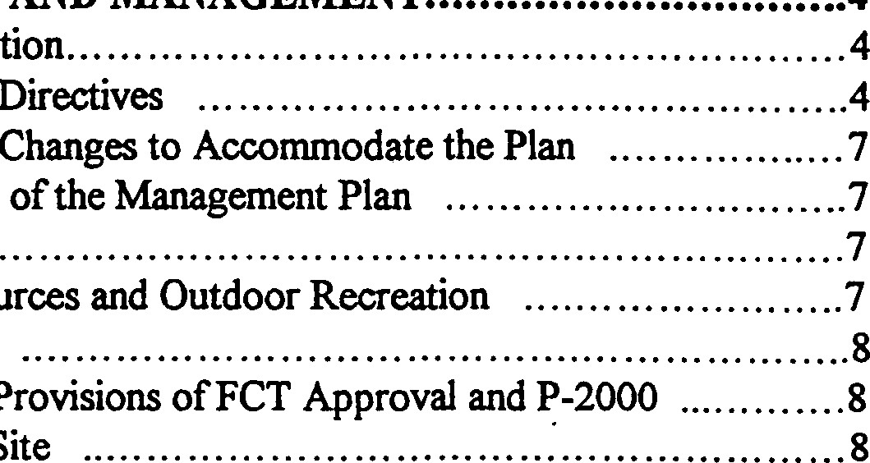
Rationale for Acquisition... . . . . . . . . . .
Comprehensive
Plan
Comprehensive
Plan
Goals
and
Objectives
Natural
Resources
Commitment
to
and
Provisions
B.
C.
D.
1. Acquisition 2.
3. Management E.
Identification of the Site
m. srrE DEVELOPNfENT, DdPROVENfENT AND ACCESS 9
Approvals from FCT B. Existing Improvements
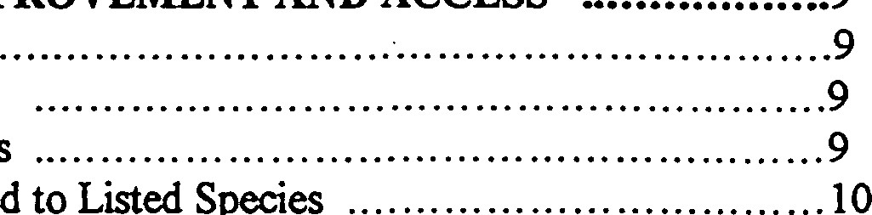
c. Proposed Improvements .
- Land Alterations Related to Listed Species
- Permits Required. . . . . 10
Signage. . 10
. . . . . . ... 1 1
- Parking
- Walking Trails11

3. Bicycling. . . . . . . ... 1 1
4. Bridle Paths11 H. Easements, Concessions and Leases .. . . . . . . . .
1. Notice to FCT of Impending Easements, Concessions or Leases. ...11
MANAGENÆNT ACTIVITIES12
A. Maintenance .. . . . . . . . . 1 2 B. Security12
c. Staffng. . . . . 12 D. Natural Resource Protection... . .13
l. Natural Resource Assets. . ...13 2. Survey - Base Line Plants and Animals.14
TABLE CONTENTS (Continued)
3. Protection of Endangered Species...
- Protection of Imperiled or Critical Imperiled
Vegetative Communities . ...14
- Geological Features . .14
- Protect Surface Water/Groundwater and Hydrology .15
- Prescribed Burns . . . . . 15
D. Resource Restoration and Enhancement.15

- Exotic Plant Removal....15
- Floodplain Wetlands . . . . . . . . . . . . . . . . . . . . . . . . . . . . . . . . . . . . . 1 6
3. Revegetation .....16
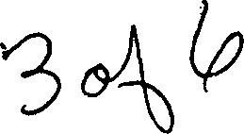
- Archaeological and ffstorical Elements .16
- Coordination of Impacts to and from Adjacent I..andowners . . . . . . . 16
v, COST ESTMATES AND FUNDNG SOURCES 17 A. Cost Estimates . . 17
B. Funding Sources. ...17

VI. PRIORITY SCHEDULE 18

MONITORNG 18
Annual Report 18 B. Ecosystem Viability . . . 18
c. Surveys to Florida Natural Areas Inventory . . . . . . . . . . . . . . . . . . . . . . 1 9 D. Plan Up-date ...19
LIST EXHIBITS
Map of Combined Malabar Sanctuary Greenway I' and Il.
B. 100 Year Floodplain Map of Malabar.
c. Project Plan.

EXHIBIT A
Map of Combined Malabar Sanctuary Greenway I and Il

BEST AVAILABLE COPY
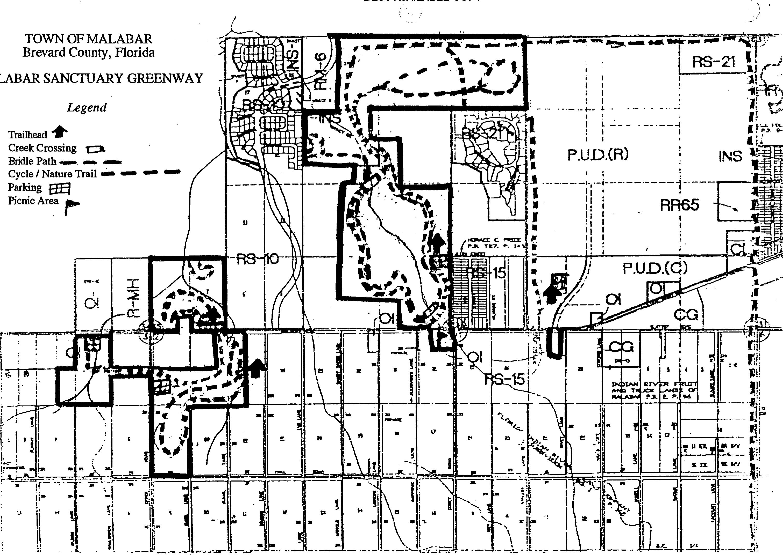

TABLE OF EXHIBITS
MALABAR SANCTUARY GREENWAY
Exhibit A - Relevant Section of Local Comprehensive Plan Elements
Exhibit B -Amendment Proposal to Local Comprehensive Plan
Exhibit C - Master Site Plan Located On USGS 7.4 Minute Quadrangle Map
Exhibit D - Map of Property Boundaries, Access Points, and Acreage
Exhibit E - Aerial Photographs of Project Site
Exhibit F Map of Vegetative Communities on Project Site
Exhibit G - Map of Physical Improvements, Alteration, and Disturbances on
Project Site
Exhibit H - Map of Future Land Use for Project Area
Exhibit I Map of Existing Land use for Project Area
Exhibit J - Map of Public Recreation and Conservation Lands
Exhibit K - Soils Map of Project Site
Exhibit L - Description of any Existing Easements on Project Site
Exhibit M - Description of Hydrology of Project Site Exhibit N - 35mm Color Slides of Project Site Features
Master Site Plan Location on USGS 7.4 minute Quadrangle Maps
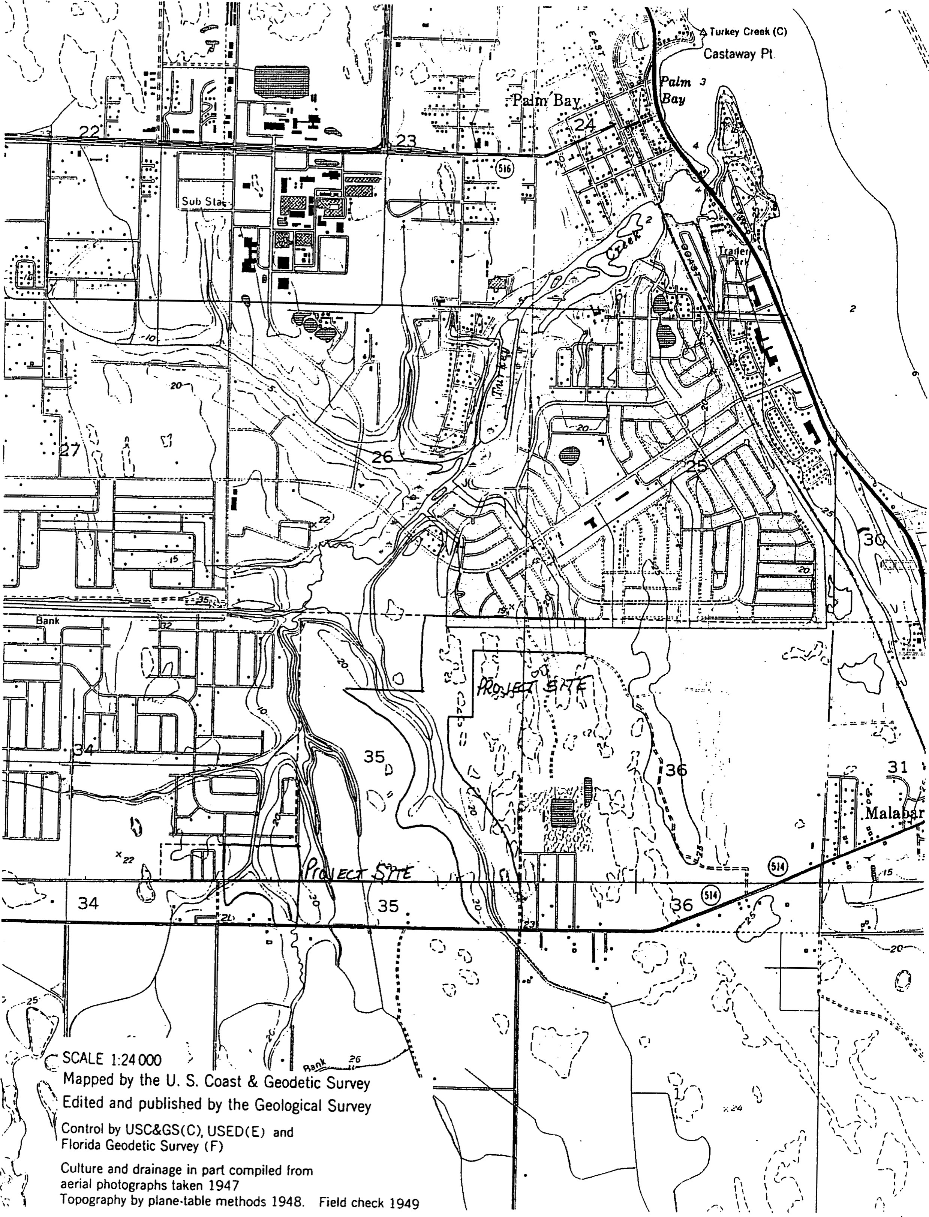
TABLE OF EXHIBITS
MALABAR SANCTUARY GREENWAY
Exhibit A - Relevant Section of Local Comprehensive Plan Elements
Exhibit B - Amendment Proposal to Local Comprehensive Plan
Exhibit C - Master Site Plan Located On USGS 7.4 Minute Quadrangle Map
Exhibit D - Map of Property Boundaries, Access Points, and Acreage
Exhibit E - Aerial Photographs of Project Site
Exhibit F Map of Vegetative Communities on Project Site
Exhibit G - Map of Physical Improvements, Alteration, and Disturbances on
Project Site
Exhibit H - Map of Future Land Use for Project Area
Exhibit I Map of Existing Land use for Project Area
Exhibit J - Map of Public Recreation and Conservation Lands
Exhibit K - Soils Map of Project Site
Exhibit L - Description of any Existing Easements on Project Site
Exhibit M - Description of Hydrology of Project Site Exhibit N - 35mm Color Slides of Project Site Features EXHIBIT C
Master Site Plan Location on Geological Survey 7-1/2 minute Quadrangle

Maps
UNITED STATES SORL E
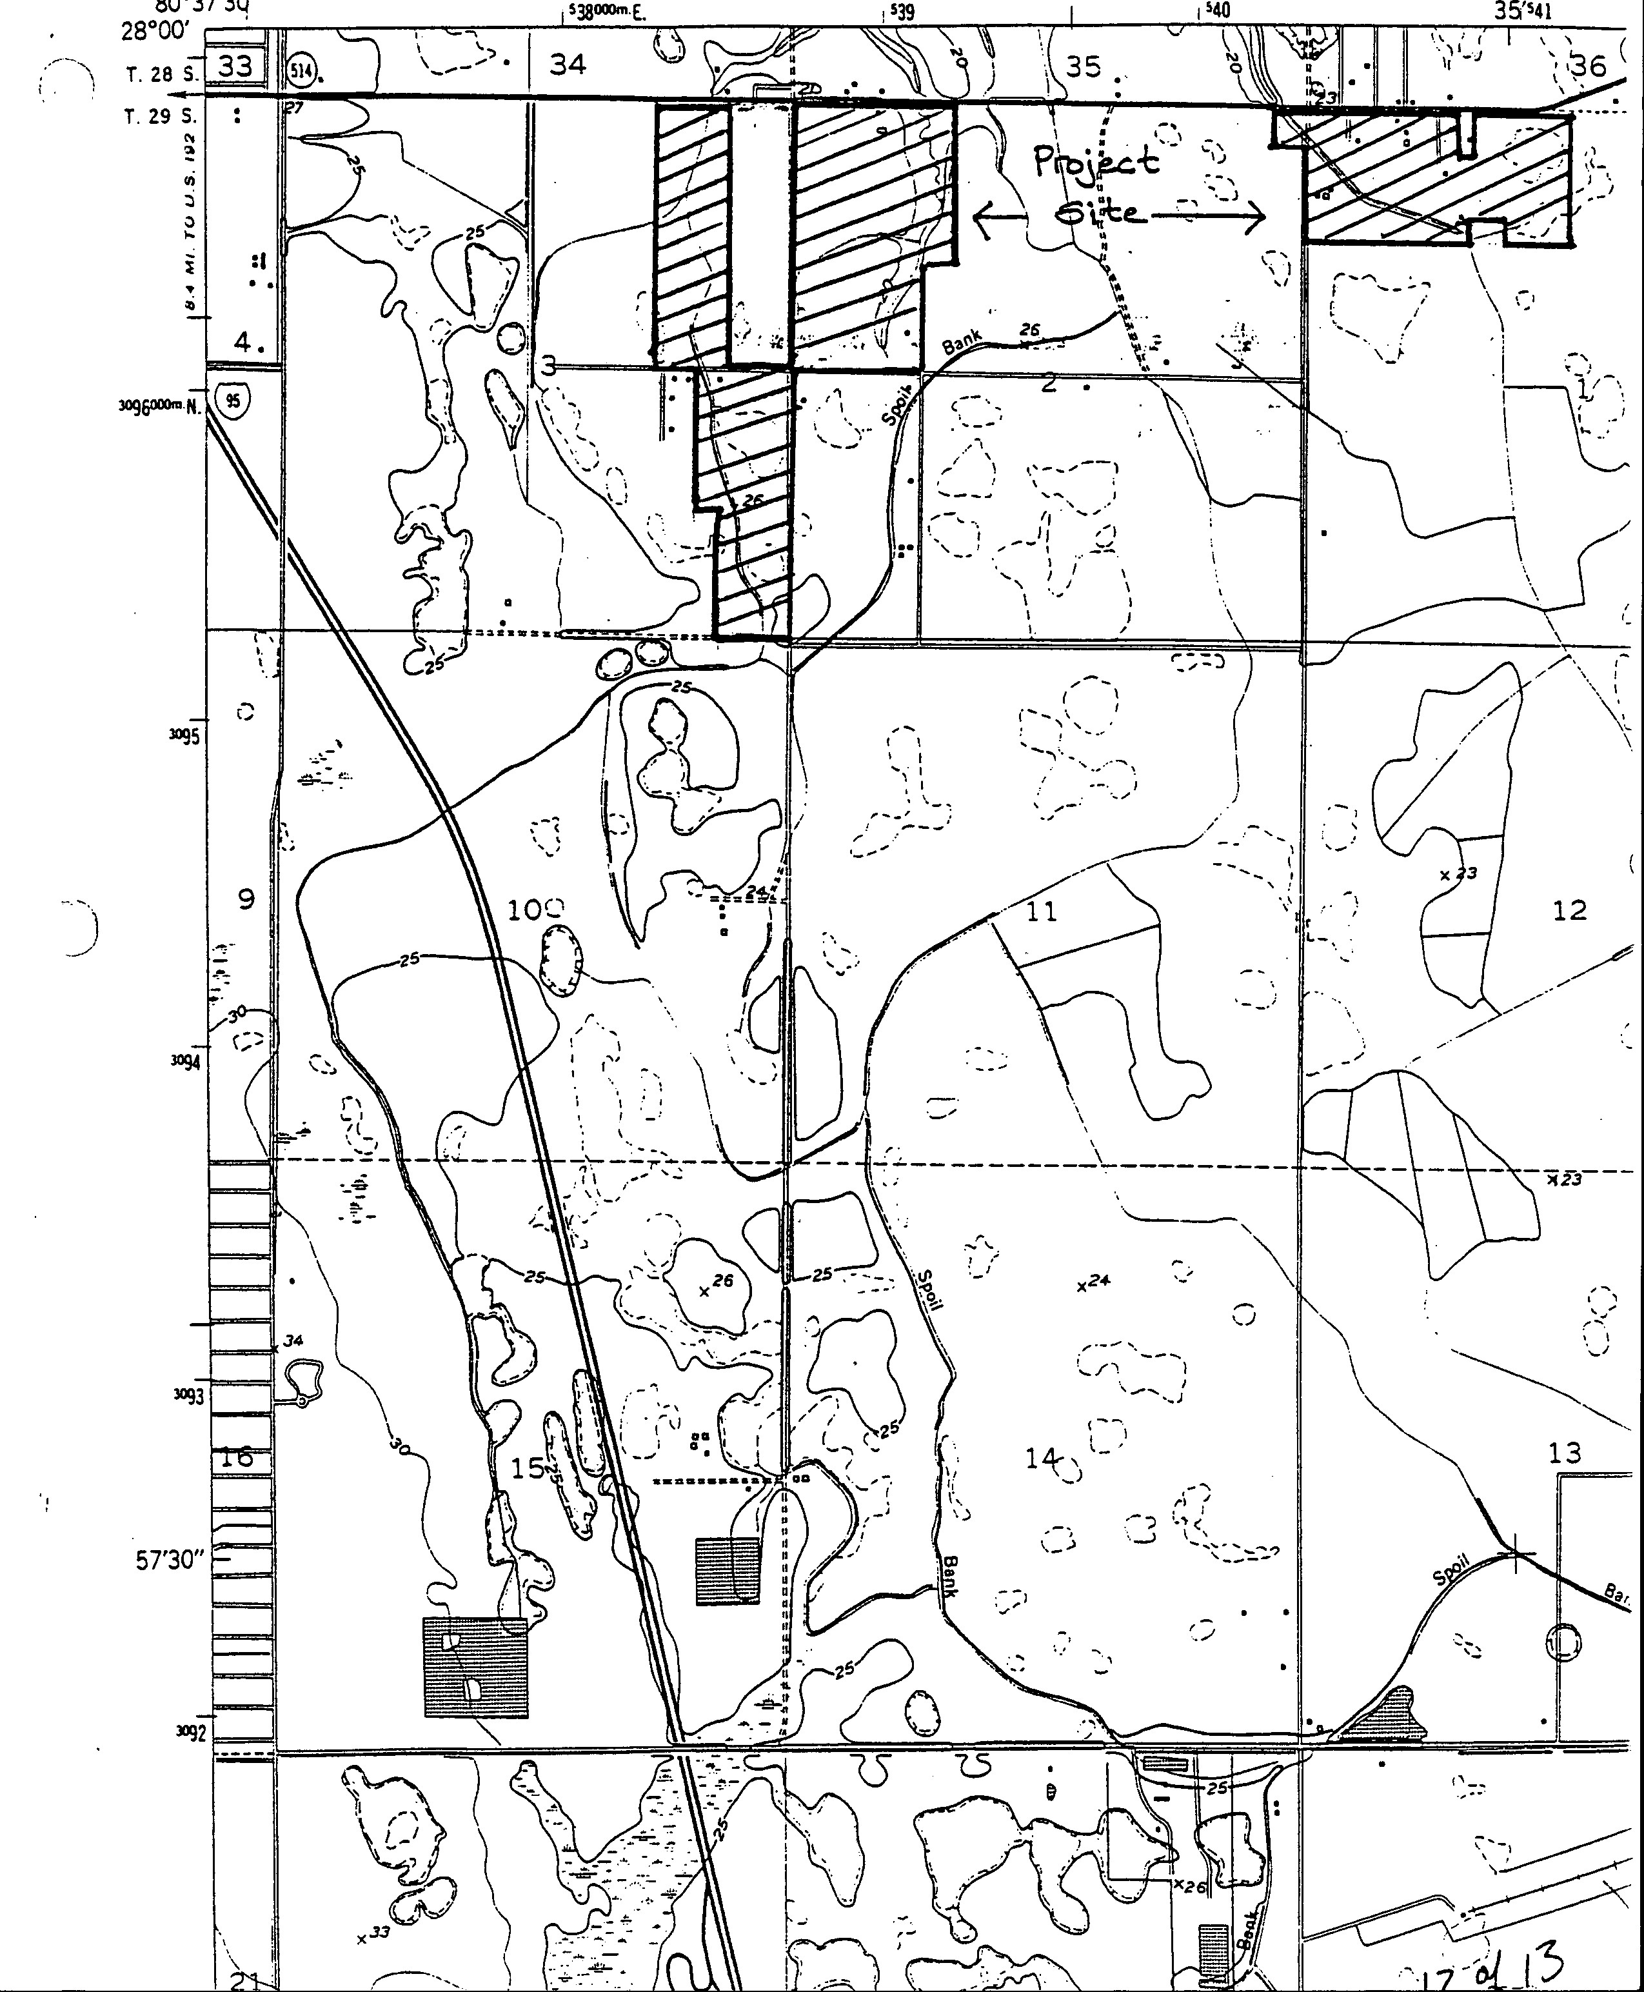
DEPARTMENT OF THE INTERIOR
80037'3Q"
GEOLOGICAL SURVEY

UNITED STATES
DEPARTMENT OF COMMERCE
COAST AND GEODETIC SURVEY
COCOA 28 Mt.
n SE MEL SOURNE 6.2 W. 32'30" R. 37 E. B. 38 E. (MELBOURNE EAST) 31
24 J
North BockY
Pans Cooe
Rock Point
LKA AIRFIELD'
18
1 1
26 X 17
i'
VALKARIA
ISSILE TRACKING

Malabar Greenways
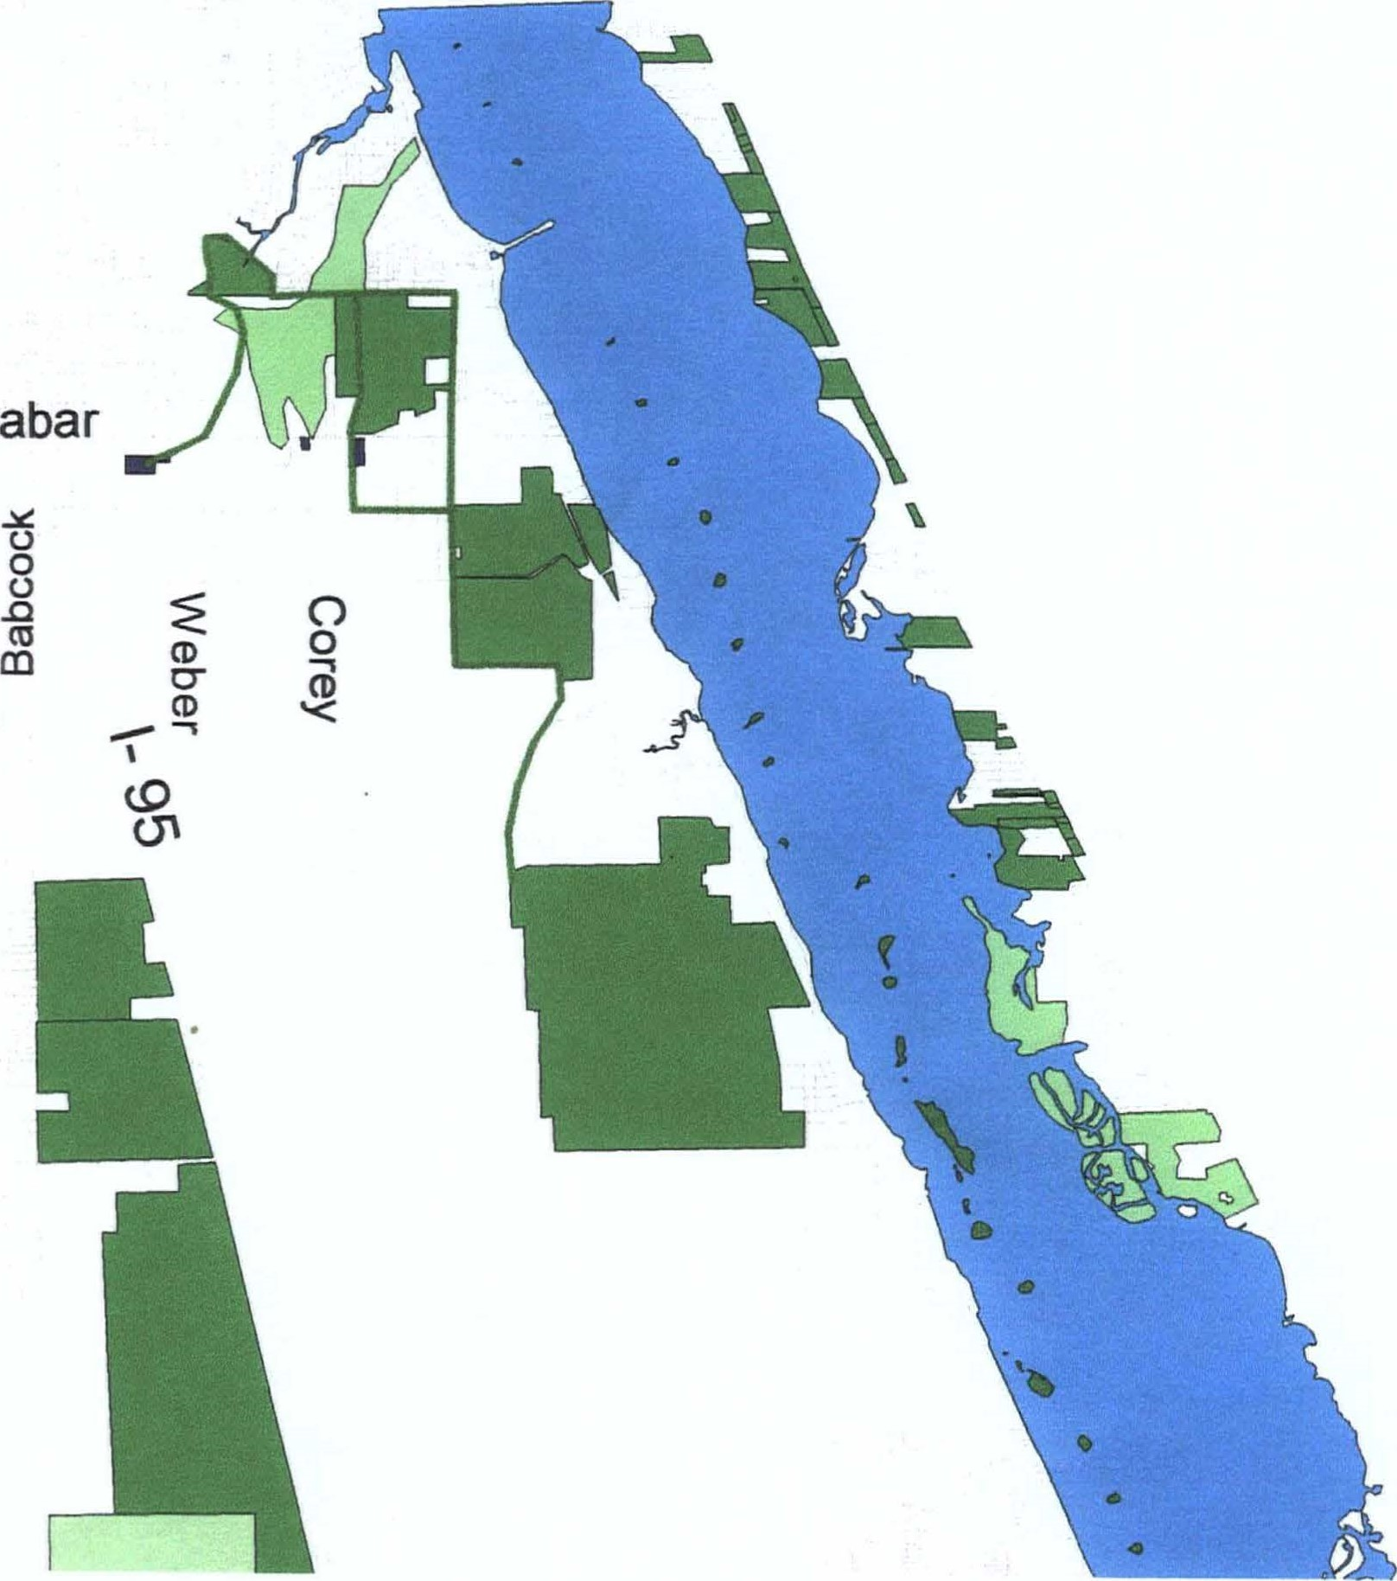
Malabar
Potential Greenway Connectors
Proposed Parcels Conservation Lands
CARL PROJECT
LAND INSIDE AQUATIC PRESERVE BOUNDARY
NATIONAL WILDLIFE REFUGE (Proposed)
STATE-OWNED AQUATIC PRESERVES
WATER MANAGEMENT DISTRICT LAND
[Z] WILDLIFE MANAGEMENT AREA s
Roads
GIS data Source: University of Florida, GeoPIan Center

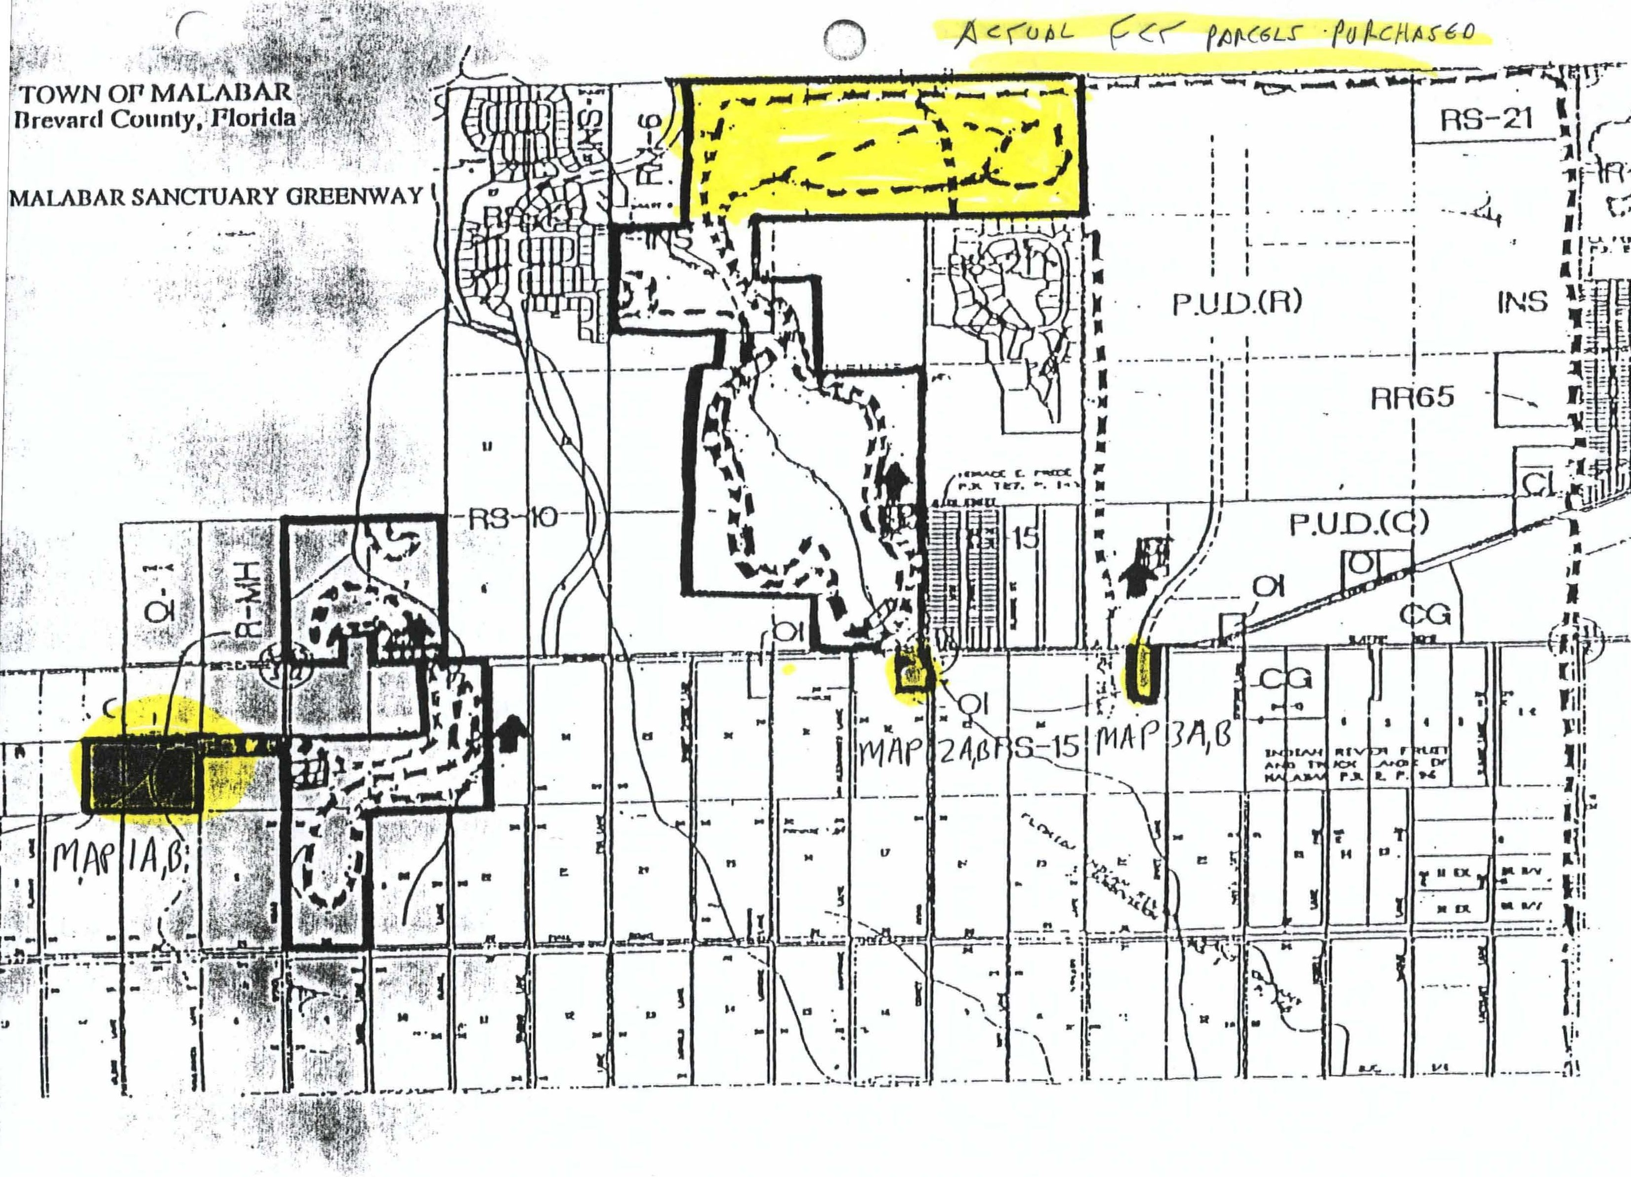

Roa sal.4
CURRENT IA
LEGEND
culvert 01 Project Boundaries
creek
2 2. 20. R/v

SCALE 1" = 150'
RE-SUE/V/S/O* OF F/*ES P/

RR 65
PROPOSED nmovmvENTS MAP#1ß 2
LEGEND
- Boardwalk
E Education _Xiosk signage bike rack trash
// walking and traü creek
Project Boundaries
berm culvert
- 2. n n 20. n/ v
Z' parEng
SCALE 1" =

RE-SVE/V/S/C*

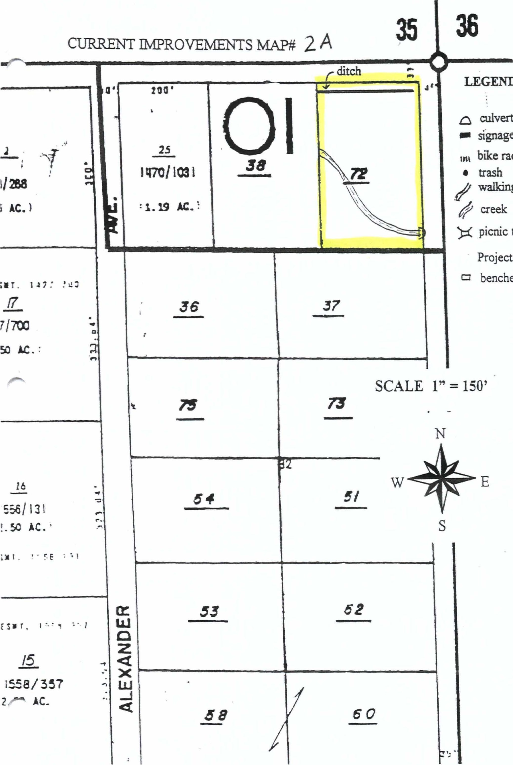
LEGEND
signage
rack
walkng
trail
table
benches
Project
Boundaries
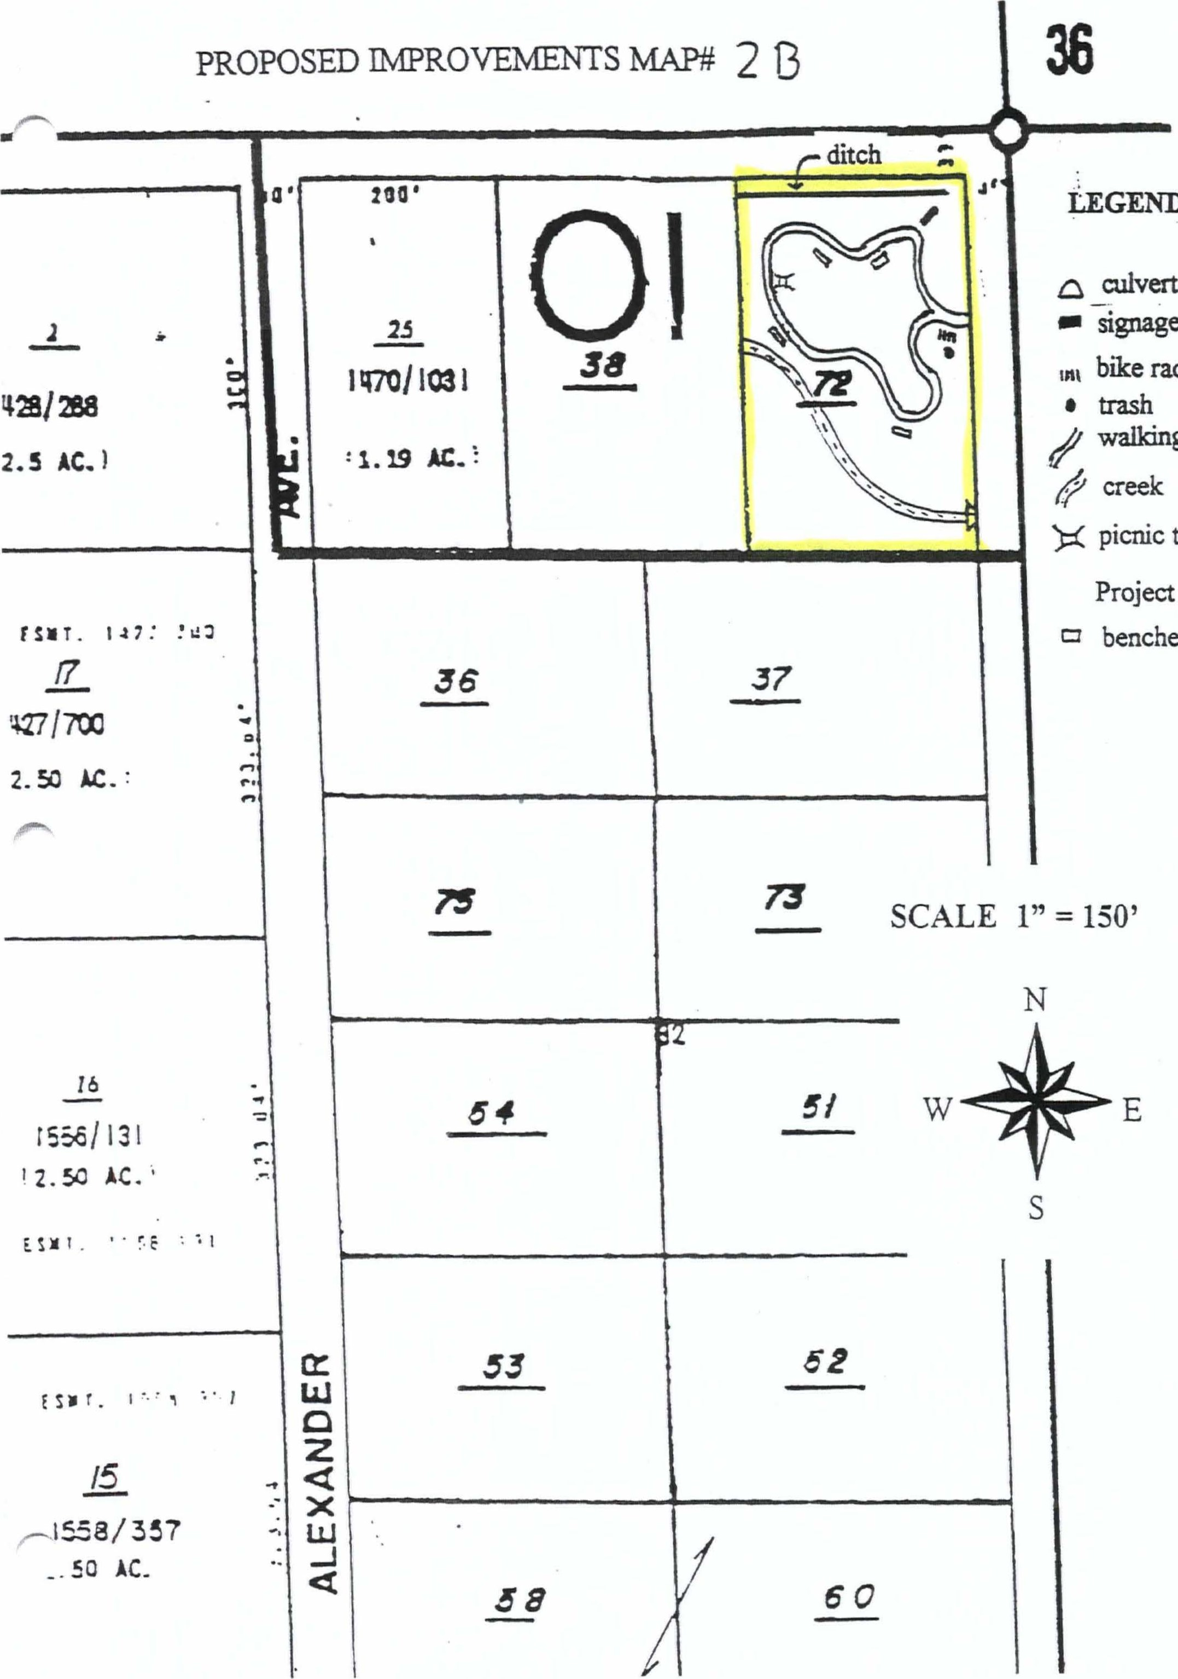
LEGEND
siY1age
rack
walking
trail
table
benches
Project
Boundaries
CURRENT UAP# 3A
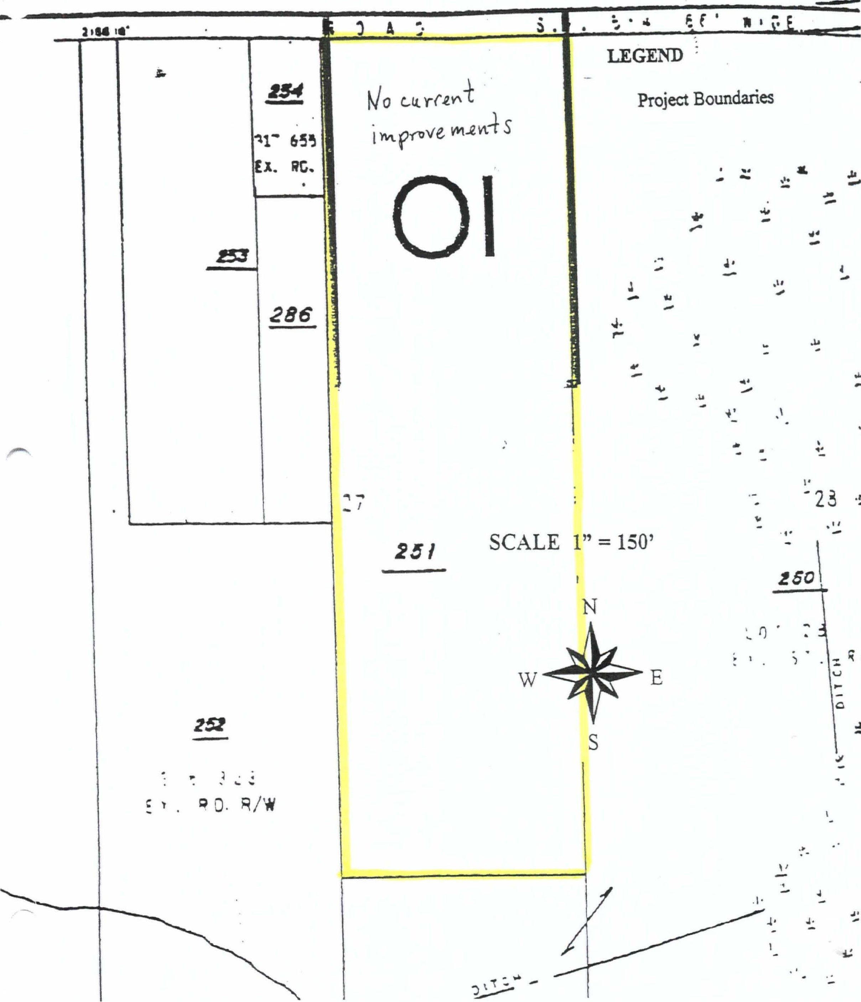
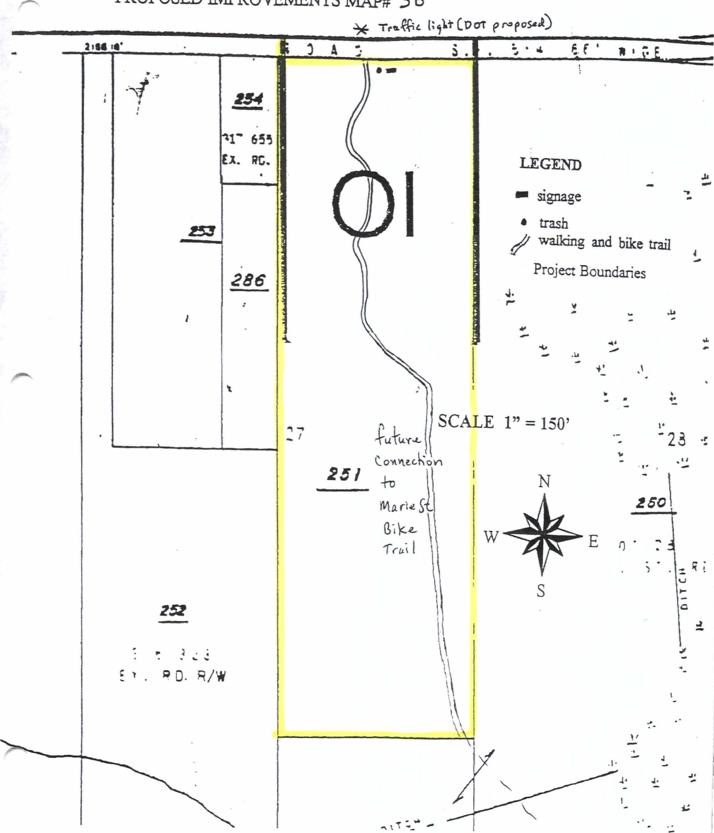
nyQROVQÆNTS
MAP#
3
B
PROPOSED
Jerry Taber /DCA/FLEOC TO bwfree@townofmalabar.org 05/20/2011 02:38 PM cc bcc
Subject Re: Fw: FCT Projects 95-063+56 and 96-019-P7At
Hi Boni,
It was a pleasure talking to you May 19, 201 1 relating to installing a disc golf course on an FCT funded site. For your information, if any resident contacts FCT seeking approval to construct a recreational facility on an FCT funded site, FCT staff would have advised them to contact the Town and then the Town would have to submit a request to FCT for approval to install the recreational facility. We do not recall discussing this matter with Hans Kemmler.
So, if the town wishes to install a disc golf course at the Richard E. Cameron Preserve (aka Malabar Sanctuary Preserve Phase I & Il), the Town of Malabar should make the request in writing and provide a revised Management Plan text. This request must identify the specific word changes (using underline for addition and s#ike-out for deletions, if any) on the affected pages of the Management Plan. Also, the Town must submit a modified master site plan showing the project boundaries and location of the proposed disc golf course along with all other as built facilities.
If you have any other question don't hesitate to call me.
Thanks,
Jerry Taber
Planner IV
Florida Communities Trust
Sadowski Building
2555 Shumard Oak Boulevard
Tallahassee, FL., 32399-2100
Phone (850) 413-8342
Jerry.Taber@dca.state.fl.us
David Copps/DCA/FLEOC
David copps /DCA/FLEOC
05/19/201 1 03:04 PM To Jerry Taber/DCA/FLEOC@fleoc cc
Subject Fw: FCT Projects 95-063-P56 and 96-019-P7A
Jerry, here is the email from Malabar concerning disk golf on an FCT park . I told Bonnie that you are the Planner for that region and gave her your phone number. Thanks, David
David Copps
Florida Communities Trust
2555 Shumard Oak Boulevard
Tallahassee, Florida 32399-2100 850/922-1705 • Fax 850/921-1747 e-mail: David.Copps@dca.state.fl.us www.floridacommunitiestrust.org
- Forwarded by David Copps/DCA/FLEOC on 05/19/201 1 03:02 PM ----"
"Bonilyn
Wilbanks
.org To <david.copps@dca.state.fl.us>
cc "Town Clerk / Treasurer" <townclerk@townofmalabar.org>
Subject FCT Projects 95-063-P56 and 96-019-P7A
David,
Thank you for taking my call today.
Basically we have several concerns which I will highlight by bullets to make it easier to address :
- Resident has stated that he has contacted your offices (Hans Kemmler) regarding the above project land being used as a Disc Golf Park and that you approved the group's use for this conservation land and approved them adding cement pads for each pin of which there are 18 pins. I have attached a photo of the cement pad. Currently only half of the pins have pads. The pins can stand and be used without the cement.
- I know that in the past Ed advised us that they have phone logs maintained for anyone that they spoke to. Our resident will not tell us who he spoke to that gave approval, nor will he provide any written approval documentation for our files.
- If this was to be approved, I believe that the management plan should reflect this use and approval. How would I go about getting that done.
- Last but not least I need to update your records with my name change which is Bonilyn
Wilbanks. I have dropped the Free in my name. Again thanks.
Bonilyn Wilbanks
Town Administrator
Town of Malabar 2725 Malabar Road Malabar, FL 32950
Ph: 321.727.7764 Fax: 321 .722.2234 www.townofmalabar.org
Please Note: Florida has a broad public records law. As a result, any written communication created or received by Town of Malabar officials and employees will be made available to the public and media, upon request, unless otherwise exempt. Under Florida law, e-mail addresses are public records. If you do not want your e-mail address released in response to a public records request; do not send electronic mail to this office. Instead, contact our office by phone or in writing.

CFN•.2000171482 09-07-2000 07:51 am OR BooWPage•. 4215 / 3064 This document prepared by:
Ann J. Wild
Florida Cornrnunities Trust Sandy Crawford
Department of Community Affairs Clerk Of Courts, Brevard County
2555 Shumard Oak Blvd. #Names: 2
Tallahassee, FL 32399 Trust: 6.000.00 Rec: 45.00Excise: Sex. 0.000.00
Deed:
Mtg: 0.00 Int Tax: 0.00
FLORIDA CQMUNITIES TRUST
P8A AWARD* 95-063-P56
ECT
GRANT AWARD AGREEMENT
THIS AGREEMENT is entered into this 7 — day of 2000, by and between the FLORIDA COI^{v}NUNITiES TRUST ( " FCT 't ) a nonregulatory agency within the State of Florida Department of Cort-muni ty Affairs, and TOWN OF MALABAR, a political subdivision of the State of Florida ( "FCT Recipient " ) , in order to impose terms , conditions, and restrictions on the use of the proceeds of certain bonds, hereinafter described, and the lands acquired with such proceeds and as described in Exhibit 'I A " attached hereto and made a part hereof ( " Project Site" ) , as shall be necessary to ensure compliance with applicable Florida Law and federal income tax law and to otherwise implement provisions of Chapters 253 259, and 380, Florida Statutes .
WHEREAS, Part Ill Chapter . 380, Florida Statutes, the Florida Communities Trust Act, creates a nonregulatory agency within the Department of Com,rnuni ty Af fairs , which will assi st local governments in bringing into compliance and implementing the conservation, recreation and open space, and coastal elements of their comprehensive • plans and in otherwise conserving natural resources and resolving land use conflicts by providing financial assistance to local governments to carry out proj ects and activities authorized by the Florida Communities Trust Act;
WHEREAS , Section 1 of the Florida Preservation 2000 Act provides for the distribution of ten percent (10%) of the net Preservation 2000 Revenue Bond proceeds to the Department of Cortununity Affairs to provide land acquisition grants and loans to local governments through the FCT;
WHEREAS , the Governor and Cabinet authorized the sale and issuance of State of Florida Department of Natural Resources Preservation 2000 Revenue Bonds ( " Bonds " ) •
WHEREAS, the Bonds were issued as tax-exempt bonds, meaning that the interest on the Bonds is excluded from the gross income of Bondholders for federal income tax purposes;
WHEREAS, Rule 9K-4.010 (2) (f) , F.A.C. , authorizes FCT to impose conditions for funding on those FCT applicants Whose projects have been selected for funding in accordance with Rule Chapter 9K—4 , F.A. C. ;
WHEREAS, the FCT has approved the terms under which the Proj ect site is acquired and the deed whereby the FCT Recipient acquires title to the proj ect Site shall contain such covenants and restrictions as are sufficient to ensure that the use of the Project Site at all tines complies with section 375. 051, Florida Statutes and Section 9, Article X 11 of the State constitution and shall contain clauses providing for the conveyance of title to the Proj ect Site to the Board of Trustees of the Internal Improvement
Trust Fund upon the failure of the FCT Recipient to use the Proj ect Site acquired thereby for such purposes; and
WHEREAS, such covenants and restrictions shall be imposed by an agreement which shall describe with particularity the real property which is subj ect to the agreement and shall be recorded in the county in which the real property is located; and
WHEREAS, the purpose of this Agreement is to set forth the covenants and restrictions that are irnposed on the Proj ect Site subsequent to its acquisition with the FCT Preservation 2000 Bond award .
NOW THEREFORE, in consideration of • the mutual covenants and undertakings set forth herein, and other good and valuable consideration, the receipt and sufficiency of which is hereby acknowledged, FCT and FCT Recipient do hereby contract and agree as follows:
- GENERAL CONDITIONS.
1 . Upon execution and delivery by the parties hereto, the FCT Recipient shall cause this Agreement to be recorded and filed in the official public records of Brevard County, Florida, as referenced in the warranty deed vesting fee simple title to the Proj ect site in the FCT Recipient, and in such manner and in such other places as FCT nay reasonably request, and shall pay all fees and charges incurred in connection therewith.
- The FCT Recipient and FCT agree that the State of Florida Department of Environmental Protection will forward this Agreement to Department of Environmental Protection Bond Counsel for review. In the event Bond Counsel opines that an amendment is required to this Agreement so that the tax exempt status of the Preservation
CAA \ 95-063-P56
CFN:2000171482
3065
OR BookJPage:
2000 Bonds is not jeopardized, FCT and FCT Recipient shall amend the Agreement accordingly.
- . This Agreement may be amended at any tine. Any amendment rnust be set forth in a written instrument and agreed to by both the ECT Recipient and FCT.
- This Agreement and the covenants and restrictions contained herein shall run with the Property herein described and shall bind, and the benefits shall inure to, respectively, the FCT and the FCT Recipient and their respective successors and assigns .
- This Agreement shall be governed by and construed in accordance with the laws of the State of Florida, with respect to both substantive rights and with respect to procedures and remedies .
Any notice required to be given hereunder shall be given by personal delivery, by registered mail or by registered expedited service at the addresses specified below or at such other addresses as may be specified in writing by the parties hereto, and any such notice shall be deemed received on the date of delivery if by personal del i very or expedited delivery service, or upon actual receipt if sent by registered nail.
FCT : Florida communities Trust
Department of Community Affairs
2555 Shumard Oak Blvd.
Tallahassee, FL 32399-2100
FCT Recipient: 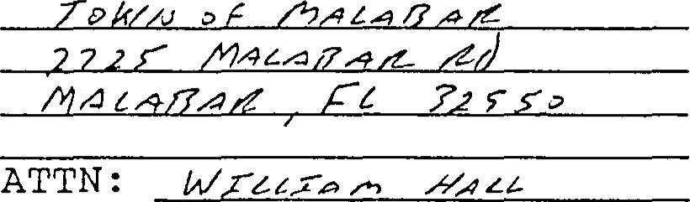
ATTN:
Executive
Director
If any provision of the Agreement shall be invalid, illegal or unenforceable, the validity, legality and enforceability of the remaining provisions shall not in any way be affected or impaired .
11. PROJECT SITE REQUIREMENTS IMPOSED BY CHAPTER 259, CHAPTER 375, CHAPTER 380, PART 111, FLORIDA STATUTES.
- . If any essential term or condition of this grant agreement is violated by the FCT Recipient or by some third party with the knowledge of the FCT Recipient and the FCT Recipient does not correct the violation within 30 days of notice of the violation, fee simple title to all interest in the Proj ect Site shall be conveyed to the Board of Trustees of the Internal
CFN:2000171482
3066
BooWPage:

Improvement Trust Fund . The FCT shall treat such property in accordance with Section 380.508 (4) (e) , Florida Statutes.
- Any transfer of the Project Site shall be subject to the approval of FCT and FCT shall enter into a new agreement with the transferee , containing such covenants , clauses, or other restrictions as are sufficient to protect the interest of the people of Florida.
- . The interest, if any, acquired by the FCT Recipient in the Project site will not serve as security for any debt of the FCT Recipient unless FCT approves the transaction .
- . If the existence of the FCT Recipient terminates for any reason, title to all interest in real property it has acquired with the FCT award shall be conveyed to the Board of Trustees of the Internal Improvement Trust Fund, unless FCT negotiates an agreement with another local government or nonprofit organization which agrees to accept title to all interest in and to manage the Proj ect Site.
- In the event that the Proj ect Site is damaged or destroyed or title to the Project Site, or any part thereof, is taken by any governmental body through the exercise or the threat of the exercise of the power of eminent domain, the FCT Recipient shall deposit with the FCT any insurance proceeds or any condemnation award, and shall promptly commence to rebuild, replace, repair or restore the Project site in such manner as is consistent with the Agreement. The FCT shall make any such insurance proceeds or condemnation award moneys available to provide funds for such restoration work. In the event that• the FCT Recipient fails to commence or to complete the rebuilding, repair, replacernent or restoration of the Proj ect Site after notice from the FCT, the FCT shall have the right, in addition to any other remedies at law or in equity, to repair, restore, rebuild or replace the Project Site so as to prevent the occurrence of a default hereunder.
Notwithstanding any of the foregoing, FCT will have the right to seek specific performance of any of the covenants and restrictions of this Agreement concerning the construction and operation of the Project Site.
111. PROJECT SITE OBLIGATIONS IMPOSED BY ECT ON FCT RECIPIENT.
1 . The Proj ect Site shall be managed only for the conservation, protection and enhancement of natural and historical resources and for passive, natural resource—based public outdoor recreation which is compatible with the conservation, protection and enhancement of the proj ect site, along with other related uses necessary for the accomplishment of this purpose . The proposed
CFN:2000171482

3067
uses for the Project site are specifically designated in the Proj ect Plan as approved by FCT.
- . The FCT Recipient shall prepare and submit to FCT an annual report as required by Rule 9K—4 . 013, F . A. C.
- . The FCT Recipient shall ensure that the future land use designation assigned to the Proj ect Site is for a category dedicated to open space, conservation, or outdoor recreation uses as appropriate . if an amendment to the FCT Recipient s comprehensive plan is required to comply with this paragraph, the amendment shall be proposed at the next comprehensive plan amendment cycle available to the FCT Recipient .
- . FCT Recipient shall ensure, and provide evidence thereof to FCT, that all activities under this Agreement comply with all applicable local, state, regional and federal laws and regulations, including zoning ordinances and the adopted and approved comprehensive plan for the jurisdiction as applicable. Evidence shall be provided to FCT that all required licenses and permits have been obtained prior to the commencement of any construction.
- . The FCT Recipient shall , through its agents and employees, prevent the unauthorized use of the Project Site or any use thereof noe in conformity with the FCT approved project plan.
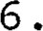FCT staff or its duly authorized representatives shall have the right at any time to inspect the Project Site and the operations of the FCT Recipient at the Proj ect Site.
All buildings, structures, improvements, and signs shall require the prior written approval of F CT as to purpose. Further, tree removal, other than non—native species, and/or major land alterations shall require the written approval of FCT. The approvals required from FCT shall not be unreasonably with—held by FCT upon sufficient demonstration that the proposed structures, buildings , improvements , signs , vegetation removal or land alterations will not adversely impact the natural resources of the Proj ect Site. The approval by FCT of the FCT Recipient s management plan addressing the items mentioned herein shall be considered written approval from FCT.
- . If archaeological and historic sites are located on the proj ect site, the FCT Recipient shall comply with Chapter 267 , Florida Statutes. The collection of artifacts from the Project Site or the disturbance of archaeological and historic sites on the Project Site will be prohibited unless prior written authorization has been obtained from the Department of State, Division of Historical Resources.
CFN:2000171482
BooWPage: 3068
- . The FCT Recipient shall ensure that the Proj ect Site is identified as being publicly owned and operated as a passive, natural resource—based public outdoor recreational site in all signs, literature and advertising regarding the Proj ect Site. The FCT Recipient shall erect a sign (s) identifying the Proj ect Site as being open to the public and as having been purchased with funds from FCT and FCT Recipient.
IV. OBLIGATIONS INCURRED BY FCT RECIPIENT RESULT OF BOND PROCEEDS BEING UTILIZED TO PURCHASE THE PROJECT SITE.
- . If the Proj ect Site is to remain subj ect, after its acquisition by the State and the FCT Recipient, to any of the below listed activities or interests, the FCT Recipient shall provide at least 60 days written notice of any such activity or interest to FCT prior to the activity taking place, and shall provide to FCT such inforrnation with respect thereto as FCT reasonably requests in order to evaluate the legal and tax con—sequences of such activity or interest:
any lease of any interest in the Project site to a non—governmental person or organization;
  - the operation of any concession on the Proj ect Site to a non—governmental person or organization;
  - any sales contract or option to buy things attached to the Project Site to be severed from the Project Site, with a non—governmental person or organization;
  - any use of the Proj ect Site by non—governmental persons other than in such person's capacity as a member of the general public;
a management contract of the Proj ect Site with a non—governmental person or organization; and
  - such other activity or interest as may be specified from time to time in writing by FCT to the FCT Recipient.
- . FCT Recipient agrees and acknowledges that the following transaction, events, and circumstances rnay not be permitted on the Project Site as they may have negative legal and tax consequences under Florida law and federal income tax law:
  - a sale of the Project Site or a lease of the Project Site to a non—governmental person or organization;
  - the operation of a concession on the Proj ect Site by a non—governmental person or organization;
CFN•.20C0171482
3069

c. a sale of things attached to the Project site to be severed from the Proj ect Site to a non—governmental person or organization;
d. any change in the character or use of the Proj ect Site from that use expected at the date of the issuance of any series of bonds from which the disbursement is to be made;
any use of the Proj ect site by non—governmental persons other than in such person's capacity as a member of the general public;
  - a management contract of the Proj ect site with a non—governmental person or organization; and
such other activity or interest as may be specified from time to time in writing by FCT to the FCT Recipient.
DELEGATIONS AND CONTRACTUAL ARRANGEMENTS BETWEEN THE FCT RECIPIENT AND OTHER GOVERNMENTAL BODIES, NOT FOR PROFIT ENTITIES, OR NON GOVERNMENTAL PERSONS FOR USE OR MANAGEMENT OF THE PROJECT SITE WILL IN NO WAY RELIEVE THE FCQ RECIPIENT OF THE RESPONSIBILITY TO ENSURE THAT THE CONDITIONS IMPOSED HEREIN ON THE PROJECT SITE AS A RESULT OF UTILIZING BOND PROCEEDS TO ACQUIRE THE PROJECT SITE ARE FULLY COMPLIED WITH BY THE CONTRACTING PARTY .
CONDITIONS ARE PARTICULAR TO PROJECT SITE A RESULT OF THE PCT APPROVED MANAGEMENT PLAN.
- . The FCT Recipient shall provide outdoor recreational facilities including nature trails, bridle paths , interpretive signage and scenic overlooks on the Proj ect Site. The facilities shall be developed in a manner that allows the general public reasonable access for observation and appreciation of the significant natural resources on the Proj ect Site without causing harm to those resources .
- . The timing and extent of a vegetative communities and plant species survey of the Project site shall be specified in the management plan. The FET Recipient shall detail how the survey shall be used during development of the site to insure the protection, restoration, and preservation of the natural resources on the Project Site.
- . The sand pine scrub, blackwater creek, xeric hardwood, hydric hammock and depress ional wetlands that exist on the Project Site shall be preserved and appropriately managed to ensure the long—term viability of these vegetative communities .
- . The Proj ect Site shall be managed in a manner that optimizes habitat for listed wildlife species that utilize or could
potentially utilize the Project site, including the scrub jay, alligåtor, gopher tortoise, indigo snake and wading birds. The FCT Recipient shall coordinate with the Came and Freshwater Fish commission on the management of the Proj ect on the management of the Proj ect Site for the protection of listed species and listed species habitat. The FCT Recipient shall also conduct periodic surveys of listed species using the Proj ect Site and develop informational signs relating to the protection of listed animal species and their habitat.
- . The FCT Recipient shall ensure that the Project Site and listed animal species and their habitat are sufficiently buffered from the adverse impacts of adj acent land uses .
The FCT Recipient shall restore 6 acres of the Proj ect Site by removing exotic vegetation and replanting with native vegetative species .
The FCT Recipient shall remove improperly placed fill from the Project Site and install culverts to restore the natural hydrology of the site. The FCT Recipient shall coordinate with the St. Johns River Water Management District in the development and implementation of a stormwater management and hydrologic restoration plan for the Proj ect Site.
8 . The FCT Recipient shall coordinate the management of the Proj ect Site with the adjacent Turkey Creek Sanctuary Park and develop a greenway management strategy designed to link local and regional conservation and recreation lands.
A vegetation analysis of the Proj ect site shall be performed to determine which areas of the Proj ect Site need a prescribed burning regime implemented to maintain natural fire— dependent vegetative communities . The FCT Recipient shall coordinate with Division of Forestry and Game and Fresh Water Fish Commission on the development of a prescribed burn plan for the Proj ect Site.
- Prior to the commencement of any proposed development activities, measures will be taken to determine the presence of any archaeological sites . All planned activities involving known archaeological sites or potential site areas shall be closely coordinated with the Department of State, Division of Historic resources , in order to prevent the disturbance of significant sites .
- Access to the Project Site by pedestrians, bicyclists and persons on non—motorized vehicles shall be promoted except in those areas where resource protection considerations warrant liniting access .

CFN:2000171482 3071
Book]Pagei 4215
12 . The requirements imposed by other grant program funds that may be sought by the FCT Recipient for activities associated with the Proj ect Site shall. not conflict with the terms and conditions of the FCT award.
THIS GRANT AWARD AGREEMENT embodies the entire Agreement between the parties.
IN WITNESS WHEREOF, the parties hereto have duly executed this Agreement .
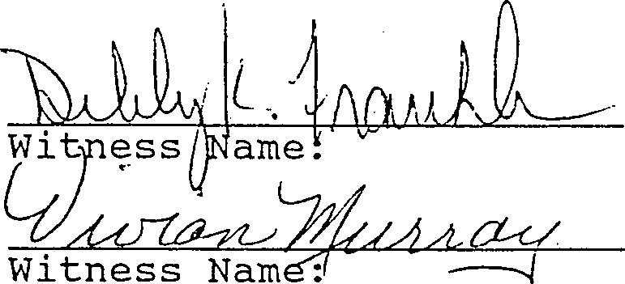
Witness: 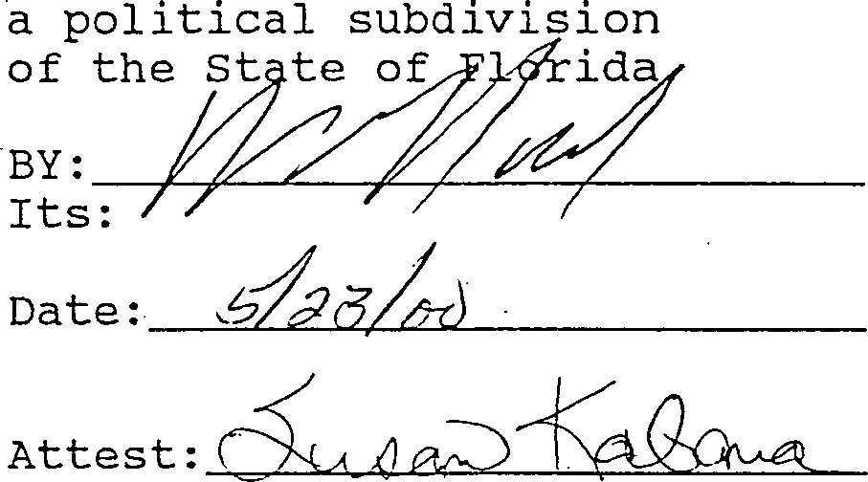
TOWN
OF
MALABAR
Clerk
Accepted as to Legal Forrn and Sufficiency :

Date :

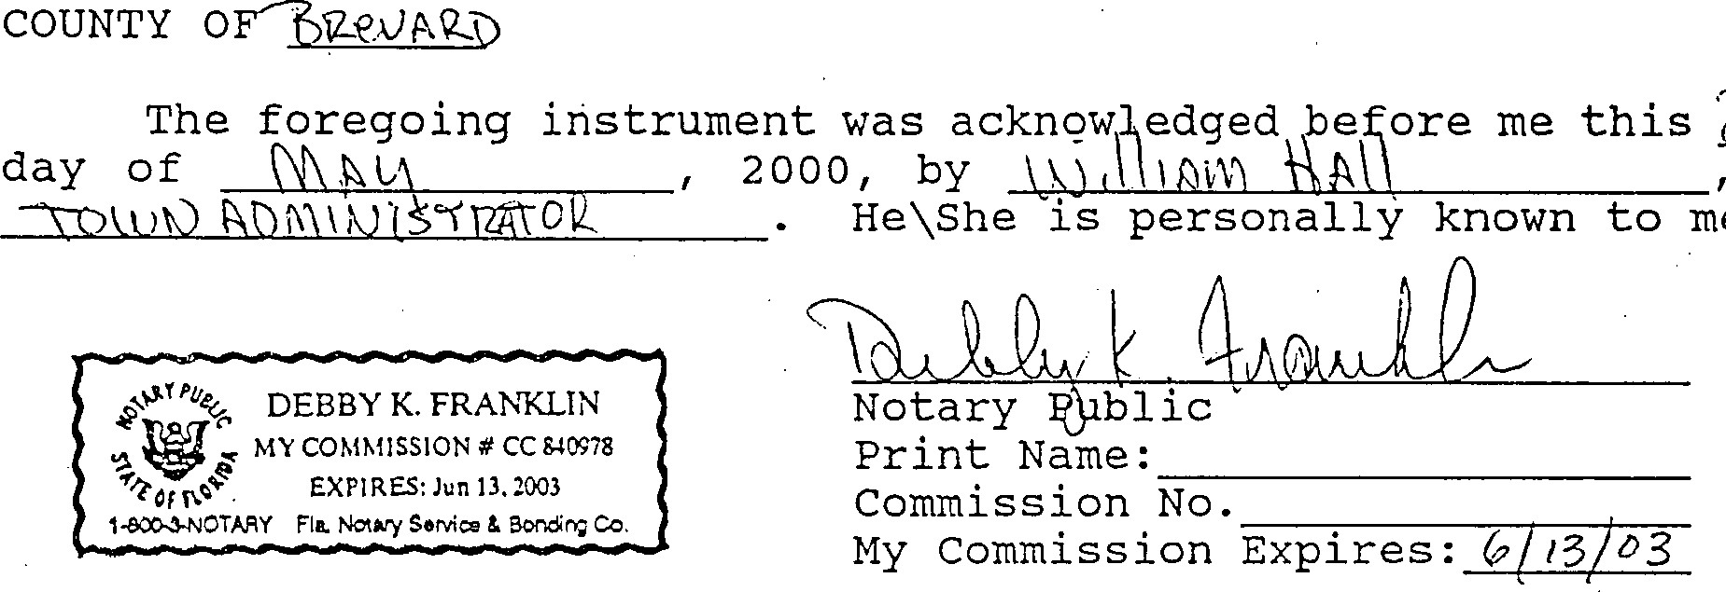as
z_
me.
STATE
OF
FLORIDA

CFN:20001714824215 / 3072
Book]? age:

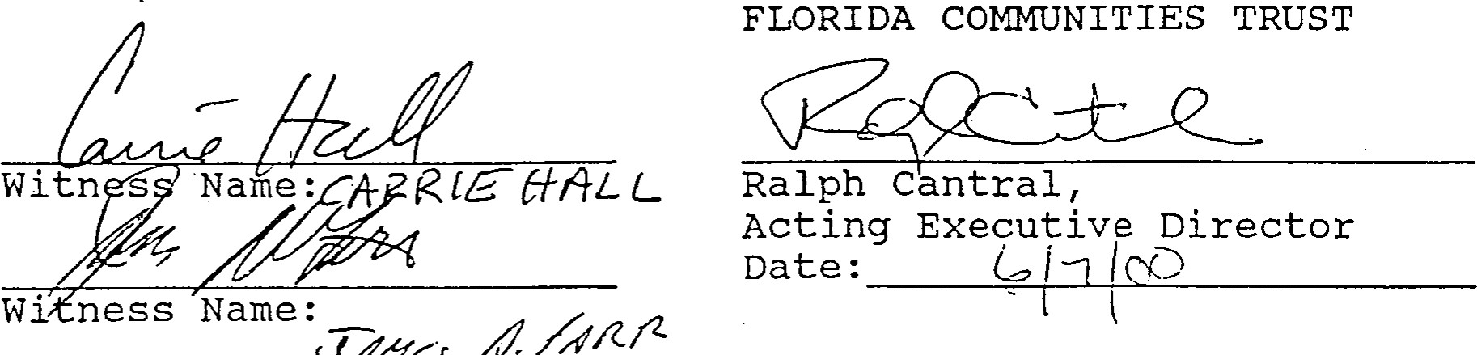
7,
(J
78<j
Accepted as to Legal Form and
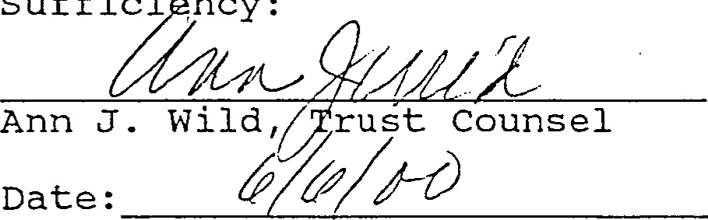
suffici
ncy:
STATE OF FLORIDA
COUNTY OF LEON
The foregoing instrument was acknowledged before me this -7
day Of 2000, by Ralph Cantral , as Acting Executive Director of the Florida Communities Trust . He is personally known to me.
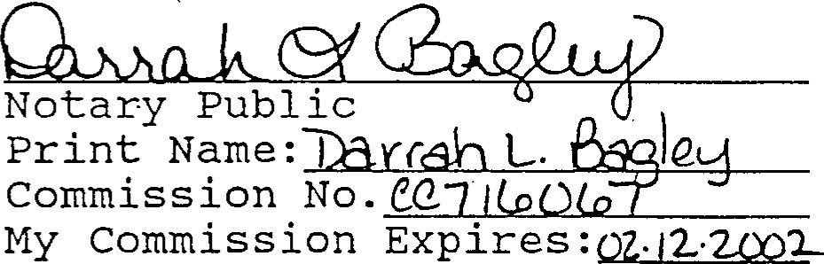
DARRAH L. BAGLEY o # cc n 6067 fil EXPIRES FEB 12, 2002 44 BONDED THRU
ATLANTIC BONDING CO., INC.
CFN.20001 71482
OR Book]Page: 4215 / 3073
EXHIBIT "A"
The Northwest one—quarter (1/4) of the Northeast one—quarter (1/4) of section 35, Township 28 South, Range 37 East, Brevard County, Florida .
LESS AND EXCEPT:
The West one—half (1/2) of the Northwest one-quarter (1/4) of the Northeast 1/4) of Section 35, Township 28 South, Range 37 East, Brevard County, Florida.
AND ALSO:
The Northwest one—quarter (1/4) of the Northwest one—quarter (1/4) , Section 36, Township 28 South, Range 37 East, Brevard County , Florida, a l kl a Lots 25 and 26 of FLORIDA INDIAN RIVER LAND COMPANY, according to the plat thereof, as recorded in Plat Book 1, Page 164, of the Public Records of Brevard County, Florida.
AND ALSO:
The East of Lot 31 and the East 1 of the Northeast 1/4 of the Northeast 1/4 in Section 35, Township 28 South, Range 37 East, (a/k/a Lot 32) , all lying in Florida Indian River Land Company Subdivision, in Section 35, Township 28 South, Range 37 East as recorded in Plat Book 1, Page 164 of the Public Records of Brevard County, Florida.
AND ALSO:
West half of Lot Thirty-One (W 1/2 of Lot 31) , in Section Thirty—
Five (35) , Township Twenty—Eight (28) South, Range Thirty—seven (37) East, as located and described upon and by the map of the subdivision of the lands of Florida-Indian River Company, in Plat Book 1, Page 164, located in the Brevard County, Florida.
CFN•2000i714824215
3074
1
OR BookJPage.
FCT/P2000-56 STAFF EVALUATION REPORT--Summary
PROJECT NAME: Malabar Sanctuary Greenway 95-063-P56
LOCAL GOVERNMENT APPLICANT: Town of Malabar
NAMES OF OTHER APPLICANTS IF A PARTNERSHIP: N/A
ESTIMATED PROJECT COST: $1, 119,299
AMOUNT OF AWARD REQUESTED: $1, 119,299
LOCAL MATCH: $0
The Town of Malabar is requesting a 100 percent FCT award. The
April 1, 1994, population estirnate for the Town of Malabar was
2, 255. (Source: University of Florida, Bureau of Economic and Business Research)
The Town of Malabar qualifies for an unmatched grant as a small local government according to Rule 9K—4 . 0031 (6) (c) , F.A.C.
ACREAGE: 123.4
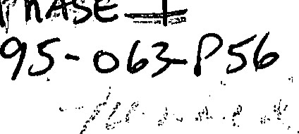
JUVENILE PROGRAM COMPONENT: No
COMPREHENSIVE PLAN STATUS: In—compliance
PROJECT SCORES BY EVALUATION CATEGORY
- Furtherance of Growth Managernent 65
Note: Pursuant to Rule 9K-4 . 010 (2) (c) , F.A.C., the score in this section, when finalized, will be adjusted upward by a factor of 1 .5.
- Furtherance of Natural Resource conservation,
Coastal Protection, and Outdoor Recreation 80
- Innovative, Unique, and Outstanding Features 15 PROJECT SUMMARY:
The purposes of the acquisition are to protect listed species and a potable water supply area, provide a link in a local greenway network, and provide outdoor recreation opportunities. Proposed management of the site provides for the removal of exotic vegetation and replanting with native species, hydrological restoration and prescribed burning. Proposed improvements to the

site include nature trails, bridle paths, interpretive signage and scenic overlooks.
The site includes two parcels that are contiguous by Malabar Road. The site is south of Turkey Creek Sanctuary Park in the City of Palm Bay and includes two tributaries to Turkey Creek. Land uses adjacent to the site include agricultural and residential uses. Future land use designations adjacent to the site include residential development .
The project site is -vegetated by blackwater creek, sand pine scrub, xeric hardwood, hydric hammock and depress ional marsh communities. Listed animal species using the site as habitat include the gopher tortoise, scrub jays, american alligator , indigo snake, and various bird species .
LOCAL PROFILE:
The City of Malabar is located in the southern end of Brevard County, south of Melbourne, between 1—95 and the Indian River Lagoon. Malabar has about 11.5 square miles of land. In 1988, the City was 51% undeveloped; less than 1% was commercial, 2% was industrial, and 17% was residential. Residential densities have historically been relatively very low, due in part to poor soil suitability for septic tanks; 94% of the developed residential area had densities averaging about 1 DU per 2 acres.
The 1990 Census permanent population was 1,977 and is projected to reach a seasonal and permanent total of 4,816 by the year 2010. The Town's planning timeframes are 1995 and 2010. No public water or sanitary sewer systems exist in the City; nearly all developed sites rely upon individual, shallow wells and individual septic tanks. Solid waste is disposed of at the Brevard County landfill. 1—95 and US I basically form the west and east boundaries of the city; SR 514 connects 1—95 and US 1.
(Source: Division of Resource Planning and Management, Department of Community Affairs)
COMMENTS :
The St. Johns River Water Management District commented that acquiring the site would benefit local water quality and the Indian River Lagoon, and would restore natural floodplains .
PROJECT SCORING
(1) FURTHERANCE OF GROWTH MANAGEMENT AND COMPREHENSIVE PLAN IMPLEMENTATION (UP TO 105 POINTS)
( a) Growth Management Objectives. The project supports and furthers growth management objectives as they relate to natural resource conservation, coastal protection, and outdoor recreation (up to 35 points) :
5 1. The local comprehensive plan and land development regulations provides for the protection of natural resources, coastal resources or outdoor recreational activities from adverse impacts that may result from uses or activities occurring on adjacent lands (5 points) .
Objective 1-3.1 and Policy 1—3.106 of the Future Land Use Element states that development within the City shall be coordinated with soils, vegetation, natural habitat, potable water well fields and other environmentally sensitive land and water resources . City ordinance 1. 4.9 . SF regulates land and water uses to ensure the compatibility of adjacent land uses- This plan directive and ordinance would regulate activities on and adjacent to the project site.
10 2. The proposed project will assist the applicant in ensuring the proper location and distribution of appropriate residential or urban densities (10 points) .
The comprehensive plan allows for urban types of development even though the property is characterized as environmentally sensitive and supports endangered species . The proposed acquisition will preserve an environmentally sensitive site for passive recreation by directing urban uses to other more appropriate sites.
3. The proposed proj ect will help rectify land use conflicts associated with antiquated subdivisions or vested land uses that became non-conforming as a result of adoption of the local comprehensive plan (10 points) .
The applicant stated that developing the project site in accordance with allowable uses under the city's adopted comprehensive plan would be in conflict with the protection of the floodplain and natural resources . However, the project site is designated for residential use and this is not a land use conflict associated with antiquated subdivisions or vested land uses that became nonconforming as a result of the adoption of the local comprehensive plan.
10 4. The proposed project will provide additional outdoor recreation opportunities within the urban service area (10 points) .
The City is becoming increasingly urbanized and provides services adjacent to the project site. The project site will provide additional outdoor recreation opportunities within the community.
(b) Local Comprehensive Plan Provisions for Natural Resource Conservation, Coastal Protection, and Outdoor Recreation. Acquisition of the project site will assist the local government in furthering the local comprehensive plan directives set forth in the obj ectives and policy statements contained in the plan elements that provide for natural resource conservation, coastal protection, and outdoor recreation. When used in this part, the term "furthered" means that proposed projects will assist the local government in realizing goals , obj ectives , or policy directives of the comprehensive plan. Up to 7 0 points based on whether :
5 1. Comprehensive plan directives that ensure the protection of natural areas through public acquisition are furthered by the proposed project (5 points) .
Policy 1—1.4 of the Future Land Use Element calls for use of the capital budget to acquire land required for recreation and conservation. The project site will be used for conservation and recreation. Acquisition of the site would further this plan directive.
5 2 . Comprehensive plan directives that ensure the preservation of rare or threatened vegetative communities are furthered by the proposed project' (5 points) .
Policy 1—3.1.6 of the Future Land Use Element provides performance standards to protect wetlands and native vegetation from the impacts of developemnt. The project site contains listed sand pine scrub, blackwater creek, xeric hardwood, hydric hammock and depressional marsh communities .
5Comprehensive plan directives that provide for standards or programs to ensure the protection of listed animal species or habitats of listed species are furthered by the proposed project (5 points) .
Policy 6—1.8.2 of the Conservation Element provides for the protection of wildlife and wildlife habitat. The project site provides habitat for listed animal species including the scrub jay, gopher tortoise, american alligator, indigo snake, and various bird species.
5 4 . Comprehensive plan directives that ensure the protection or enhancement of beach , or shoreline ecosystems, are furthered by the proposed proj ect (5 points) .
Policy .11.8 of the Future Land Use Element provides for the protection of the tributaries of Turkey Creek. The project site would preserve a tributary of Turkey Creek. Acquisition of the site would further this •plan directive .
5 . comprehensive plan directives that provide for • standards or programs to restore or enhance degraded natural areas (including, but not limited to, removal of non—native vegetation, reforestation, shoreline or dune restoration, or restoration of natural hydrology) are furthered by the proposed project (5 points) .
Obj ective 5—1.1 of the Coastal Management Element provides for the removal of invasive exotic species.
The applicant proposes to remove exotic vegetation from the proposed* site and acquisition of the site would further these plan directives.
5 6 . comprehensive plan directives that ensure the protection or enhancement of surface and groundwater quality are furthered by the proposed project (5 points) .
Objective 4—2.1 of the Public Utilities Element provides for the protection of potable water supply areas and drainageways. The project site includes tributaries- to Turkey Creek, a natural drainage feature, and would assist in the protection of the ecological and hydrological functions of this area and the associated surface water quality.
5Cornprehensive plan directives that provide for standards or programs to protect or restore aquatic vegetation (including, but not limited to, aquatic weed control, restoration or creation of aquatic grass beds, or shoreline restoration) are furthered by the proposed project (5 points) .
Policy 5—1.2. 1 of the Coastal Management Element provides for the protection of shorelines and buffer zones for wetlands and submerged lands . This policy is implemented through the city's Landscaping Ordinance. The project site includes tributaries to Turkey Creek, composed on wetlands and aquatic vegetation. Acquisition of the site would protect this aquatic vegetation and further this plan directive,
5 8. Comprehensive plan directives that ensure or enhance public access to publicly—owned or publicly accessible natural areas (including, but not limited to, water bodies, saltwater beaches, and to existing protected areas) are furthered by the proposed proj ect (5 points) .
Policy 7—1.4.1 of the Recreation and Open Space Element states that access be provided to Turkey Creek and its tributaries. The project site would provide additional public access within the Turkey Creek area. Acquisition of the site would further this plan directive.
- The proposed project will provide for acreage dr outdoor recreational facilities necessary to maintain or irnprove levels of service or other standards established in the comprehensive plan for outdoor recreation areas (10 points) .
The applicant did not cite a plan directive that provides for acreage or outdoor recreational facilities necessary to maintain or improve levels of service, as specified by this criterion.
- Comprehensive plan directives that ensure the provision of facilities for outdoor recreation activities ( including, but not limited to, nature trails or boardwalks , waterway trails , interpretive displays , educational programs, or wildlife observation areas) are furthered by the proposed project (5 points) .
The applicant did not identify directives from the comprehensive plans that ensure the provision of facilities for outdoor recreation activities, as specified by this criterion.
- Future land use designations or cornprehensive plan directives with the purpose of creating natural area greenways consisting of environmentally sensitive lands or outdoor recreation opportunities are furthered by the proposed project (5 points) .
The applicant stated that the City Commission adopted a resolution to create a greenway. The applicant did not identify directives from the City's comprehensive plan that designate or create natural area greenway network consisting of environmentally sensitive lands or outdoor recreation opportunities, as specified by this criterion.
- Comprehensive plan directives that ensure the preservation of unique geological and historical sites are furthered by the proposed project (5 points) .
The applicant cited several comprehensive plan directives relating to natural resource protection. The project site does not possess any unique geological or historical features. •Acquisition of the site would not further the plan directives cited.
13 . Comprehensive plan directives that provide for coordination with existing resource protection plans such as resource planning and management committee plans , aquatic preserve management plans , and - estuarine sanctuary plans are furthered by the proposed project (5 points) .
Policies 1—13.7. 1 of the Future Land Use Element requires the City to coordinate with other governments concerning development and conservation issues inpacting the Indian River Lagoon Aquatic Preserve This directive does address any specific resource protection plan nor does it require the implementation of . existing resource protection plans.
65 PRELIMINARY TOTAL FOR FURTHERANCE OF GROWTH MANAGEMENT
Note: Pursuant to Rule 9K—4 . 010 (2) (c), F.A.C., the score in this section, when finalized, will be adjusted upward by a factor of 1.5.
(2 ) FURTHERANCE OF NATURAL RESOURCE CONSERVATION, COASTAL
PROTECTION, AND OUTDOOR RECREATION (UP TO 100 POINTS)
(a) Protectiori of vegetative communities . Ecologically

viable natural vegetative communities occur on the project site. Up to 20 points based on whether:
5 1. The project site contains predominantly native forested or non—forested vegetative communities that have not been subj ected to significant disturbances or alteration as a result of current or past human activities (5 points) .
The project site contains predominately native vegetative communities including sand pine scrub, blackwater creek, xeric hardwood, hydric hammock and depress ional marsh communities . A minor portion of the site has been impacted by invasive exotic species .
5 2 . The proj ect site contains native vegetative communities or plant species that are recognized as rare or threatened locally or regionally in the applicable comprehensive regional policy plan, local comprehensive plan, or by the state (5 points) .
County environmental staff documented that the project site contains sand pine scrub, blackwater creek, xeric hardwood , hydric hammock and depressional marsh communities, which are listed vegetative communities.
5 3 . The proj ect site contains types of vegetative communities recognized by the Florida Natural Areas Inventory as " imperiled" or "critically imperiled" (5 points) .
The project site contains a scrub community, which is recognized by the Florida Natural Areas Inventory as an imperiled vegetative community.
5 4. Degraded or altered vegetative communities that occur on the project site will be restored or enhanced to their natural state in terms of biological composition and ecological function (5 points) .
The applicant proposes to restore 6 acres, or 5%, of the project site. Restoration will consist of removing exotic species and replanting with native vegetative species, and installing culverts to improve flow patterns of the tributary,
(b) Protection of Wildlife. The project site protects wildlife populations or their habitat. Up to 15 points, based on whether:
5 1. The project site contains habitat recognized by appropriate state or federal agencies as typically suitable for one or more listed animal species (5 points) .
The project site contains undisturbed sand pine scrub, blackwater creek, xeric hardwood, hydric hammock and depressional marsh com.munities . These communities are recognized as providing habitat for listed animal species including the gopher tortoises, scrub lizards, indigo snakes and scrub jays.
5 2. One or more listed animal species have been recently documented by professionally accepted methods to use all or a portion of the project site as habitat (5 points) .
County biologists have documented the presence of scrub jays on the project site.
5 3. The project site supports or is critical to the recovery or maintenance of regionally significant populations (as recognized by the appropriate agency) of one or more listed animal species, or colonial or migratory birds (5 points) .
The applicant stated that the project site supports the recovery and maintenance of regionally signif icant populations of scrub jays . This was supported by a report prepared by the Florida Game and Fresh Water Fish Commiss ion.
(c) Protection of Water Resources. The project site protects the quality and quantity of surface and groundwater resources. Up to 15 points, based on whether :
5 1. The quality of surface waters occurring on the project site is proposed to be improved through programs including, but not limited to , the elirnination of pollution sources, or restoration of aquatic habitat (5 points) .
The applicant stated that fill will be removed from the project site and existing culverts will be improved to improve the quality of stormwater runoff from the site into Turkey Creek.
5 2. Surface water resources occurring on or adjacent to the project site are designated as Class Il waters, Outstanding Florida Waters, a National Estuary or Marine Sanctuary, aquatic preserve, wild and scenic river, or other local government special status designation intended to protect the natural resources and water quality of the waterbody (5 points) .
The project site is adjacent to Turkey Creek, which is part of the Malabar to Sebastian Aquatic Preserve. These waters are also designated Outstanding Florida Waters.
5 3. The project site protects prime aquifer recharge areas or potable water supply areas as recognized by the applicable water management district, United States Geological Survey , or (with appropriate support documentation) other local, state, or federal agencies (5 points) .
The project site is adjacent to the municipal well field which is used as a potable water source for city residents .
(d) Providing Outdoor Recreation. The project site provides for outdoor recreation opportunities. Up to 50 points, based on whether:
10 1. The project site will be utilized as urban open space and is accessible and usable to the population concentrations located within the local government' s jurisdiction (10 points) .
The project site is located near lands that are either developed or designated for urban uses by the Future Land Use Map. The project site abuts local roads that will easily facilitate public access to the site.
10 2. The proposed project will provide nature trails , boardwalks, waterway trails, wildlife observation areas, scenic overlooks, interpretive displays or other such facilities to promote outdoor recreation with as minimal disturbances as possible to the natural resources on -the project site (10 points) .
The applicant proposes to provide nature trails, bridle paths, interpretive signage and scenic overlooks on the project site.
10 3. The acquisition of the project site will provide for new or enhanced access for outdoor recreational or management purposes to other natural areas used for
outdoor recreation including, but not limited to existing parks, greenways and waterways (10 points) .
The project site will provide enhance access to Turkey Creek Sanctuary Park and other park areas located along Turkey Creek for outdoor recreation.
4. The project site contains intact salt or freshwater beach that will be managed for recreation uses while preserving the natural character and functions of the site - (10 points) .
Not Applicable.
5. The proposed project will provide educational programs and other such facilities on the project site to promote protection of natural resources (10 points) .
The applicant referred to the interpretive center at Turkey Creek Sanctuary but did not propose any educational programs or other such facilities on the project site.
80 PRELIMINARY TOTAL FOR FURTHERANCE OF NATURAL RESOURCES CONSERVATION, COASTAL PROTECTION, AND OUTDOOR RECREATION
(3) INNOVATIVE, UNIQUE, AND OUTSTANDING PROJECT ELEMENTS (UP TO 90 POINTS)

5 (a) Acquisition. The proposed proj ect provides for alternatives to the acquisition of fee interests in land, including, but not limited to, acquisition of less than fee interest of all or a significant portion of the project site through conservation easements, development rights, leases, and leaseback arrangements (5 points) .
The applicant stated that a conservation easement would be obtained that covers a portion of the project site. The applicant supplied a letter from the City Manager and the President of the Homeowners Association to confirm this.
- (b)Management. The proposed proj ect will provide for innovative and outStanding land and/or water management techniques or facilities design that promote natural resource conservation, coastal protection, or outdoor recreation (5 points) .
The proposed management plan is adequate to meet the intent of Preservation 2000 acquisitions and appears to be appropriate for the site, but does not demonstrate innovative or outstanding features as specified in this criterion.
- (c) Special Planning and Management Areas. (5 Points)
  - Areas of critical State Concern. The project site is located within an Area of Critical State Concern as designated pursuant to Section 380.05, Florida Statutes, and the applicant is not requesting funding under Rule 9K—4.0031 (6) (b) , Florida Administrative Code (5 points) ; or ,
Not Applicable.
  - Resource Planning and Management Areas . The project site is located within a Resource Planning and Management Area as designated pursuant to Section 380. 045, Florida Statutes (5 points) .
Not Applicable.
O (d) Unique Site Features. The project site contains unique natural features , or historical , archeological or cultural sites as recognized in the local comprehensive plan or by the appropriate state or federal agency (10
Points) .
The project site does not contain any unique natural features, or historical, archeological or cultural sites, as recognized in the local comprehensive plan or by state or federal agencies.
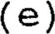 Multiple Benefits. The acquisition of the project site is being pursued in conjunction and collaboration with other state, federal , local, or non—profit agencies acquiring adjacent lands . The multiple acquisition of these sites by multiple agencies will provide synergistic benefits for resource conservation and/or outdoor recreation (5 points) .
The applicant did not provide documentation that acquisition of the proj ect site is being pursued in conjunction and collaboration with other state, federal, local, or non—profit agencies acquiring adjacent lands.
o (f) Neighborhood Park. The entire site is proposed for use as a neighborhood park less than 10 acres and located along streets where people can walk or bike without encountering heavy traffic, or is of a size defined as a neighborhood park in the local plan (10 points) .
The project site is greater than 10 acres and does not conform with the definition of a neighborhood park as described in the local comprehensive plan.
o (g) Urban Core Park. The project site is located within a built up commercial, industrial, or mixed use area and functions to intersperse congested urban core areas with open areas (10 points) .
The project site is not located within a built up commercial, industrial, or mixed use area .
o (h) Providing a Greater Share of the Match. The applicant is committed to providing a greater percentage of a local match for an award. Up to 20 points based on whether:
1. the applicant provides a local match for 50 percent or more of the project costs (10 points) ; or
Not Applicable .
2. the applicant provides a local match for 55 percent or more of the project costs (15 points) ; or
Not Applicable.
3. the applicant provides a local match for 60 percent or more of the project costs (20 points) .
Not Applicable.
10 (i) Greenway Network. The project will enhance a local or regional network of linked greenways by connecting two or more greenways, by extending existing greenways, or by contributing to closing gaps in existing greenways (10 points) .
The city commission adopted a resolution to create the Malabar Sanctuary Greenway. Acquiring the proj ect site will link the site with Turkey Creek Sanctuary Park and

other park areas located along Turkey Creek.
(j) Proj ect Excellence . The proposed proj ect furthers natural resource conservation , coastal protection , outdoor recreation or growth management in a manner that cannot be adequately evaluated with the criteria established elsewhere in this rule chapter (up to 10 points) .
No additional information concerning natural resource conservation, coastal protection, or outdoor recreation was presented that was not covered in the criteria established elsewhere in the application.
15 PRELIMINARY TOTAL FOR INNOVATION, UNIQUE, AND OUTSTANDING PROJECT ELEMENTS

This document prepared by: Ann J. Wild
Florida communities Trust Department of Community Affairs 2555 Shumard Oak Blvd.
Tallahassee, FL 32399

/ 10773-Q
03-04-99 03:22 pm
CFN•.99043500
OR Book/Page: 3975 1 2450

Sandy Crawford
Clerk Of Courts, Brevard County #Names: 2
Trust: 6.00 Rec: 45.00 Serv: 0.00
Deed: 0.00 Excise: 0.00
Mtg: 0.00 Int Tax: 0.00

FLORIDA COMMUNITIES TRUST
P7A AWARD# 96-019-P7A
FCT Contract# 79-67-ÄF- -52- o/
GRANT AWARD AGREEMENT
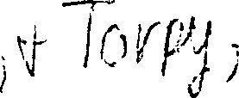
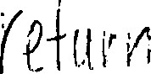
THIS AGREEMENT is entered into this/o day of by and between the FLORIDA COPff1UNITIES TRUST ("FCT") a nonregulatory agency within the State of Florida Department of Community Affairs, and TOWN OF MALABAR, a political subdivision of the State of Florida ("FCT Recipient") , in order to impose terms, conditions, and restrictions on the use of the proceeds of certain bonds, hereinafter described, and the lands acquired with such proceeds and as described in Exhibit ' ^{I} A" attached hereto and made a part hereof ( 't Proj ect Site") , as shall be necessary to ensure compliance with applicable Florida Law and federal income tax law and to otherwise implement provisions of Chapters 253 , 259, and 380, Florida Statutes.
WHEREAS, Part Ill Chapter 380, Florida Statutes, the Florida Communities Trust Act, creates a nonregulatory agency within the Departrnent of Community Affairs , which will ass ist local governments in bringing into compliance and implementing the conservation, recreation and open space, and coastal elernents of their comprehensive plans and in otherwise conserving natural resources and resolving land use conflicts by providing financial assistance to local governrnents to carry out proj ects and activities authorized by the Florida communities Trust Act;
WHEREAS , Section 1 of the Florida Preservation 2000 Act provides for the distribution of ten percent (10%) of the net Preservation 2000 Revenue Bond proceeds to the Department of Community Affairs to provide land acquisition grants and loans to local governments through the FCT ;
WHEREAS, the Governor and Cabinet authorized the sale and issuance of State of Florida Department of Natural Resources Preservation 2000 Revenue Bonds ("Bonds") ;
WHEREAS, the Bonds were issued as tax—exempt bonds, meaning that the interest on the Bonds is excluded from the gross income of Bondholders for federal income tax purposes ;
WHEREAS, Rule 9K-4.010(2) (f) , F.A.C., authorizes FCT to impose conditions for funding on those FCT applicants whose projects have been selected for funding in accordance with Rule Chapter 9K—4 , F.A.C. ;
WHEREAS, the FCT has approved the terms under which the Project Site is acquired and the deed whereby the FCT Recipient acquires title to the Project Site shall contain such covenants and restrictions as are sufficient to ensure that the use of the Project Site at all times complies with section 375.051, Florida Statutes and Section 9, Article XII of the State Constitution and shall contain clauses providing for the conveyance of title to the Proj ect Site to the Board of Trustees of the Internal Improvement
Trust Fund upon the failure of the FCT Recipient to use the Project Site acquired thereby for such purposes; and
WHEREAS, such covenants and restrictions shall be irnposed by an agreement which shall describe with particularity the real property which is subj ect to the agreement and shall be recorded in the county in which the real property is located; and
WHEREAS, the purpose of this Agreement is to set forth the covenants and restrictions that are imposed on the Proj ect Site subsequent to its acquisition with the FCT Preservation 2000 Bond award.
NOW THEREFORE, in consideration of the mutual covenants and undertakings set forth herein , and other good and valuable consideration, the receipt and sufficiency of which is hereby acknowledged, FCT and FCT Recipient do hereby contract and agree as follows :
1. GENERAL CONDITIONS.
- Upon execution and delivery by the parties hereto, the FCT Recipient shall cause this Agreement to be recorded and filed in the official public records of Brevard County, Florida, and referenced in the warranty deed(s) vesting fee simple title to the Proj ect site in the FCT Recipient, and in such rnanner and in such other places as FCT may reasonably request, and shall pay all fees and charges incurred in connection therewith.
- The FCT Recipient and FCT agree that the State of Florida Department of Environmental Protection will forward this Agreement to Department of Environmental protection Bond Counsel for review. In the event Bond Counsel opines that an amendment is required to this Agreement so that the tax exempt status of the Preservation
2
2000 Bonds is not jeopardized, FCT and FCT Recipient shall amend the Agreement accordingly.
- . This Agreement may be amended at any time. Any amendment must be set forth in a written instrument and agreed to by both the PCT Recipient and FCT.
- . This Agreement and the covenants and restrictions contained herein shall run with the Property herein described and shall bind, and the benefits shall inure to, respectively, the FCT and the FCT Recipient and their respective successors and assigns.
- . This Agreement shall be governed by and construed in accordance with the laws of the State of Florida, with respect to both substantive rights and with respect to procedures and remedies .
- . Any notice required to be given hereunder shall be given by personal delivery, by registered mail or by registered expedited service at the addresses specified below or at such other addresses as may be specified in writing by the parties hereto, and any such notice shall be deemed received on the date of delivery if by personal delivery or expedited delivery service, or upon actual receipt if sent by registered mail.
FCT : | Florida communities Trust  Department of Community Affairs  2555 Shumard Oak Blvd. Tallahassee, FL 32399-2100  ATTN: Executive Director
FCT Recipient: | Town of Malabar  2725 Malabar Road  Malabar, FL 32950-4427  ATTN: William Hall,  Town Administrator
If any provision of the Agreement shall be invalid, illegal or unenforceable, the validity, legality and enforceability of the remaining provisions shall not in any way be affected or impaired .
11. PROJECT SITE REQUIREMENTS IMPOSED BY CHAPTER 259, CHAPTER 375, AND CHAPTER 380, PART 111, FLORIDA STATUTES.
- . If any essential term or condition of this grant agreement is violated by the FCT Recipient or by some third party with the knowledge of the FCT Recipient and the FCT Recipient does not correct the violation within 30 days of notice of the violation, fee simple title to all interest in the Project site shall be conveyed to the Board of Trustees of the Internal
3
Improvement Trust Fund . The FCT shall treat such property in accordance with Section 380.508 (4) (e) , Florida Statutes.
- . Any transfer of the Proj ect Site shall be subject to the approval of FCT and FCT shall enter into a new agreement with the transferee, containing such covenants , clauses , or other restrictions as are sufficient to protect the interest of the people of Florida.
The interest, if any, acquired by the FCT Recipient in the Proj ect Site will not serve as security for any debt of the FCT Recipient unless FCT approves the transaction.
- If the existence of the FCT Recipient terminates for any reason, title to all interest in real property it has acquired with the FCT award shall be conveyed to the Board of Trustees of the Internal Improvement Trust Fund, unless FCT negotiates an agreement with another local government or nonprofit organization which agrees to accept title to all interest in and to rnanage the Project Site.
- . In the event that the Proj ect Site is damaged or destroyed or title to the Proj ect site, or any part thereof, is taken by any governmental body through the exercise or the threat of the exercise of the power of eminent domain, the FCT Recipient shall deposit with the FCT any insurance proceeds or any condemnation award, and shall promptly commence to rebuild, replace, repair or restore the Project Site in such manner as is consistent with the Agreement . The FCT shall make -any such insurance proceeds or condemnation award moneys available to provide funds for such restoration work. In the event that the FCT Recipient fails to commence or to complete the rebuilding, repair, replacement or restoration of the Proj ect site after notice from the FCT, the FCT shall have the right, in addition to any other remedies at law or in equity, to repair, restore, rebuild or replace the proj ect site so as to prevent the occurrence of a default hereunder.
Notwithstanding any of the foregoing, FCT will have the right to seek specific performance of any of the covenants and restrictions of this Agreement concerning the construction and operation of the Project site.
111. PROJECT BITE OBLIGATIONS IMPOSED BY ECT ON THE PCT RECIPIENT.
- . The Proj ect site shall be managed only for the conservation, protection and enhancement of natural and historical resources and for passive, natural resource—based public outdoor recreation which is cornpatible with the conservation, protection and enhancement of the Proj ect Site, along with other related uses necessary for the accomplishment of this purpose . The proposed
4
uses for the Proj ect Site are specifically aeslgnacea -L 11 the Proj ect Plan as approved by FCT.
- . The FCT Recipient shall prepare and submit to FCT an annual report as required by Rule 9K—4 . 013, F. A, C.
- . The FCT Recipient shall ensure that the future land use designation assigned to the Proj ect Site is for a category dedicated to open space, conservation, or outdoor recreation uses as appropriate . If an amendment to the FCT Recipient s comprehensive plan is required to comply with this paragraph, the amendment shall be proposed at the next comprehensive plan arnendment cycle available to the FCT Recipient.
- . FCT Recipient shall ensure, and provide evidence thereof to FCT, that all activities under this Agreement comply with all applicable local, state, regional and federal laws and regulations, including zoning ordinances and the adopted and approved cornprehensive plan for the jurisdiction as applicable. Evidence shall be provided to FCT that all required licenses and perrnits have been obtained prior to the commencement of any construction.
- . The FCT Recipient shall , through its agents and employees, prevent the unauthorized use of the project Site or any use thereof not in conformity with the FCT approved proj ect plan.
FCT staff or its duly authorized representatives shall have the right at any time to inspect the Proj ect site and the operations of the FCT Recipient at the Proj ect Site.
All buildings, sEructures, improvements, and signs shall require the prior written approval of FCT as tot purpose. Further, tree removal, other than non—native species, and/or major land alterations shall require the written approval of FCT . The approvals required from FCT shall not be unreasonably with— held by FCT upon sufficient demonstration that the proposed structures, buildings , improvements , signs , vegetation removal or land alterations will not adversely impact the natural resources of the Proj ect Site . The approval by FCT of the FCT Recipient s management plan addressing the items mentioned herein shall be considered written approval from FCT .
- . If archaeological and historic sites are located on the Proj ect Site, the FCT Recipient shall comply with Chapter 267 , Florida Statutes. The collection of artifacts from the proj ect Site or the disturbance of archaeological and historic sites on the Project site will be prohibited unless prior written authorization has been obtained from the Department of State, Division of Historical Resources .
5

- . The FCT Recipient shall ensure that the Pro) ect site is identified as being publicly owned and operated as a passive, natural resource—based public outdoor recreational site in all signs, literature and advertising regarding the Proj ect Site. The FCT Recipient shall erect a sign(s) identifying the Project Site as being open to the public and as having been purchased with funds from FCT and FCT Recipient.
IV. OBLIGATIONS INCURRED BY ECT RECIPIENT A RESULT OF BOND PROCEEDS BEING UTILIZED TO PURCHASE THE PROJECT SITE.
- . If the Proj ect Site is to remain subj ect, after its acquisition by the State and the FCT Recipient, to any of the below listed activities or interests, the FCT Recipient shall provide at least 60 days written notice of any such activity or interest to PCT prior to the activity taking place, and shall provide to FCT such information with respect thereto as FCT reasonably requests in order to evaluate the legal and tax con— sequences of such activity or interest:
  - any lease of any interest in the Proj ect Site to a non—governmental person or organization;
  - the operation of any concession on the Project Site to a non—governmental person or organization;
  - any sales contract or option to buy things attached to the Project Site to be severed from the Proj ect Site, with a non—governmental person or organization;
  - any use of the Prdj ect Site by non-governmental persons other than in such person's capacity as a member of the general public ;
a management contract of the proj ect site with a non—governmental person or organization; and
f. such other activity or interest as may be specified from tirne to time in writing by FCT to the FCT Recipient.
- . FCT Recipient agrees and acknowledges that the following transaction, events, and circumstances may not be permitted on the Proj ect site as they may have negative legal and tax consequences under Florida law and federal income tax law:
  - a sale of the Project Site or a lease of the Project Site to a non—governmental person or organization;
  - the operation of a concession on the Proj ect site by a non—governmental person or organization;
6
  - a sale of things attacnea to tne Pro-J ect site to be severed from the Project Site to a non-governmental person or organization;
  - any change in the character or use of the proj ect Site from that use expected at the date of the issuance of any series of bonds from which the disbursement is to be made;
any use of the Proj ect Site by non—governmental persons other than in such person's capacity as a member of the general public;
f. a management contract of the Proj ect Site with a non—governmental person or organization; and
such other activity or interest as may be specified from time to time in writing by FCT to the FCT Recipient.
DELEGATIONS AND CONTRACTUAL ARRANGEMENTS BETWEEN THE PCT RECIPIENT AND OTHER GOVERNMENTAL BODIES, NOT FOR PROFIT ENTITIES, OR NON GOVERNMENTAL PERSONS FOR USE OR MANAGEMENT OF THE PROJECT SITE WILL IN NO WAY RELIEVE THE FCT RECIPIENT OF THE RESPONSIBILITY TO ENSURE THAT THE CONDITIONS IMPOSED HEREIN ON THE PROJECT SITE AS A RESULT OF UTILIZING BOND PROCEEDS TO ACQUIRE THE PROJECT SITE ARE FULLY COMPLIED WITH BY THE CONTRACTING PARTY.
CONDITIONS THAT ARE PARTICULAR TO THE PROJECT SITE AS A RESULT OF THE PCT APPROVED MANAGEMENT PLAN,
- . The FCT Recipient shall provide outdoor recreational facilities including nature trails, bridle paths , interpretive signage and scenic overlooks on the Project site. The facilities shall be developed in a manner that allows the general public reasonable access for observation and appreciation of the significant natural resources on the Project site without causing harrn to those resources .
- . The timing and extent of a vegetative conmunities and plant species survey of the Project site shall be specified in the management plan. The FCT Recipient shall detail how the survey shall be used during development of the site to insure the protection, restoration, and preservation of the natural resources on the project site.
- . The blackwater creek, hydric hammock and depress ional marsh communities that exist on the proj ect Site shall be preserved and appropriately managed to ensure the long-term viability of
these vegetative communities.
4 . The Proj ect Site shall be managed in a manner that optimizes habitat for listed wildlife species that utilize or could
7
potentially utilize the Proj ect Site, 1 ncludlng the scrub jay, indigo snake, saltrnarsh snake, alligator, gopher tortoise and wading birds. The FCT Recipient shall coordinate with the Game and Freshwater Fish Commission on the management of the proj ect site for the protection of listed species and listed species habitat. The FCT Recipient shall also conduct periodic surveys of listed species using the Proj ect Site and develop informational signs relating to the protection of listed anirnal species and their habitat .
5 . The FCT Recipient shall ensure that the Project Site and listed animal species and their habitat are sufficiently buffered from the adverse irnpacts of adjacent land uses .
6. The FCT Recipient shall restore four acres of the Proj ect Site by removing exotic species and replanting with native vegetation.
The FCT Recipient shall improve water quality on the Proj ect site by removing debris and fill, planting wetland vegetation to control sedimentation and rernoving or improving existing culverts to improve hydrological flow patterns within the Turkey Creek watershed .
8. The FCT Recipient shall coordinate with the St. Johns River •Water Management District in the development and implementation of a hydrologic restoration and stormwater management plan for the Proj ect site.
9 . The FCT Recipient shall incorporate the proj ect site into an overall Greenway management and resource protection strategy that includes the Malabar Sanctuary Greenway and the Turkey Creek and Indian River Lagoon Greenway networks being established within the city of Palm Bay.
- The FCT Recipient shall remove all trash and debris from the Project Site.
- Prior to the commencement of any proposed development activities, rneasures will be taken to determine the presence of any archaeological sites . All planned activities involving known archaeological sites or potential site areas shall be closely coordinated with the Department of State, Division of Historic Resources, in order to prevent the disturbance of significant sites.
- Access to the Project Site by pedestrians, bicyclists and persons on non—motorized vehicles shall be promoted except in those areas where resource protection considerations warrant limiting access .
8
- The requirements imposed by other grant program funds that may be sought by the FCT Recipient for activities associated with the proj ect Site shall not conflict with the terms and conditions of the FCT award.
THIS GRANT AWARD AGREEMENT embodies the entire Agreement between the parties.
IN WITNESS WHEREOF, the parties hereto have duly executed this Agreement .
Witness : T0WN OF MALABAR,
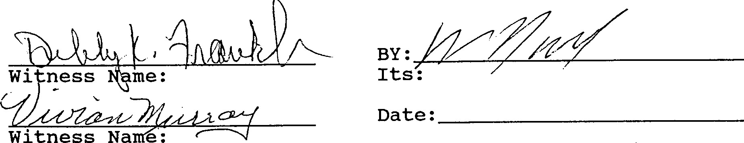
a political subdivision of the State of Florida
Attest
Clerk
Accepted as to Legal Form and Sufficiency:

Date :

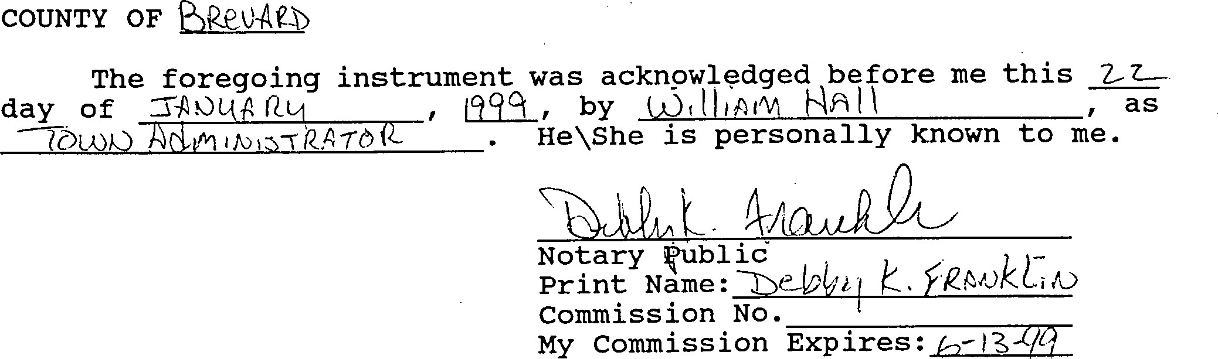
STATE
OF
FLORIDA
9
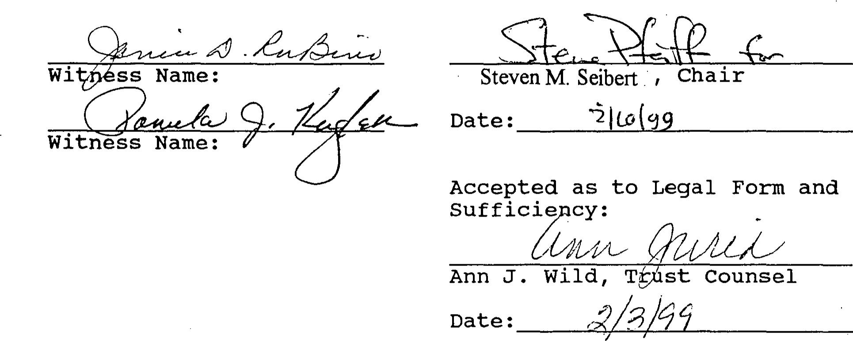
FLORIDA
C010fUNITIES
TRUST
STATE OF FLORIDA
COUNTY OF LEON
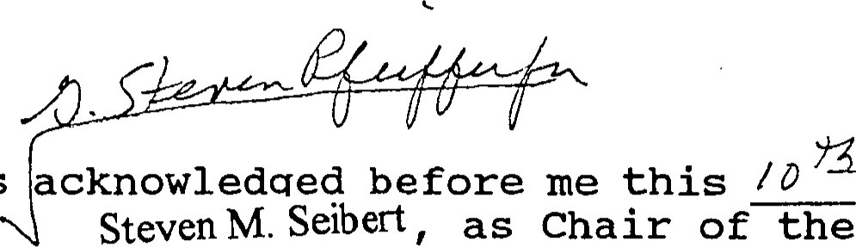
The foregoing instrument was acknowledqed before rne this ^{B}/ ^{D} day of1992 by
Florida Communiti Trust. He is personally known to me.
EXPIRES NpSary Publ ic PE int Name:
INC. Commission No.
My commission Expires:
10

Exhibit "A" CFN:99043500
OR Book.]Page•. 3975 / 2460
LEGAL DESCRIPTION

All of Lot 1, WEBER ROAD ACRES, as recorded in Plat Book 43, page 69, of the Public Records of Brevard County, Florida .
LESS AND EXCEPT:
That portion of Lot 1, WEBER ROAD ACRES, recorded in Plat Book 43, page 69, of the Public Records of Brevard County, Florida, being more. particularly described as follows :
Commence at the Northeast corner of the aforesaid Lot 1; thence South 00 ⁰ 32' 36 ' I along the East line of Lot 1 for a distance of 150.00 feet to the Point of Beginning of the herein described parcel of land; thence continue South 00 ⁰ 32' 36" West along said East line for a distance of 330.80 feet to the Northeast corner of Lot 2 t WEBER ROAD ACRES; thence North 89 ⁰ 16' 21" West along the North line of Lot 2, WEBER ROAD ACRES, for a distance of 626.04 feet; thence departing the North line of Lot 2, run North 00 ⁰ 33' 43" E for a distance of 330.26 feet; thence South. 89 ⁰ 19' 2 0" E. for a distance of 625.93 feet to the Point of Beginning.
GAA/96-019-P7A

10/27/98 11
?hnsé
9b - o)C1-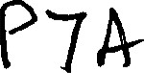
FCT/P2000-P7A STAFF EVALUATION REPORT--Summary
PROJECT NAME: Malabar Sanctuary Greenway 11 96-019-P7A
LOCAL GOVERNMENT APPLICANT: Malabar
NAMES OF OTHER APPLICANTS IF A PARTNERSHIP: N/A
ESTIMATED PROJECT COST: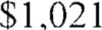
AMOUNT OF AWARD REQUESTED: 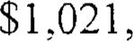
LOCAL MATCH: $0
Malabar is requesting a 100 percent FCT award. The April l, 1995, population estimate for
Malabar was 2,313. (Source: University of Florida, Bureau of Economic and Business Research)
Malabar qualifies for an unmatched grant as a small local government according to Rule 9K-
4.0031 F.A.C.
ACREAGE: 95
COMPREHENSIVE PLAN STATUS: In Compliance
PROJECT SCORES BY EVALUATION CATEGORY
(l) Furtherance of Growth Management 65
Note: Pursuant to Rule 9K-4.010(2)(c), F.A.C., the score in this section, when finalized, will be adjusted upward by a factor of 1.5.
- Furtherance of Natural Resource Conservation,
Coastal Protection, and Outdoor Recreation 75
- Innovative, Unique, and Outstanding Features
PROJECT SUMMARY:
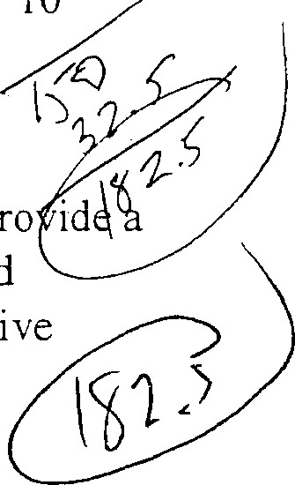
The purposes of the acquisition are to protect listed species and a potable water supply, pro idÅq link in a local greenway network, and provide outdoor recreation opportunities. Proposed management of the site provides for removal of exotic vegetation and replanting with native
10
1
species, hydrological restoration and prescribed burning. Proposed improvements to the site include nature trails and interpretive signage.
The project site consists of three sections of land that are contiguous with Malabar Road. The site is south of Turkey Creek Sanctuary Park in the City of Palm Bay and an FCT site funded during the P 56 cycle (Malabar Sanctuary Greenway, #95-063-P56)), and includes three tributaries to Turkey Creek. Land uses adjacent to the site include agricultural, residential and vacant land uses. Future land use designations adjacent to the site include residential development.
The project site is vegetated by blackwater creek, pine flatwoods, wetlands, hydric hammock and depressional marsh communities. Listed animal species using the site as habitat include the american alligator, gopher tortoise, indigo snake, saltmarsh snake and numerous wading bird species.
LOCAL GOVERNMENT PROFILE:
The City of Malabar is located in the southern end of Brevard County, south of Melbourne, between 1-95 and the Indian River Lagoon. Malabar has about 11.5 square miles of land. In 1988, the City was 51% undeveloped; less than 1% was commercial, 2% was industrial, and 17% was residential. Residential densities have historically been relatively very low, due in part to poor soil suitability for septic tanks; 94% of the developed residential area had densities averaging about I DU per 2 acres.
The 1990 Census pennanent population was 1,977 and is projected to reach a seasonal and permanent total of 4,816 by the year 2010. The planning timeframes are 1995 and 2010. No public water or sanitary sewer systems exist in the City; nearly all developed sites rely upon individual, shallow wells and individual septic tanks. Solid waste is disposed of at the Brevard County landfill. 1-95 and US I basically form the west and east boundaries of the City; SR 5 14 connects 1-95 and US 1.
(Source: Division of Resource Planning and Management, Department of Community Affairs)
COMMENTS:
The St. Johns River Water Management District commented that acquiring the site would benefit local water quality and the Indian River Lagoon, and would restore natural floodplains.
1
PROJECT SCORING
(1) FURTHERANCE OF GROWTH MANAGEMENT AND COMPREHENSIVE PLAN IMPLEMENTATION (UP TO 105 POINTS)
(a) Growth Management Objectives. The project supports and furthers management objectives as they relate to natural resource conservation, coastal protection, and outdoor recreation (up to 35 points):
5 I . The local comprehensive plan and land development regulations provides for the protection of natural resources, coastal resources or outdoor recreational activities from adverse impacts that may result from uses or activities occurring on• adjacent lands (5 points).
Objective 1-3.1 and Policy 1-3.1.6 of the Future Land Use Element state that development within the City shall be coordinated with soils, vegetation, natural habitat, potable water well fields and other environmentally-sensitive land and water resources. City ordinance 1.4.9.SF regulates land and water uses to ensure the compatibility of adjacent land uses. This plan directive and ordinance would regulate activities on and adjacent to the project site.
10 2. The proposed project will assist the applicant in ensuring the proper location and distribution of appropriate residential or urban densities (10 points).
The comprehensive plan allows for urban types of development even though the property is characterized as environmentally sensitive, flood-prone and supports endangered species. The proposed acquisition will preserve an environmentally sensitive, flood-prone site for passive recreation by directing urban uses to other more appropriate sites.
0 3. The proposed project will help rectify land use conflicts associated with antiquated subdivisions or vested land uses that became non-conforming as a result of adoption of the local comprehensive plan (10 points).
The applicant stated that developing the project site in accordance with allowable uses under the City's adopted comprehensive plan would be in conflict with the protection of the floodplain and natural resources. The project site is designated for residential use. This is not a land use conflict associated with antiquated subdivisions or vested land uses that became nonconforming as a result of the adoption of the local comprehensive plan.
10 4. The proposed project will provide additional outdoor recreation opportunities within the urban service area (10 points).
The City is becoming increasingly urbanized and provides services adjacent to the project site. The project site will provide additional outdoor recreation opportunities within the community.
(b) Local Comprehensive Plan Provisions for Natural Resource Conservation, Coastal Protection, and Outdoor Recreation. Acquisition of the project site will assist the local government in furthering the local comprehensive plan directives set forth in the objectives and policy statements contained in the plan elements that provide for natural resource conservation, coastal protection, and outdoor recreation. When used in this part, the term "furthered" means that proposed projects will assist the local government in realizing goals, objectives, or policy directives of the comprehensive plan. Up to 70 points based on whether:
5L Comprehensive plan directives that ensure the protection of natural areas through public acquisition are furthered by the proposed project (5 points).
Policy 1-1.4 of the Future Land Use Element calls for use of the capital budget to acquire land required for recreation and conservation. The project site will be used for conservation and recreation. Acquisition of the site would further this plan directive.
5 2. Convpru•hensive plan directives that ensure the preservation of rare or threatened vegetative conununities are furthered by the proposed project (5 points).
Policy 1-3.5.4 of the Future Land Use Element states that rare and endangered flora and fauna having special status as identified in the Conservation Element shall be protected. The project site contains listed blackwater creek, hydric hammock and depressional marsh communities. These communities are identified in the Conservation Element as rare and endangered and requiring protection.
5 3. Comprehensive plan directives that provide for standards or programs to ensure the protection of listed animal species or habitats of listed species are furthered by the proposed project (5 points).
Policy 6-1.8.2 of the Conservation Element provides for protection of wildlife and wildlife habitat. This policy is implemented through the City's Land Development Code. The project site provides habitat for listed animal
1
species including the scrub jay, american alligator, indigo snake, and numerous wading bird species.
5 4. Comprehensive plan directives that ensure the protection or enhancement of beach, or shoreline ecosystems, are furthered by the proposed project (5 points).
Policy 1-3.11.8 of the Future Land Use Element provides for protection of the tributaries of Turkey Creek. The project site would preserve a tributary of Turkey Creek. Acquisition of the site would further this plan directive.
5 5. Comprehensive plan directives that provide for standards or programs to restore or enhance degraded natural areas (including, but not limited to, removal of non- native vegetation, reforestation, shoreline or dune restoration, or restoration of natural hydrology) are furthered by the proposed project (5 points).
Objective 5-1.1 of the Coastal Management Element provides for removal of invasive exotic species. This policy is implemented through the City's Landscape Ordinance. The applicant proposes to remove exotic vegetation from the proposed site. Acquisition of the site would further this plan directive.
5 6. Con-Iprehensive plan directives that ensure the protection or enhancement of surface and groundwater quality are furthered by the proposed project (5 points).
Objective 4-2.1 of the Public Utilities Element provides for the protection of potable water supply areas and drainageways. The project site includes tributaries to Turkey Creek, a natural drainage feature, and would assist in the protection of the ecological and hydrological functions of this area and the associated surface water quality.
5 7. Comprehensive plan directives that provide for standards or programs to protect or restore aquatic vegetation (including, but not limited to, aquatic weed control, restoration or creation of aquatic grass beds, or shoreline restoration) are furthered by the proposed project (5 points).
Policy 5-1.2.1 of the Coastal Management Element provides for the protection of shorelines and buffer zones for wetlands and submerged lands.
This policy is implemented through the City's Landscape Ordinance. The project site includes tributaries to Turkey Creek that are composed of wetlands and aquatic vegetation. Acquisition of the site would protect this aquatic vegetation and further this plan directive.
1
5 8. Comprehensive plan directives that ensure or enhance public access to publicly owned or publicly accessible natural areas (including, but not limited to, water bodies, saltwater beaches, and to existing protected areas) are furthered by the proposed project (5 points).
Policy 7-1.4.1 of the Recreation and Open Space Element states that access be provided to Turkey Creek and its tributaries. The project site would provide additional public access within the Turkey Creek area. Acquisition of the site would further this plan directive.
0 9. The proposed project will provide for acreage or outdoor recreational facilities necessary to maintain or improve levels of service or other standards established in the comp'rehensive plan for outdoor recreation areas (1 0 points).
The applicant did not cite a plan directive that provides for acreage or outdoor recreational facilities necessary to maintain or improve levels of service, as specified by this criterion.
10. Comprehensive plan directives that ensure the provision of facilities for outdoor recreation activities (including; but not limited to, nature trails or boardwalks, waterway trails, interpretive displays, educational programs, or wildlife observation areas) are furthered by the proposed project (5 points).
The applicant did not identify directives from the coniprehe,nsive piansthat ensure provision of facilities for outdoor recreation activities, as spccificd by this criterion. -
I l . Future land use designations or comprehensive plan directives with the purpose of creating natural area greenways consisting of environmentally sensitive lands or outdoor recreation opportunities are furthered by the proposed project (5 points).
The applicant stated that the City Commission adopted a resolution to create a greenway. The applicant did not identify comprehensive plan directives with the purpose of creating natural area greenways consisting of environmentally sensitive lands or outdoor recreation opportunities, as specified by this criterion.
0 12. Comprehensive plan directives that ensure the preservation of unique geological and historical sites are furthered by the proposed project (5 points).
The applicant cited several comprehensive plan directives relating to natural resource protection. The project site does not possess any unique geological or historical features. Acquisition of the site would not further the plan directives cited.
0 13. Comprehensive plan directives that provide for coordination with existing resource protection plans such as resource planning and management committee plans, aquatic preserve management plans, and estuarine sanctuary plans are furthered by the proposed project (5 points).
Policy 1-13.7.1 of the Future Land Use Element requires the City to coordinate with other governments concerning development and conservation issues impacting the Indian River Lagoon Aquatic Preserve. This directive does not address any specific resource protection plan nor does it require the implementation of existing resource protection plans.
65 PRELIMINARY TOTAL FOR FURTHERANCE OF GROWTH
MANAGEMENT
Note: Pursuant to Rule 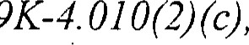 F.A.C., the score in this section, when finalized, will be adjusted upward by a factor of 1.5.
(2) FURTHERANCE OF NATURAL RESOURCE CONSERVATION, COASTAL PROTECTION, AND OUTDOOR RECREATION (UP TO 100 POINTS)
(a) Protection of Vegetative Communities. Ecologically viable natural vegetative communities occur on the project site. Up to 20 points based on whether:
5 I . The project site contains predominantly native forested or non-forested vegetative communities that have not been subjected to significant disturbances or alteration as a result of current or past human activities (5 points).
The project site contains predominately native vegetative communities including blackwater creek, hydric hammock and depressional marsh communities. A small portion of the site has been impacted by invasive exotic species.
5 2. The project site contains native vegetative communities or plant species that are recognized as rare or threatened locally or regionally in the applicable comprehensive regional policy plan, local comprehensive plan, or by the state (5 points).
County environmental staff documented that the project site contains blackwater creek, hydric hammock and depressional marsh communities, which is recognized by the Florida Natural Areas Inventory as listed vegetative communities.
5 3. The project site contains types of vegetative communities recognizecl by the
Florida Natural Areas Inventory as "imperiled" or "critically inveriled ^{t} ' (5 points).
The project site contains a blackwater creek community, which is recognized by the Florida Natural Areas Inventory as an imperiled vegetative community.
5 4. Degraded or altered vegetative communities that occur on the project site will be restored or enhanced to their natural state in terms of biological composition and ecological function (5 points).
The applicant proposes to remove 4 acres of exotic species from the site and replant with native vegetative species. The applicant will also install culverts to restore the natural hydrology of the entire project site and improve flow patterns within the tributaries to Turkey Creek.
1
(b) Protection of Wildlife. The project site protects wildlife populations or their habitat. Up to 15 points, based on whether:
5 I . The project site contains habitat recognized by appropriate state or federal agencies as typically suitable for one or more listed animal species (5 points).
The project site contains blackwater creek, hydric hammock and depressional marsh communities. These communities are recognized as providing habitat for listed animal species including the indigo snake and saltmarsh snake, and numerous wading bird species.
52. One or more listed animal species have been recently documented by professionally accepted methods to use all or a portion of the project site as habitat (5 points).
County biologists and several local environmental groups have documented the presence of the listed gopher tortoise, indigo snake, saltmarsh snake and wading birds on the site.
The Florida Natural Areas Inventory commented that gopher tortoises have been found on the project site.
3. The project site supports or is critical to the recovery or maintenance of regionally significant populations (as recognized by the appropriate agency) of one or tnore listed animal species, or colonial or liligratory birds (5 points).
The applicant stated that the project site supports the recovery and maintenance of regionally significant populations of manatees, scrub jays, gopher tortoises and wading birds.
The Florida Game and Fresh Water Fish Commission commented that the project site potentially supports a regionally significant population of listed sandhill cranes and wood storks.
(c) Protection of Water Resources. The project site protects the quality and quantity of surface and groundwater resources. Up to 15 points, based on whether:
5 1. The quality of surface waters occurring on the project site is proposed to be improved through programs including, but not limited to, the elimination of pollution sources, or restoration of aquatic habitat (5 points).
1
The applicant stated that fill, debris and trash will be removed from the project site, existing culverts will be improved and new culverts will be added to improve the quality of stormwater runoff from the site into Turkey Creek.
0 2. Surface water resources occurring on or adjacent to the project site are designated as Class Il waters, Outstanding Florida Waters, a National Estuary or Marine Sanctuary, aquatic preserve, wild and scenic river, or other local government special status designation intended to protect the natural resources and water quality of the waterbody (5 points).
Turkey Creek and its navigable tributaries are part of the Malabar to Sebastian Aquatic Preserve. The tributaries to Turkey Creek on the project site are not considered navigable waters.
5 3. The project site protects prime aquifer recharge areas or potable water supply areas as recognized by the applicable water management district, United States Geological Survey, or (with appropriate support documentation) other local, state, or federal agencies (5 points).
The project site is adjacent to the municipal wellfield that is used as a potable water source for city residents.
(d) Providing Outdoor Recreation. The project site provides for outdoor recreation opportnnities. Up to 50 points, based on whether:
10 l . The project site will be utilized as urban open space and is accessible and usable to the population concentrations located within the local government's jurisdiction (10 points).
The project site is located near lands that are either developed or designated for urban uses by the Future Land Use Map. The project site abuts local roads that will facilitate public access to the site.
10 2. The proposed project will provide nature trails, boardwalks, waterway trails, wildlife observation areas, scenic overlooks, interpretive displays or other such facilities to promote outdoor recreation with as minimal disturbances as possible to the natural resources on the project site (10 points).
The applicant proposes to provide nature trails, interpretive signage and scenic overlooks on the project site.
10 3. The acquisition of the project site will provide for new or enhanced access for outdoor recreational or management purposes to other natural areas used for outdoor recreation including, but not limited to existing parks, greenways and waterways (10 points).
The project site will enhance access to the Malabar Sanctuary Greenway project site funded by FCT during the P56 cycle and to Turkey Creek Sanctuary Park.
0 4. The project site contains intact salt or freshwater beach that will be managed
for recreation uses while preserving the natural character and functions of the site (10 points).
Not Applicable.
0 5. The proposed project will provide educational programs and other such facilities on the project site to promote protection of natural resources (10 points).
The applicant referred to the interpretive center at Turkey Creek Sanctuary Park but did not propose any educational programs or other such facilities on the project site.
75 PRELIMINARY TOTAL FOR FURTHERANCE OF NATURAL RESOURCES
CONSERVATION. COASTAL PROTECTION, AND OUTDOOR
RECREATION
1
O | (a) | Acquisition. The proposed project provides for alternatives to the acquisition of fee interests in land, including, but not limited to, acqui>ition of less than fee interest of all or a significant portion of the project site through conservation easements, development rights, leases, and leaseback arrangements (5 points).  The applicant states that a conservation easement would be obtained that includes a portion of the project site. The applicant did not supply documentation to confirm this response and the easement would not cover a significant portion of the project site. The bulk of the site would be acquired through fee simple acquisition.
O | (b) | Management. The proposed project will provide for innovative and outstanding land and/or water management techniques or facilities design that promote natural resource conservation, coastal protection, or outdoor recreation (5 points).  The proposed management plan is adequate to meet the intent of  Preservation 2000 acquisitions and appears to be appropriate for the site, but does not demonstrate innovative or outstanding features as specified in this criterion.
0 | (c) | Special Planning and Management Areas. (5 Points)  l . Areas of Critical State Concern. The project site is located within an Area of Critical State Concern as designated pursuant to Section 380.05, Florida Statutes, and the applicant is not requesting funding under Rule 9K-4.0031 Florida Administrative Code (5 points); or,  Not Applicable.  2. Resource Planning and Management Areas. The project site is located within a Resource Planning and Management Area as designated pursuant to Section 380.045, Florida Statutes (5 points).  Not Applicable.
o | (d) | Unique Site Features. The project site contains unique natural features, or historical, archeological or culturål sites as recognized in the local comprehensive plan or by the appropriate state or federal agency (10 Points).
(3) INNOVATIVE, UNIQUE, AND OUTSTANDING PROJECT ELEMENTS (UP TO 90 POINTS)
The project site does not contain any unique natural features, or historical, archeological or cultural sites, as recognized in the local comprehensive plan or by state or federal agencies.
(e) Multiple Benefits. The acquisition of the project site is being pursued in conjunction and collaboration with other state, federal, local, or non-profit agencies acquiring adjacent lands. The multiple acquisition of these sites by multiple agencies will provide synergistic benefits for resource conservation and/or outdoor recreation (5 points).
The applicant did not provide documentation that acquisition of the project site is being pursued in conjunction and collaboration with other state, federal, local, or non-profit agencies acquiring adjacent lands.
0 (f) Neighborhood Park. The entire site is proposed for use as a neighborhood park less than 10 acres and located along streets where people can walk or bike without encountering heavy traffic, or is of a size defined as a neighborhood park in the local plan (10 points).
The project site is greater than 10 acres and does not conform with the definition of a neighborhood park as described in the local comprehensive plan.
0 (g) Urban Core Park. The project site is located within a built up .conunercial inclustrial, or lni,xed use area and functions to intersperse congested urban core areas with open areas (10 points).
The project site is not located within a built up commercial, industrial, or mixed use area.
0 (h) Providing a Greater Share of the Match. The applicant is committed to providing a greater percentage of a local match for an award. Up to 20 points based on whether:
l . the applicant provides a local match for 50 percent or more of the project costs (10 points); or
Not Applicable.
-2. the applicant provides a local match for 55 percent or more of the project costs (15 points); or

Not Applicable.
3. the applicant provides a local match for 60 percent or more of the project costs (20 points).
Not Applicable.
10 (i) Greenway Network. The project will enhance a local or regional network of linked greenways by connecting two or more greenways, by extending existing greenways, or by contributing to closing gaps in existing greenways (10 points).
The City Commission adopted a resolution to create the Malabar Sanctuary
Greenway. Acquiring the project site will link the site with Malabar Greenway Park and Turkey Creek Sanctuary Park to the north to form a continous greenway along the tributaries of Turkey Creek.
(j) Project Excellence. The proposed project furthers natural resource conservation, coastal protection, outdoor recreation or growth management in a manner that cannot be adequately evaluated with the criteria established elsewhere in this rule chapter (up to 10 points).
No additional information concerning natural resource conservation, coastal protection, or outdoor recreation "'as presented that was not covered in the criteria established élsewhere in the application.
10 PRELIMINARY TOTAL FOR NNOVATION, UNIQUE, AND
OUTSTANDING PROJECT ELEMENTS
1

om a onanmunnfies Trust
March 3, 1999
Mr. William Hall City Manager
Town of Malabar
2725 Malabar Road
Malabar, Florida 32950
RE: Management Plan for FCT Projects #95-063-P56 (Malabar Sanctuary Greenway I) and #96-019-P7A (Malabar Sanctuary Greenway Il)
Dear Mr. Hall:
The governing body of the Florida Communities Trust (FCT) approved the project plan for the Malabar Sanctuary Greenway Il project on October 27, 1998, contingent upon final review and acceptance of the management plan by FCT staff.
FCT staff reviewed your revised draft management plan and found it adequately addresses the issues identified in our February 18, 1999 comment letter. Your revised management plan is approved. Please incorporate all additions and deletions into a final document and provide one bound copy for our records. As a reminder, if the acquisition of other parcels within the Malabar I and/or Malabar Il project sites reaches a point where a contract is signed, the management plan will need to be amended to include the management details on the parcel(s) before closing.
Thank you for satisfying this contingency for project plan approval. If you have any questions concerning this matter, please contact me or Edward Eckstein at (850) 922-2207.
Sincerely,
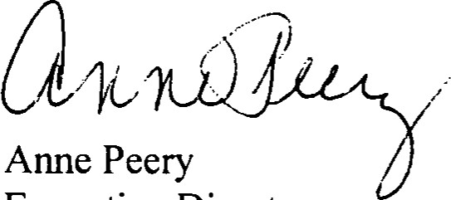Anne Peery
Executive Director
AP/ee cc: Mr. Jim Egan, Executive Director, Marine Resources Council
DEPARTMENT OF COMMUNITY AFFAIRS • 2555 SHUMARD OAK BOULEVARD • TALLAHASSEE, FL 32399-2100 850/922-2207 • SUNCOM 292-2207 • FAX 850/921-1747
FLORIDA COMNUNTiES TAUST REQ'(.IB
FACSIMILE
to: Debbie Franklin - Town of Malabar 321 722-2234
from:
Edward Eckstein phone # 850 922-2207 Fax # 850 921-1747 re: Malabar Sanctuary I and Il Management Plan Revisions
date:
Debbie, Your outline for revisions looks good. Delbert stated that the 4 parcels could possibly close by the end of June. I have added a few suggestions below for revisions.
Thanks ! Ed
Intro - add that 4 parcels are on south side of drainage canal that borders Palm Bay.
2. Site Development
A. Existing - Need an exhibit showing existing improvements (ditch, access road, trails). This could be a hand drawn map like ones at end of management plan. Revision says 5 parcels, should be 4 ?
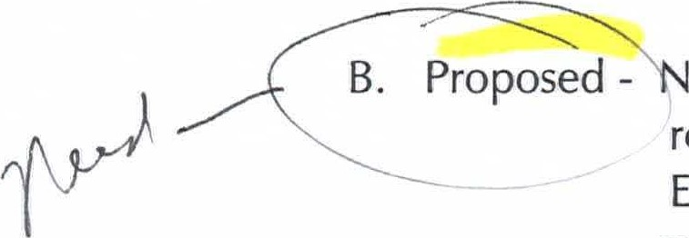
eed an exhibit showing proposed improvements (ditch, access road, trails, bridal trails, bike trails, entrance sign, proposed bridge?, Etc.). This could be a hand drawn map like ones at end of management plan.
An additional map showing relationship of 4 parcels to Malabar Comm. Park, Conservation Area, Turkey Creek Sanc., etc., would be helpful.
If no other section revisions are relevant, I think that should do it. You can fax me revised pages when completed.
FACSIMILE
Jim Egan or Beth McMillan
to:
from:
Edward Eckstein phone # 850 922-2207# 850 921-1747 re: Malabar Sanctuary I and Il Management Plan
date: 02-24-99
Please address the following two issues and fax me the revised pages by 4:00 pm today or by 9:00 am Thursday,
- Revise the design of the parking area on Map 2B. Parking appears too close to stream channel. Design parking area as follows and state that parking will be set back at least 25' from any wetlands on the stream channel.
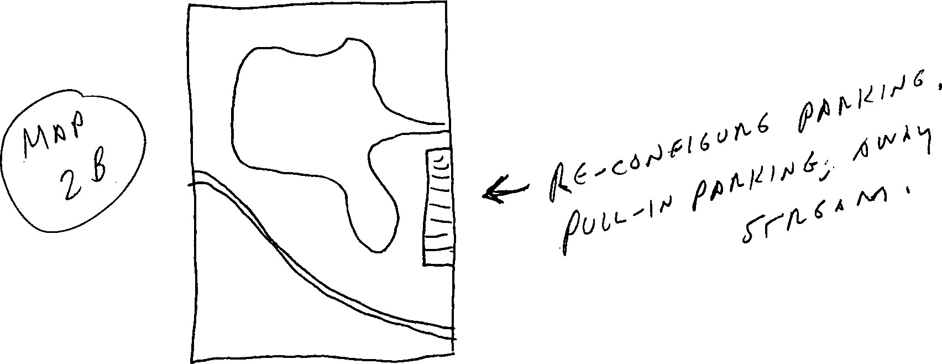
- Revise page 16 (floodplain wetlands) to include: State the goal of the restoration effort (why doing). Describe the past condition of the area (wetland, floodplain, native veg, etc.) and discuss how the restoration effort will return the area to its natural state.
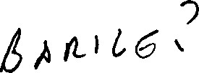
om
February 18, 1999
Mr. William Hall City Manager
Town of Malabar
2725 Malabar Road
Malabar, Florida 32950

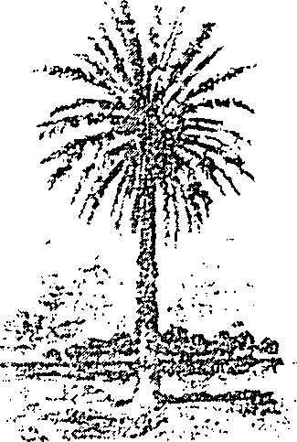
ommunhGes Trust

RE: Management Plan for FCT Projects #95-063-P56 (Malabar Sanctuary Greenway I) and #96-019-P7A (Malabar Sanctuary Greenway Il)
Dear Mr. Hall:
Thank you for submitting revisions to the above-referenced management plan for reviexv. The Florida Communities Trust (FCT) has reviewed the revised draft management plan according to the requirements of Rule Chapter 9K-4.01 1(l)(b), Florida Administrative Code, Conceptual Approval Agreements (CAA) #95-063-P56 and #96-019-P7A, and Exhibit C. Writing a Management Plan.
The FCT governing body approved the project plan for Malabar Sanctuary Greenway Il on October 27, 1998, contingent upon fmal review and acceptance of the management plan by FCT staff. Grant funds cannot be released until this contingency is removed. Please address the following comments in preparing a revised mana^{c}ement plan for FCT review and approval.
INTRODUCTION:
Ensure the introductory narrative discusses the current status of the Malabar I and Malabar Il projects. The FCT has negotiated sales contracts on three parcels (i.e., Shaw, Oliviera and Chulyak) within the Malabar [I project boundary and negotiations on other parcels in the Malabar I and Malabar Il projects are continuing at this time. Include a statement indicating that if the acquisition of other parcels within the Malabar I and Malabar Il project sites reaches a point where a contract is signed, the management plan will be amended to include the management details on the parcel(s) before closing.
DEPARTMENT OF COMMUNITY AFFAIRS • 2555 SHUMARD OAK BOULEVARD • TALLAHASSEE, FL 32399-2100 850/922-2207 • SUNCOM 292-2207 • FM 850/921-1747
FLORIDA TRVST

Two
Page 3 states that the Town will submit a land use amendment to DCA to include the land
0) use classification for conservation, preservation and recreation/open space. Include a provision stating that once the Town adopts this new land classification, the Town will change the Future Land Use and zoning designation of all acquired parcels within the Malabar I and Malabar Il project sites to conservation, preservation or recreation/open space. [CAA, Sec. V
STRUCTURE AND IMPROVEMENTS:
Clearly identify the project site boundary on each of the maps that show the location of existing and proposed physical improvements on the three parcels. [CAA, Sec. V #5]
Revise the Map of Combined Malabar Sanctuary Greenway I and I (Exhibit A) to identify the location of the three parcels by parcel or map number and delete the legend (proposed improvements are shown on individual maps). [CAA, Sec. V #5]
Page 9 mentions existing fencing. Fencing is depicted on the Shaw parcel (map 1b). If c applicable, show the location of existing fencing on the other two parcels.
,...t•- Page 9 states that a parking area will be provided on the Oliviera parcel (map 2b). Show the location of the parking area on map 2b.
Under the section on walking trails on Page I I it states that a 24-foot berm will be designed as part of the water management system on the Shaw parcel (map 1b) that will be used for cycling, walking and as a bridle path. Including a bridle path on the Shaw parcel is not mentioned under "Bridle Paths" and a bridle path is not shown on map lb. Please correct this inconsistency in the management plan text and on mapl b, if applicable.
On page I l , provide a brief discussion on the issues, problems and proposed management techniques for ensuring the compatibility of horseback riding with other outdoor recreation activities proposed in the management plan. [CAA, Exhibit C]
KEY MANAGEMENT ACTIVITIES:
Greenway Management
Include a statement that the project site parcels will be formally incorporated into the Town's greenway network (i.e., greenway resolution by Town Council). Include a statement the the Town will coordinate with Brevard County and the City of Palm Bay to develop and implement a resource management strategy to protect and manage the separate parcels of the greenway. Provide a greenway map that identifies all greenway parcels in Three
the area (i.e., Malabar Sanctuary - Turkey Creek Greenway, Malabar Community Park, Turkey Creek Sanctuary and the County's Scrub Habitat Conservation Area). Move the discussion on greenways to a separate "Greenway Management" subheading in the management plan. [CAA, Sec. V Il #9]
RESOURCE ENHANCEMENT:
Page 16 discusses the amount of disturbed area on the three parcels and how each parcel will be enhanced or restored. Include the map number (la, 1b, etc) or name of the property owner in the discussion for reference purposes. In addition, the discussion on disturbed areas appears out of place with a discussion on greenways. Move the discussion on disturbed areas under "Floodplain Wetlands" or "Revegetation."
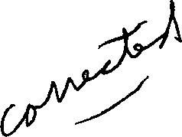
The discussion on the amount of disturbed area on page 16 states that the site at the corner of Malabar and Corey Road is 95% disturbed (Shaw parcel) and the site south of Malabar
Scrub Sanctuary is 95% disturbed. Is the site south of the sanctuary referring to the
Oliviera or Chulyak parcel? These two parcels were thought to be largely undisturbed.
Please check the accuracy of the statements made on page 16 regarding disturbed areas.
Maplb (Shaw parcel) identifies a substantial wetland area to be restored. Indicate the approximate acreage of the wetland restoration area on page 16. Include a discussion on any other wetland or upland areas to be restored on the three parcels, including approximate acreage, and locate the restoration areas on the appropriate map.
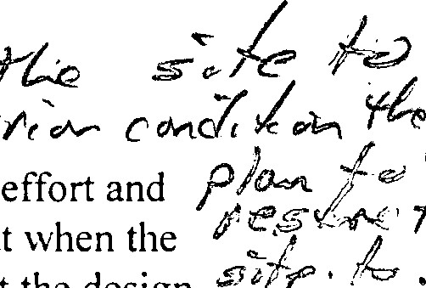
[CAA, sec. Vll # // re ft-v ^{l} J. / s and (
'C
The ofthe wetlands on the Shaw parcel is a complex and ambitious effort the details of the restoration are still unclear. Include a statement indicating that when the Town develops a design plan for the wetlands restoration, the Town will submit the design plan to FCT for review and approval. The design plan should include a detailed description of the wetlands restoration and a discussion on the intended function and dimensions of the proposed berm, the source of funding for the restoration, potential impacts to adjacent properties not within the project boundary, etc.
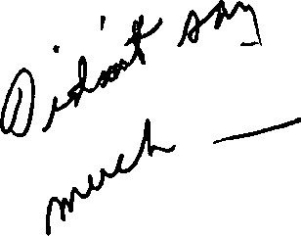
Include a brief discussion on page 16 on the intended benefits of the FDOT culvert improvements on water quality in Turkey Creek. [CAA, Sec. V Ill #7]
I hope you will find these comments helpful in finalizing the management plan. Please address the above comments in the management plan and resubmit the draft plan to the FCT. Trust staff will then conduct another review of the management plan to determine if it is approved.
Four
If you have any question concerning the staff review and comments you can contact me or Edward Eckstein at 2555 Shumard Oak Boulevard, Tallahassee, Florida 32399-2100 or call us at (850) 922-2207. Sincerely,
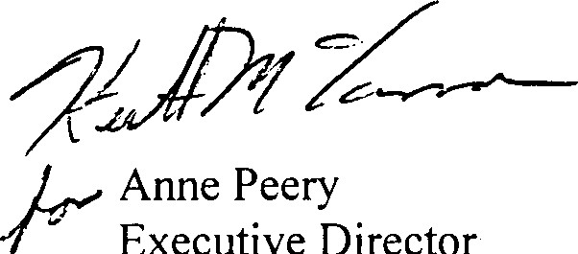
Executive
Director
AP/ee cc: Mr. Jim Egan, Executive Director, Marine Resources Council

FCT FACSIMILE
to:
from:
Edward Eckstein phone #: 850-922-2207 fax 850-921-1747

re:
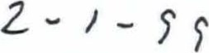
11 c/ re date: 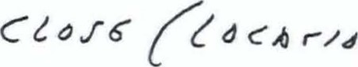
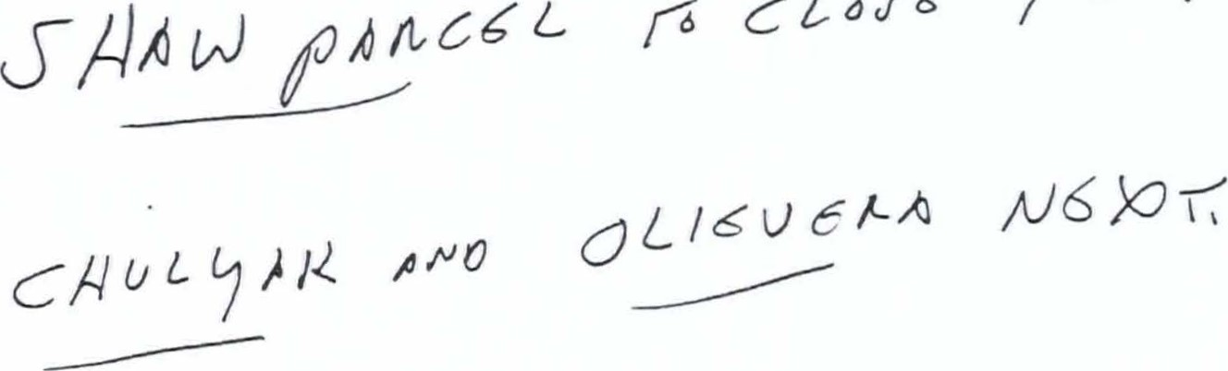
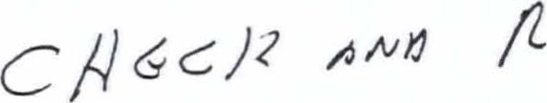
61//Jé uN 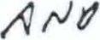
9
C h) q cbl /6]2 /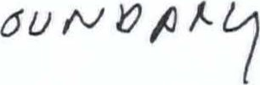 1

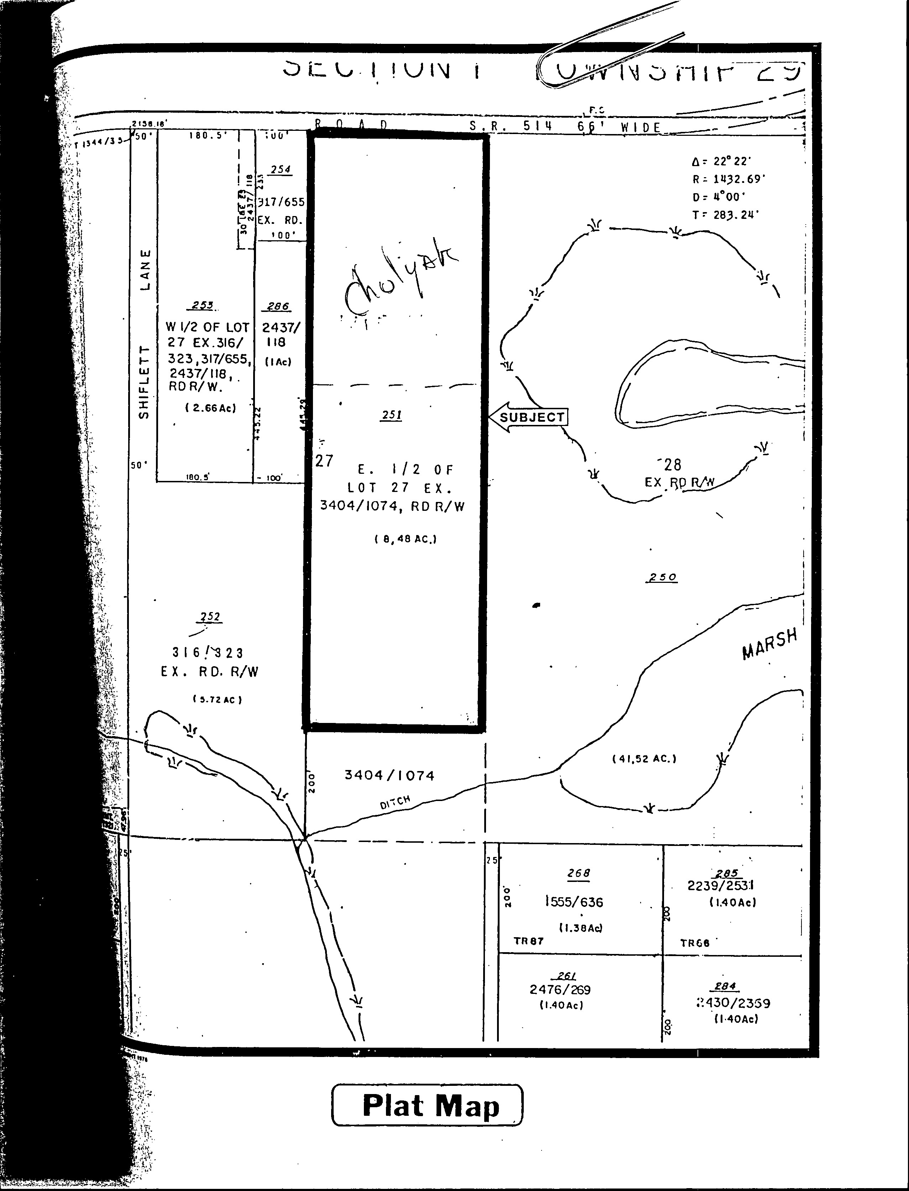

W.  EX. | E 1/2 OF LOT 3 1  Ex S. 970.92' ,  E. 2 5', ŔD. R/w  2•. 1 0
. ESM I.  20  IM33/901  ( 2. 115 AC. ) | E SM T . 1 4 2 7/ roo  1202/709  AC.)
1433/908  EX  1554 /771  ( 2. 115 AC. ) | 16  1202/708  EX. E. 25  ( 2 SI  T.SD E SM T . ' 556/ 1 3 1
( 2. ¹15 AC. )
 | 1 590/780
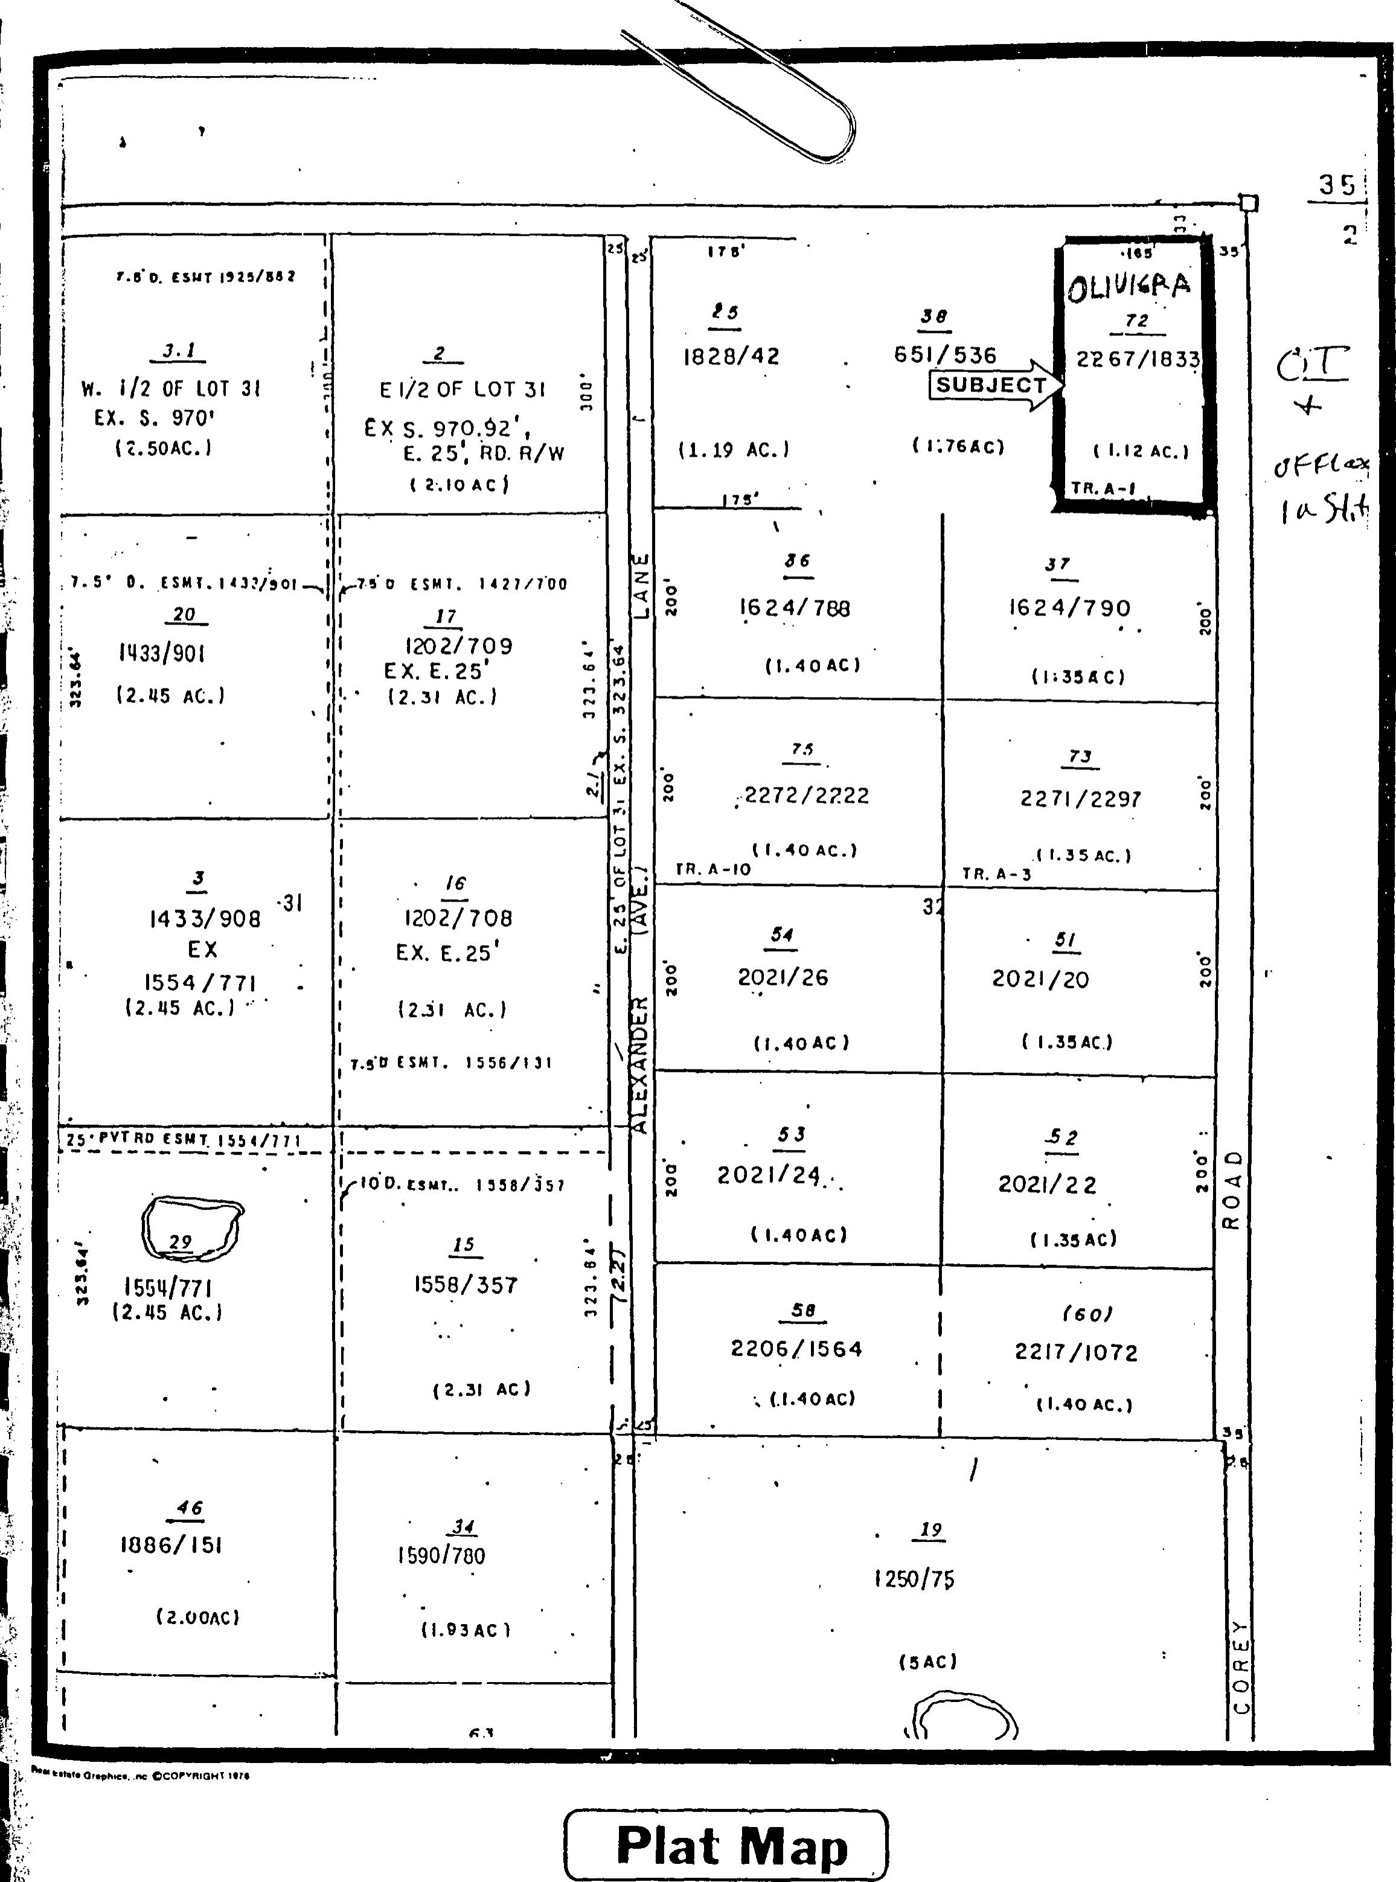
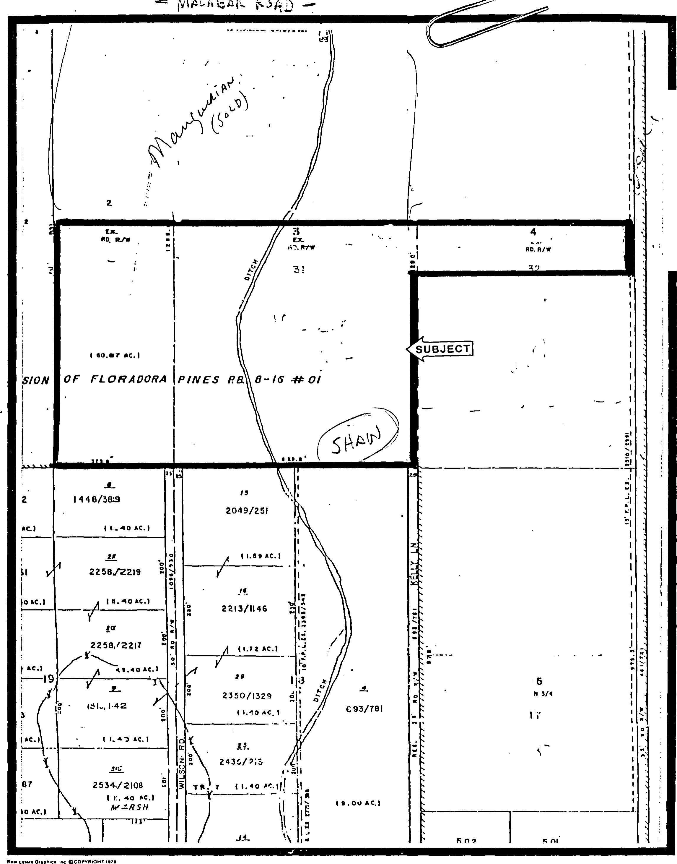
Plat Map Plat Map
FACSIMILE
to: Bill Hall - Town of Malabar
from: Edward Eckstein phone # 850 922-2207 Fax # 850 921-1 747 re: Malabar Sanctuary I and Il Management Plan date: 01-2099
At our 01-19-99 FCT acquisition meeting Anne Peery stated that 3 parcels in the Malabar
Il project site could possibly close in February 1999. These are the Chulyak, Oliveira and Shaw parcels. However, in order to close on these 3 parcels we need to review and approve the combined Malabar Sanctuary I and Il Management Plan.
The 3 parcels that could close in February 1999 are not associated with the two stormwater detention ponds proposed by the St. Johns WMD. The stormwater ponds would only affect the Reynolds and Galvez parcels. Therefore, in order to expedite review and approval of the combined management plan we are suggesting the following:
If it would take an extraordinary amount of time for Diane Barile to completely address the
2 stormwater ponds in the revised management plan (per our 12-10-98, 12-31-98 and 01-1 5-99 comment letters and fax), addressing the ponds in the management plan could be postponed until the Reynolds and Galvez parcels are about to be purchased. In essence, the combined management plan could be amended in the future to include the two stormwater ponds and related information.
Therefore, by February l , 1999, FCT needs to receive a revised management plan for the Malabar Sanctuary I and Il sites that address the comments made in our 12-10-98 letter, except for those comments that relate to the two proposed stormwater ponds. All other comments must be addressed, including the comment made on culvert improvements.
Please make Ms. Diane Barile and Mr. Steve Morgan aware of this strategy and have Ms. Barile submit a revised management plan to FCT by February 1, 1999, so we can close on the 3 parcels.
Please call me if any information is needed. Thanks !!!!
FACSIMILE
Bill Hall - Town of Malabar
to:
Steve Morgan - Frazier Engineering 90 2 3 1
from: | Edward Eckstein phone # 850 922-2207 | Fax # 850 921-1747
re: | Malabar Management Plan Comment
date: | 01-15-99
The following provision needs to be added to the stormwater management section of the revised Malabar Sanctuary Greenway Management Plan. Please see that Diane Barile is made aware of this addition.
Provision to add:
To ensure that the proposed stormwater detention ponds are compatible with the protection of natural resources and meets the multi-use objectives proposed in the original application, the following parameters shall be incorporated into the design of the detention ponds. In addition, the final design of the detention ponds shall be submitted to FCT for review and approval prior to construction.
- the stormwater detention ponds shall incorporate a sloped littoral zone that provides wildlife habitat and is attractive to park visitors.
- the stormwater detention ponds shall incorporate a flat underwater safety bench where possible to eliminate the need for a continuous fence. all fill material associated with the stormwater detention ponds shall be located outside of the 100-year floodplain to prevent encroachment on the natural shoreline ecosystem.
- the stormwater detention ponds shall incorporate locations for educational displays.
Consulting Civil and Structural Engineers
Mr. Edward Eckstein January
Florida Community Trust
Department of Community Affairs
2555 Shumard Oak Boulevard JAN 1999
Tallahassee, Florida 32399-2100
DEPT. OF CCM%UNITY AFFAIRS
Subject: Proposed Stormwater Improvements for FCT Projects #95-063-+SG'DA TRUST (Malabar Sanctuary I) and #96-019-P7A (Malabar Sanctuary Il)
Dear Mr. Ecksein,
This letter serves as a response to your letter dated December 31, 1998. Included below are responses to the requested information from your letter.
Item # I The approximate locations of the two wet detention ponds are shown on the attached aerial photograph and USGS quadrangle map from the original submittal.
FRAZIER ENGINEERING, INC.
Item #2 The wet detention ponds are being built to provide the Town of Malabar with flood protection and water quality improvements. A majority of the Town of Malabar is susceptible to flooding during various storm events.
The Town of Malabar stormwater management plan is being developed in conjunction with the St. Johns River Water Management District (SJRWMD). This project will take into account the future land uses of the Town and apply those uses in developing stormwater runoff calculations. These calculations will be applied to the proposed wet detention ponds to calculate peak flow rate and provide flood attenuation and water quality improvements with the addition of the two wet detention ponds. Pollutant levels will also be greatly reduced with the addition of the two wet detention systems.
Item #3 Two proposed wet detention ponds will be approximately 20 acres each. The first proposed pond location is at the northeast corner of Weber and Hall Roads. Discharge from the pond will be along Weber Road, which will eventually discharge into Turkey Creek. The second proposed pond will be northwest of Corey and Malabar Roads. Inflow and outflow will be from a tributary of Turkey Creek. The natural base flow of Turkey Creek will be maintained. We will propose a minimum buffer of 25 feet from the top bank of Turkey Creek to the top bank of the wet detention pond.
Native vegetation will be removed from both sites, however we feel this impact will be very minimal due to the fact that both sites are being used as pastureland for grazing animals. Both ponds will be 12 feet in depth or less per SJRWMD regulations.
The addition of the ponds will greatly improve the water quality of Turkey Creek, which eventually discharges into the Indian River. The target pollutant loads after construction and operation of the ponds will be to the year 1943. (before most development occurred in the Town of Malabar).
Item #4 We feel the recreation benefits will greatly outweigh the negative impacts of the project. We are planning to integrate into the plans of the project, areas for bike trails and interpretive trails describing the positive impacts ofthe stormwater management system. We are also planning to coordinate with the Florida Game and Fresh Water Fish Commission to stock each system with fish for catch and release fishing. We feel this project would be of great recreational value too not only the residents of Malabar but of residents from surrounding communities.
Item #5 We anticipate the water quality discharged from these ponds to improve greatly over current pollutant levels. Because the runoff is discharged into Turkey Creek and eventually into the Indian River, the pollutant reduction of these systems will greatly reduce the impacts downstream, therefore benefiting both the wildlife residing in and around these systems and the water quality of these systems.
Item #6 Enclosed is a copy of the contract between the Town of Malabar and the
SJRWMD
I hope the above mentioned information will answer all the questions you have concerning this very important and beneficial project to the residents of the Town of Malabar and surrounding communities. If I can be of further assistance in this matter please call myself at (407) 253-8131, or Mr. William Hall at (407) 727-7764.
Very Truly Yours,
Frazier Engineering Inc.
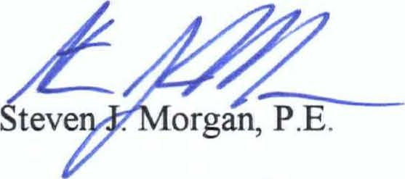
Cc. William Hall, Town of Malabar
Whit SJRWMD
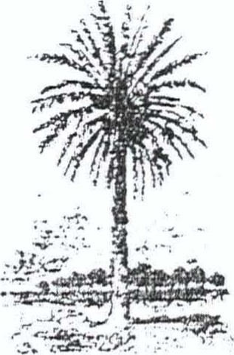
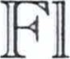orn a ommunhfhes Trust
December 31, 1998
Mr. William Hall City Manager
Town of Malabar
2725 Malabar Road
Malabar, Florida 32950
RE: Proposed Stormwater Improvements for FCT Projects #95-063-P56 (Malabar Sanctuary I) and #96-019-P7A (Malabar Sanctuary Il)
Dear Mr. Hall:
The Florida Communities Trust (F CT) recently received the enclosed letter from Mr. Steven
Morgan, of Frazier Engineering, Inc., regarding the location of two wet detention ponds on the
Malabar Sanctuary I and Il sites. A 17-acre wet detention pond is proposed to be located north of Malabar Road on the Reynold's property and the other 20-acre pond is to be located south of Malabar Road along Weber Road.
A review of the location maps included with Mr. Morgan's letter showed the proposed detention ponds would be situated on parcels already disturbed by clearing and agricultural activities. While the proposed locations of the two detention ponds may prove to be suitable, these improvements need to be reviewed in the context of the management plan for the Malabar Sanctuary I and Il sites.
The FCT's review comments on the draft Malabar Sanctuary management plan were mailed to you on December 10. 1998. The draft management plan did not provide any information on the proposed detention ponds. In order for the FCT to evaluate the suitability of the project sites for the proposed detention facilities, the following information must be included in the revised management plan, in addition to addressing our December 10th comments:

l . Show the location of the two wet detention ponds on the Master Site Plan (Exhibit C).
- Discuss the purpose of constructing the wet detention ponds (i.e., mitigate flooding, improve water quality, accommodate existing or future development. etc.) and discuss how the ponds will further the hydrologic restoration and enhancement purposes of the project.
DEPARTMENT OF COMMUNITY AFFAIRS • 2555 SHUMARD OAK BOULEVARD • TALL\HASSEE, FL 32399-2100 850/922-2207 • SUNCOM 292-2207 • FAX 850/921-17A7
FLORJt)A Tn•sT t.ES

31,
Two
- Provide a description on the location and design of the two wet detention ponds (i.e., proximity to creek, acres, depth, control structures, etc.) and discuss the impact of pond construction on natural resources, including native vegetation.
- Discuss how the detention ponds may hinder or complement proposed recreation improvements on the sites (i.e., pedestrian and bicycle trails, etc.).
- Discuss the anticipated benefits to wildlife and the water quality of Turkey Creek by constructing the wet detention ponds.
Provide an outline of the process for coordinating with the St. Johns River Water
6.
Management District in the development and implementation of a stormwater management and hydrologic restoration plan for the project sites.
As requested in previous correspondence, to ensure that all parties are kept informed of the project, future correspondence from the SJRWMD and Frazier Engineering, Inc., regarding the project should be directed through you as the designated Key Contact for the FCT projects.
If you have any questions or comments, please contact me or Edward Eckstein at (850) 922-2207 or SUNCOM 292-2207.
Sincerely,
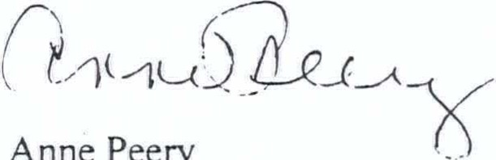Anne Peery
Executive Director
AP/ee
Enclosure
cc: Mr. Steven Morgan, Frazier Engineering, Inc.
Mr. Whit Green, SJRWMD
om
December 10, 1998
Mr. William Hall City Manager
Town of Malabar
2725 Malabar Road
Malabar, Florida 32950

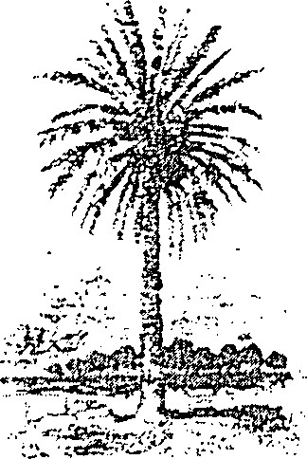

ommunifies Trust

RE: Management Plan for FCT Projects #95-063-P56 (Malabar Sanctuary Greenway I) and #96-019-P7A (Malabar Sanctuary Greenway Il)
Dear Mr. Hall:
Thank you for submitting the above-referenced management plan for review. The Florida Communities Trust (FCT) has reviewed the draft management plan according to the requirements of Rule Chapter 9K-4.0i I(l)(b), Florida Administrative Code, Conceptual Approval Agreements (CAA) #95-063-P56 and #96-019-P7A, and Exhibit C, Writing a Management Plan. Please consider the following staff comments in preparing vour management plan for submittal to the FCT Governing Body for approval.
The FCT governing body approved the project plan for Malabar Sanctuary Greenway Il on October 27, 1998, contingent upon final review and acceptance of the management plan by FCT staff. Grant funds cannot be released until this contingency is removed. Please consider the following comments in preparing a revised management plan for FCT review and approval.
FORMAT:
Include the FCT project numbers (95-063-P56 and 96-019-P7A) on the cover page of the management plan. [CAA, Exhibit C]
INTRODUCTION:
The Malabar Sanctuary Greenway Phases I and Il projects ihvolve the acquisition of multiple parcels that will close at varying points in time. Include a discussion of the acquisition plan for the project indicating the sequence and expected timeframe for
DEPARTMENT OF COMMUNITY AFFAIRS ' 2555 SHUMARI) OAK BOULEVARD • TALLAHASSEE, FL 32399-2 100
850/922-2207 • SUNCOM 292-2207 • FAX
Two
acquiring the separate parcels of the project sites. Discuss how this acquisition schedule will impact the various key management activities in the management plan and what interim measures will be implemented to ensure success of the entire project. It would be appropriate to place this discussion under a separate heading entitled Acquisition Schedule.
The original grant application stated that conservation easements would be used to acquire a portion of the Malabar Sanctuary Phase I project and evaluation points were awarded for this under criterion (3)(a) of the application. In your November 14, 1995, letter to FCT you stated that the Brook Hollow Homeowners Association had agreed to provide conservation easements relative to their portion of property. However, the appraisals for the project were based on fee simple acquisition and did not include an analysis of conservation easements. Please state whether the use of conservation easements is still anticipated by the Town and, if applicable, provide a discussion on this under the Acquisition Schedule heading suggested above. If the use of conservation easements is anticipated outside of the project boundaries to extend the proposed greenway, provide a discussion on this under the Greenway Management heading.
The discussion on page 3 regarding land use classification only mentions zoning. What is the Future Land Use Map (FLUM) designation for the two Project Sites and what FLUM designation is proposed? The future land use and zoning designation assigned to the Project Sites are required to be dedicated to open space, conservation, or outdoor recreation uses as appropriate. If a new FLUM classification dedicated to open space, conservation, or outdoor recreation is needed to satisfy this requirement, a new land use classification should be adopted by the Town. Once adopted, the Town could then change the zoning and FLUM designation of the sites subsequent to or after acquisition during the next comprehensive plan amendment cycle. Please revise page 3 to state that the Town will adopt a new zoning and FLUM classification and change the designation of the Project Sites, as discussed above. [CAA, Sec. V #1]
STRUCTURE AND IMPROVEMENTS:
Provide an exhibit that shows the location of existing physical improvements on the Project Sites (i.e., fences, gates, corrals, culverts, houses). [CAA, Sec. V #5]
Provide a reference for the Master Site Plan on page 9 and re-name Exhibit C as the Master Site Plan, instead of Project Plan. [CAA, Exhibit C]

Three
The Master Site Plan (Exhibit C) is not of an appropriate scale to show the level of detail necessary to identify the location of proposed improvements. In addition, the two sites have undergone boundary modifications and the boundaries drawn for Phases I and Il are not correct. Refer to the attached maps showing the amended boundary for Phases I and Il. The Master Site Plan also needs to show that Phase I of the project is located north of Malabar Road and Phase Il is south of Malabar Road. Provide a revised Master Site Plan that is of an appropriate scale and shows the correct project boundaries and identifies Phases I and Il of the project. [CAA, Exhibit C]
Revise the Master Site Plan (Exhibit C) to show the location of the proposed nature education centers and creek crossovers. [CAA, Exhibit C]
Since the boundary for the Malabar Sanctuary Greenway Phase I site is depicted incorrectly, the proposed location of a parking area and trailhead will be impacted and their location may need to be adjusted. Revise the Master Site Plan, as appropriate. [CAA, Exhibit C]
On page I l , provide a discussion of bicycle and pedestrian safety issues associated with crossing Malabar Road. This discussion would include using traffic control techniques such as speed zones, pavement markings, center islands or other traffic-calming methods.
Provide additional information on the 24-foot berm mentioned on page I I of the management plan. Is the berm existing or is it proposed as part of the proposed stormwater management system? Please provide an explanation.
On page I l , discuss the issues, problems and proposed management techniques for ensuring the compatibility of horseback riding with other outdoor recreation activities proposed in the management plan. In addition, it is not possible to differentiate the bridle path from the cycle/nature trail on the Master Site Plan (Exhibit C). Revise the Master Site Plan by using another symbol to clearly delineate the bridle path from other trails on the sites. [CAA, Exhibit C]
The Priority Schedule (Appendix IV) states that the Reynold's ranch house will be moved and restored. If moved elsewhere on the Project Sites, show its proposed location on the Master Site Plan and discuss the intended use of the ranch house. [CAA, Exhibit C]
The discussion on alterations of the two Project Sites on page 9 is insufficient. Identify all proposed alterations of land or vegetation at the Project Site and the total extent of this work in quantifiable terms (i.e., acres or square feet). This discussion should include
Four
the approximate size of the three proposed trailhead and parking areas, the typical crosssection of the walking, bicycle and equestrian trails and other alterations associated with hydrological restoration and stormwater management improvements. [CAA, Exhibit C]
Include a provision on page I I of the management plan that all parking areas shall incorporate pervious materials, wherever feasible. [CAA, Exhibit C]
Page 9 of the management plan makes reference to nature education centers. Provide a brief narrative on the location of these nature education centers and discuss what type of education programs or activities will be offered at these facilities. [CAA, Exhibit C]
Add a provision on page I I to provide bicycle racks at appropriate locations on the two Project Sites. [CAA, Exhibit C]
Although the plan has identified the required permits or approvals necessary for proposed development or restoration work, the plan also is required to contain a procedure for providing evidence to the Florida Communities Trust that all required licenses and permits have been obtained prior to the initiation of construction. Please include a procedure in the management plan to accomplish this requirement. [CAA, Sec.IV #2]
Include a procedure that requires the Town to provide 60 day prior written notice and information regarding any lease of any interest, the operation of any concession, any sale or option, any management contracts for the Project Site, and any use of the Project Site by any person other than in such person's capacity as a member of the general public. [CAA, sec. VI
KEY MANAGEMENT ACTIVITIES:
Natural resource protection:
The discussion on page 14 regarding the protection of scrub jays and scrub jay habitat needs to be expanded to address the location of scrub jay habitat and the proposed management techniques associated with protecting scrub jays and scrub jay habitat. Does the County have a Habitat Conservation Plan (HCP) in effect? How will management of the Project Sites be coordinated with the County's nearby Malabar Scrub Conservation Area and with other scrub jay refugia proposed in the area?
Five
Include a statement that the survey of vegetative communities and plant species on the Project Sites will be used to locate physical improvements in areas that will not adversely impact these resources. [CAA, Exhibit C and Sec. VIll, #3 and #4]
Provide a statement that the Town shall coordinate with the Florida Game and Fresh Water Fish Commission for appropriate guidance, recommendations, and necessary permits to avoid impacts to listed species. [CAA, Exhibit C and Sec. V Ill, #4]
Provide a statement on page 15 that the Town shall coordinate with the Division of
Forestry and the Game and Fresh Water Fish Commission on the development of a
Prescribed Burn Plan for the scrub habitat on the Project Site. [CAA, Sec. V Ill, #9]
Page 19 states that the Town will forward information on any newly-identified listed species found on the Project Site to the Florida Natural Areas Inventory (FNAI) on the appropriate forms. Provide the attached FNAI forms as an attachment to the management plan and reference the attachment on page 19 of the plan. [CAA, Exhibit C]
Archeological and historical resource protection:
The management plan has been forwarded to the Division of Historical Resources for their review. If they recommend any changes to the plan, their comments will be forwarded to your office. [CAA, Exhibit C and Sec. V Ill, #10]
On page 16, identify the timing and extent of the historical and archaeological survey of the Project Site. [CAA, sec. Vlll, #10]
RESOURCE ENHANCEMENT:
In the original application, the land area of each Project Site was considerably less than the present modified boundary. While the original boundary of each site included predominantly native vegetation, the modified boundary included more disturbed area (i.e., pastureland, etc.). Specify how much of the land area within the modified project boundaries are disturbed and discuss how disturbed areas will be managed.
The CAAs for the two Project Sites state that approximately 10 acres of wetland and upland vegetation on the Project Site will be restored in terms of biological composition and ecological function. On page 16, provide specific details on the 10 acres of wetland and upland vegetation to be restored and locate the 10-acre restoration area on the Master Site Plan or another exhibit. [CAA, Sec. V Ill #6]
Six
Page 15 states that field ditches and channels will be redirected through wetlands and/or retention-detention facilities. Is the St. Johns River Water Management District still contemplating the construction of a stormwater retention facility on one of the Project Site parcels? As mentioned in our April 13, 1998, letter to you, any proposed stormwater facilities must be compatible with the purposes and objectives of the project and not harm natural resources and must be submitted to FCT for review and approval. Our letter also requested that the Town coordinate with the St. Johns River Water Management District in the development and implementation of a stormwater management and hydrologic restoration plan for the Project Sites and that the Town work closely with the District in developing a combined management plan for both sites. Include a provision on page 15 stating that the Town will coordinate with the St. Johns River Water Management District in developing a stormwater management and hydrological restoration plan for the Project Sites and outline the steps necessary to accomplish this task. [CAA, Sec. V Ill #7 and #8]
Page 9 states that the FDOT has improved the culverts that connect the Phase I and Il sites. Restate this on page 16 under Resource Enhancement and discuss how the culverts were improved and the intended benefits of the culvert improvements on water quality in Turkey Creek. [CAA, sec. Vill
Greenwav Mana^{g}ement
Provide a discussion on the Malabar Sanctuary Greenway and provide details on how the Project Sites will further the Malabar Sanctuary - Turkey Creek Greenway network being established within the Town of Malabar and the City of Palm Bay. Discuss management coordination efforts with the City of Palm Bay and how management of the Project Sites will be integrated into an overall resource protection strategy for the greenway network. Provide documentation that the Project Sites are already formally incorporated into the Town's greenway network (i.e., greenway resolution by Town Council) or include a procedure to formally incorporate the sites into the Town's greenway network. Identify all greenway parcels in the area on a map and show how the various sites will be connected (i.e., Malabar Sanctuary - Turkey Creek Greenway, Malabar Community Park, Turkey Creek Sanctuary and the County's Scrub Habitat Conservation Area). Consolidate this discussion under a separate "Greenway Management" subheading in the management plan.
[CAA, sec. Vll
PRIORITY SCHEDULE:
The Priority Schedule provided in Appendix IV is confusing. Revise the Priority Schedule to tie key management activities to specific calendar years (i.e., 1999, 2000) instead of two-year periods. [CAA, Exhibit C]
Seven
MONITORING AND REPORTING:
The discussion on the date to provide an annual stewardship on page 18 is incorrect. Revise the annual stewardship report submittal date to the anniversary of the date on which the project plan was approved, which was October 27, 1998. The first annual stewardship report will be due October 27, 1999. [CAA, Exhibit C]
SUPPORT DOCUMENTS:
The appendix should contain a list of all the special management conditions from Section VIll of the Conceptual Approval Agreement and a statement on how each of the conditions were addressed. Provided the page number(s) in the management plan where the special conditions were addressed. [CAA, Exhibit C]
The appendix should contain a copy of the Grant Award Agreement and recorded deed when they become available. Include a reference for these documents in the Table of Contents. [CAA, Exhibit C]
I hope you will find these comments helpful in finalizing the management plan. Please address the above comments in the management plan and resubmit the draft plan to the FCT. Trust staff will then conduct another review of the management plan to determine if it is approved.
If you have any question concerning the staff review and comments you can contact me or Edward Eckstein at 2555 Shumard Oak Boulevard. Tallahassee, Florida 32399-2100 or call us at (850) 922-2207.
Sincerely,

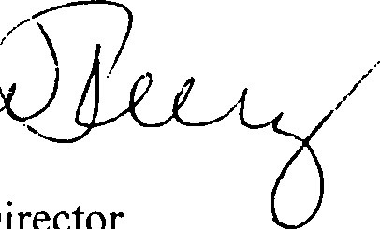
(I/ u; ICC)
Anne Peery
Executive Director
AP/ee
Attachments

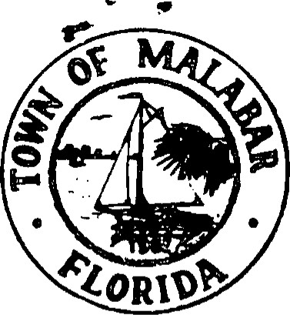
WILLIAM HALL
TOWN ADMINISTRATOR2725 MALABAR ROAD

(407) 723-3261MALABAR, FLORIDA 32950-4427
FAX (407) 722-2234

September 30, 1998
Mr. Edward Eckstein
Florida Communities Trust
Room 310
2555 Shumard Oak Boulevard
Tallahassee, FL 32399-2100
Subject: Management Plan
Dear Mr. Eckstein,
Please accept the enclosed copies of the Management Plan for FCT Project Number 96-019-P7A and FCT Project Number 95-063-P56 for your consideration.
Sincerely,
William Hall, Town Administrator
OCT
DEPT. OF COMMUNIÜ
FLORIDA COMMUNIT\FS

